Development of Web-Based Anonymous Feedback System for CCIS Students Using Sentiment Analysis and Algorithmic Concern Ranking

Submitted by:
Orenza, Leah Joy D.
Queypo, Ckhiel Joshua G.
Viloria, Julian Shaun M
Mariano Marcos State University
College of Computing and Information Sciences

CMPSC 146: Software Engineering

October 5, 2026
TABLE OF CONTENTS
CHAPTER 1 INTRODUCTION 7
1.1 Background of the Project 7
1.2 Statement of the Problem and Project Gap 9
1.3 Objectives of the Project 10
1.3.1 Main Objective 10
1.3.2 Specific Objectives 10
1.4 Scope and Limitations of the Project 11
1.5 Significance of the Project 13
1.6 Definition of Terms 14
CHAPTER 2 REVIEW OF RELATED LITERATURE AND SYSTEMS 15
2.1 Review Focus 15
2.2 Student Feedback and Institutional Review 15
2.2.1 Collection Review and Use of Feedback 15
2.2.2 Responsible Faculty Interpretation 16
2.3 Web Based Feedback and Evaluation Systems 17
2.3.1 Philippine Development Studies 17
2.3.2 International Development Example 19
2.4 Graphical Reporting and Dashboard Design 19
2.4.1 Designing Around Reviewer Tasks 19
2.4.2 Evaluating What the Dashboard Claims 20
2.5 Iterative Website Development and Concern Prioritization 21
2.5.1 Agile Data Science 2.0 for Website Development 21
2.5.2 Transparent Ranking of Concerns 21
2.6 Review of Related Systems 22
2.6.1 Google Forms 22
2.6.2 Moodle Feedback 22
2.6.3 Microsoft Forms 23
2.6.4 Watermark Course Evaluations and Surveys 23
2.6.5 Comparison and Synthesis 24
2.7 Software Quality Usability and Data Governance 25
2.8 Conceptual Framework 26
CHAPTER 3 METHODOLOGY 27
3.1 Project and Research Design 27
3.2 Setting Participants and Requirements Gathering 28
3.3 Agile Data Science 2.0 Development Process 29
3.3.1 Records 29
3.3.2 Charts 30
3.3.3 Reports 30
3.3.4 Recommendations 31
3.3.5 Actions 31
3.3.6 Implementation Testing and Release Preparation Across Stages 32
3.4 System Requirements and Architecture 33
3.5 Feedback Processing and Graphical Reporting 37
3.5.1 Submission and Record Handling 37
3.5.2 Definition of Graph Measures 38
3.5.3 Filters and Report Consistency 39
3.5.4 Programmed Concern Ranking 40
3.6 Functional and Software Quality Evaluation 41
3.7 Usability Evaluation and Data Analysis 43
3.8 Ethical Procedures and Data Management 45
3.9 Documentation and Expected Outputs 46
REFERENCES 47
APPENDIX A FISHBONE DIAGRAM 50
APPENDIX B GANTT CHART 53
APPENDIX C USE CASE DIAGRAM 58
APPENDIX D USE CASE DESCRIPTIONS 60
APPENDIX E ACTIVITY DIAGRAMS 95
APPENDIX F CLASS DIAGRAMS 117
APPENDIX G COMPONENT DIAGRAM 124
APPENDIX H PACKAGE DIAGRAM 126
APPENDIX I DEPLOYMENT DIAGRAMS LOCAL AND ONLINE 128
LIST OF FIGURES
Figure 1 ResBack conceptual framework for website development 26
Figure 2 Agile Data Science 2.0 stages adapted to ResBack 33
Figure 3 Local development architecture 35
Figure 4 Roles and use case overview 36
Figure 5 Core data relationships 37
Figure 6 Feedback processing and failure paths 38
Figure 7 ResBack fishbone diagram 50
Figure 8 ResBack Gantt chart using Agile Data Science 2.0 54
Figure 9 ResBack UML use case diagram 59
Figure 10 Activity diagram for register an account 97
Figure 11 Activity diagram for log in 98
Figure 12 Activity diagram for submit feedback complete flow panel 1 of 3 99
Figure 13 Activity diagram for view my feedback history 102
Figure 14 Activity diagram for view dashboard and ranked concerns 103
Figure 15 Activity diagram for manage accounts 106
Figure 16 Activity diagram for analyze feedback 109
Figure 17 Activity diagram for export feedback to Excel 112
Figure 18 Activity diagram for generate a PDF analytics report 113
Figure 19 Activity diagram for delete feedback 114
Figure 20 Activity diagram for edit my profile 115
Figure 21 Activity diagram for log out 116
Figure 22 Class diagram for core domain model 118
Figure 23 Class diagram for authentication accounts and profiles 119
Figure 24 Class diagram for feedback submission and protection 120
Figure 25 Class diagram for sentiment analysis and concern ranking 121
Figure 26 Class diagram for dashboard and report generation 122
Figure 27 Class diagram for account access middleware 123
Figure 28 ResBack UML component diagram 125
Figure 29 ResBack UML package diagram 127
Figure 30 ResBack UML local deployment diagram 129
Figure 31 Proposed online deployment diagram 130
LIST OF TABLES
Table 1 Comparison of feedback collection and reporting systems 24
Table 2 Requirements and implementation traceability 33
Table 3 Planned system evaluation measures 42
Table 4 Alignment of research questions objectives and evaluation 46
Table 5 UC-01 Create Account 61
Table 6 UC-02 Login 63
Table 7 UC-03 Submit Feedback 65
Table 8 UC-04 Screen Feedback 67
Table 9 UC-05 Edit Own Profile 69
Table 10 UC-06 Analyze Accepted Feedback 71
Table 11 UC-07 View My Feedback 73
Table 12 UC-08 View Dashboard 75
Table 13 UC-09 Filter Feedback 77
Table 14 UC-10 Download PDF Report 79
Table 15 UC-11 Export Feedback 81
Table 16 UC-12 Delete Feedback 83
Table 17 UC-13 View / Search Account 85
Table 18 UC-14 Delete Another Account 87
Table 19 UC-15 Change Account Role 89
Table 20 UC-16 Deactivate / Reactivate Account 91
Table 21 UC-17 Logout 93
ACKNOWLEDGMENT
I thank the Lord for giving me the capability to do this research project. I also thank Mr. Noel S. Rafanan, my professor in CMPSC 146 Software Engineering for the assistance he rendered in the development of the project and its documentation.
The following are the development background and evaluation of ResBack for the College of Computing and Information Sciences of Mariano Marcos State University. There were twenty-five students who already answered a pre-questionnaire using Google Forms. The stakeholder validation and evaluation of the system will be done once the necessary permission is given.

CHAPTER 1 INTRODUCTION

1.1 Background of the Project
Student feedback gives a college a way to understand students' experiences of teaching, facilities, schedules, and academic services. Collecting comments is only one part of this process. Faculty and administrators also need a practical way to retrieve submissions, review patterns, and prepare information for discussion. A feedback website should therefore support both the person submitting a concern and the personnel who will review the results.
Studies of student feedback emphasize that its usefulness depends on how institutions interpret and use the information. Feedback practices that involve students and communicate how their input is considered can support dialogue, but collecting more responses does not by itself demonstrate better teaching or institutional action. Research on student evaluations also cautions against treating feedback scores as complete measures of an instructor's performance. These findings support a system that presents information for informed human review rather than making institutional decisions automatically. [1] [2]
For the College of Computing and Information Sciences (CCIS) of Mariano Marcos State University, this project focuses on developing ResBack, a web-based feedback management system with graphical reporting for faculty and administrators. The system provides account access, feedback submission, personal feedback history, a faculty dashboard, filtering, and downloadable reports. Its purpose is to organize the submission and review process in one application and help authorized users understand the feedback that has been received.
The earlier project manuscript records an exploratory Google Forms questionnaire involving 25 student volunteers in September 2026. This provides initial requirements context concerning feedback, identity protection, and perceived usefulness. It does not establish the experience of all CCIS students or prove that the completed website is usable. Faculty requirements and the usability of the website will be examined through separate walkthroughs and task-based evaluation.
Graphs can make the distribution and movement of feedback easier to inspect, provided that labels, reporting periods, and counts are clear. A reviewer should be able to identify what a graph measures, apply a filter, and consult the comments behind a summary. Educational dashboard research provides supporting design principles for these activities, although studies of learning activity dashboards do not directly demonstrate the effectiveness of a feedback management website. [3] [4]
ResBack's implemented dashboard includes a distribution of positive, neutral, and negative feedback, a daily positive-versus-negative trend, and a chart of ranked concerns. These displays use labels and scores produced by supporting processing services. The study's main contribution is the development and evaluation of the integrated website: whether users can submit and retrieve feedback, whether authorized faculty can understand its graphical presentation, and whether filters and reports behave correctly. Developing, training, fine-tuning, or comparing language models is outside the research objectives.
Identity protection is also part of the system design. ResBack privately links a submission to its account for personal history and submission safeguards. Faculty dashboards and reports omit account identifiers, but this does not make the database anonymous, and a comment can identify its writer through its content. The system will communicate this distinction and apply role-based access and appropriate data-handling procedures. The Philippine Data Privacy Act implementing rules provide a governance basis for transparency, legitimate purpose, and proportionality. [5]

1.2 Statement of the Problem and Project Gap
The development problem is how to provide CCIS with a web-based feedback system that supports organized submission and storage and gives faculty a clear, controlled way to view the results through graphs and reports. The requirements to be validated include convenient account access, protection of identities in reviewer-facing outputs, understandable graphical summaries, consistent filtering, and reliable retrieval of feedback records.
Existing form and evaluation systems show that online collection and graphical reporting are established capabilities. The project gap is therefore a local integration and evaluation need: fitting these capabilities to the intended CCIS feedback workflow, access rules, and reporting tasks. This study does not claim that graphical feedback reporting is a new invention or that current institutional practices are ineffective without local evidence.
The study addresses the following questions.
1. What functional, privacy, and reporting requirements should guide the development of a web-based feedback system for CCIS?
2. How can the system be designed and developed through Agile Data Science 2.0 adapted to website development to support account access, feedback submission, record storage, personal history, and authorized management?
3. How can faculty be provided with graphical summaries, filters, supporting comments, and downloadable reports for reviewing CCIS feedback?
4. How can a programmed concern-ranking procedure organize recurring concerns and present the basis of its scores for faculty review?
5. To what extent does the developed website meet its specified functional, access-control, reporting-consistency, reliability, and performance requirements under defined test conditions?
6. How usable is the website for the intended student, faculty, and administrative tasks, including faculty interpretation of graphs and concern rankings?

1.3 Objectives of the Project

1.3.1 Main Objective
To develop and evaluate ResBack, a web-based feedback system for CCIS that organizes feedback submissions and supports faculty and administrative review through graphical dashboards, concern ranking, and downloadable reports.

1.3.2 Specific Objectives
1. Identify and document stakeholder requirements for feedback submission, identity protection, access, graphical reporting, and concern review.
2. Design and develop the interfaces, database, and role-based workflows for account access, feedback submission and safeguards, personal history, and authorized management through Agile Data Science 2.0 adapted to website development.
3. Provide faculty with graphical summaries, date and language filters, supporting feedback records, Excel exports, and PDF summaries with clearly defined measures and coverage.
4. Implement and verify the programmed concern-ranking procedure, including its topic groupings, scoring factors, ordering, and supporting examples.
5. Verify the website's functional behavior, access controls, graph and report consistency, failure handling, and performance using documented test cases and controlled records.
6. Evaluate usability through role-based tasks and user feedback, emphasizing faculty interpretation of graphs and concern rankings, and use the findings to refine the website.

1.4 Scope and Limitations of the Project
The project covers the development and evaluation of a browser-based feedback management website for the initial CCIS setting. The system has Student, Faculty, Admin, and Super Admin account roles. Student and Faculty users can submit feedback and inspect their own history. Faculty, Admin, and Super Admin users can access the dashboard and reports. Administrative account management and feedback deletion depend on the account's authorization and protection rules.
The feedback reviewed on the dashboard is college-wide. The existing data model does not assign each response to an individual instructor, subject, or course section. ResBack is therefore not presented as a formal instructor-rating or course-evaluation system. It also does not currently provide a configurable rating questionnaire, an issue-assignment workflow, faculty replies, resolution tracking, or measures of institutional response time.
The website stores free-text submissions and processing status, provides search or pagination where implemented, and excludes rejected submissions from faculty reporting. The dashboard offers a sentiment-distribution graph, a positive-versus-negative daily trend, and a concern-score chart. Language counts are presented as a summary list. Date and language filters narrow the reporting scope. Excel exports contain the selected feedback records, while PDF reports present summaries, concern information, and selected supporting comments. The current PDF report does not reproduce the interactive Chart.js graphs.
Existing automated classification and concern calculation are supporting implementation features. Their outputs will be described accurately and their integration, availability, and display behavior will be checked as part of system testing. The study does not claim to establish classification accuracy, regional-language performance, or superiority over another model. A correct graph can still summarize an incorrect automated label, so reviewers must retain access to context and exercise judgment. Concern scores are review aids and do not establish the seriousness, truth, or resolution priority of a complaint.
Authentication restricts access, but registration alone does not verify CCIS enrollment or employment. Authorized institutional account provisioning and membership checks require an approved operating procedure before a wider pilot. Identity suppression in reports is limited by private account links, privileged database access, and identifying information that users may write in comments. Accepted comment text is processed through an external service in the current implementation, which requires an appropriate disclosure and approved handling arrangements.
The local development configuration and a proposed online hosting architecture are documented separately. Online deployment, production performance, recovery capability, and institutional acceptance will only be reported as completed when corresponding evidence is available. The external processing service currently runs during the submission request; its delays or failures can affect the user's experience. A native mobile application, university-wide rollout, emergency response, and automated institutional decisions are outside this project.

1.5 Significance of the Project
For students, the project provides a common web interface for submitting feedback and reviewing personal submission history. Identity protection in faculty-facing outputs and clear explanations of processing status are intended to support informed participation.
For faculty, the dashboard brings graphical summaries, filters, and supporting comments into one review interface. The evaluation will examine whether faculty can identify the selected period, interpret the measures, locate relevant comments, and produce the reports needed for review. It will not assume that visually attractive graphs are automatically understandable.
For administrators and CCIS, the project provides a documented feedback workflow, permission structure, and reporting process. Exported information can support discussion and follow-up through existing institutional procedures. Whether institutional concerns are addressed will still depend on assigned personnel, decisions, and resources beyond the website.
For future developers and researchers, the study provides requirements, design diagrams, test cases, and evaluation procedures for a feedback management application. These materials can support later work on account verification, response workflows, deployment, and reporting, subject to stakeholder needs and additional testing.

1.6 Definition of Terms
Feedback management system refers to the website functions used to submit, store, retrieve, organize, and present feedback for authorized review.
Graphical reporting refers to presenting stored feedback measures through charts with defined labels and reporting periods. It does not by itself establish the validity of the underlying comments or automated labels.
Faculty reviewer refers to a user with permission to inspect the college-wide dashboard and reports. It does not mean that the feedback is individually attributed to that faculty member.
Identity suppression refers to omitting account identifiers from faculty dashboards and reporting outputs while retaining private account links for permitted system operations.
Software Development Life Cycle or SDLC refers to the organized activities of planning, requirements analysis, design, implementation, testing, deployment preparation, and maintenance. In this project, these activities are revisited as requirements and evaluation findings change.
Usability refers to the extent to which specified users can achieve specified goals with effectiveness, efficiency, and satisfaction in a specified context of use. Task success, time, errors, and user ratings are complementary measures in this study. [6]

CHAPTER 2 REVIEW OF RELATED LITERATURE AND SYSTEMS

2.1 Review Focus
This chapter reviews literature on student feedback processes, web-based feedback and evaluation systems, faculty interpretation of results, dashboard design, and software evaluation. It also examines established collection and reporting platforms. The review provides a basis for developing and evaluating ResBack as a feedback website with graphical reporting.
The sources are used according to their relevance. Studies of feedback websites provide direct comparisons of collection and reporting workflows. Research on student evaluations informs responsible interpretation, although ResBack does not currently implement instructor ratings. Studies of learning analytics dashboards provide supporting design principles; their findings are not treated as direct evidence of ResBack's effectiveness. Product documentation establishes documented features, while standards inform the proposed evaluation criteria.

2.2 Student Feedback and Institutional Review

2.2.1 Collection Review and Use of Feedback
Setterington, McLean, and Woods developed and evaluated an interactive Students as Partners feedback model through iterative action-research cycles. Participants valued a channel for student voice and visible responses to feedback, although results were not uniform and participation limitations remained [1]. The study indicates that the value of feedback depends on the process that connects collection, interpretation, and response. For ResBack, this supports giving authorized reviewers organized access to comments and their context. It does not establish that providing a website automatically improves teaching.
Nederhand and colleagues investigated whether explaining how feedback would inform course changes improved participation in student evaluation. Their intervention did not significantly improve response rate, response quality, or confidence in the evaluation process in that setting [7]. Lai and colleagues also examined participation in online course evaluation as an empirical question [8]. These studies caution against assuming that online availability or transparency alone ensures participation. ResBack should report actual feedback activity and evaluate users' tasks without promising a higher participation rate before evidence is collected.
For reporting purposes, a feedback count must be distinguished from the number of unique participating students. One person may submit more than one comment. A response rate also requires a known eligible population and a clearly defined opportunity to respond. ResBack's current dashboard is best described in terms of the feedback records included in a selected scope, rather than as a representative measure of all CCIS students' opinions.

2.2.2 Responsible Faculty Interpretation
Kreitzer and Sweet-Cushman's review identifies measurement and equity concerns in student evaluations of teaching [2]. Stoesz and colleagues similarly reviewed research on bias in student ratings of instruction and cautioned against relying on ratings as the only basis for assessing teaching [9]. These findings are relevant to the interpretation of student-provided information. They do not mean that feedback should be disregarded; they support presenting it as one source of evidence that requires context.
Stark and Freishtat discuss limitations of course-evaluation summaries and the need to consider distributions, participation, and other evidence [10]. Drue and Bifulco examine how academic leaders interpret feedback in evaluating teaching [11]. Together, these works support clear reporting periods, visible denominators, and access to underlying comments. For ResBack, a graph should not imply a percentage of students when it measures comments or a calculated concern score.
Cornes and colleagues describe ways to help faculty receive and respond constructively to difficult student comments [12]. This adds a human dimension to system design: a report should help reviewers understand feedback without presenting an automated judgment as a verified conclusion. The proposed faculty tasks therefore include reading the graph's labels and inspecting supporting text. Institutional action and professional judgment remain outside the automatic operation of the website.

2.3 Web Based Feedback and Evaluation Systems

2.3.1 Philippine Development Studies
Amboya and colleagues developed HighTeach, a web-based teacher evaluation system in a Philippine higher-learning setting. Their work used SDLC activities covering planning and requirements analysis, design, development, and testing [13]. It is a close methodological precedent for describing the construction of a website as the main project output. The reported scope excluded deployment, maintenance, and subsequent user or expert assessment. It should therefore not be cited as evidence of completed institutional adoption or a measured level of user acceptance.
Plata and Facun reported the development and implementation of the Paperless Student Evaluation for Teachers system at Isabela State University [14]. The study used a sequential development life cycle and described electronic evaluation and reporting. Although published in 2020, its initial pilot concerned the 2014–2015 period. This distinction matters when using it as a local precedent. Its relevance to ResBack is the organization of collection, storage, and report production through a web application; its historical implementation does not establish the performance of the current project.
Taguiam described a web-based faculty evaluation system for Apayao State College using PHP and MySQL and reported favorable assessments in that institutional setting [15]. The study supports the feasibility of building a locally appropriate evaluation application using a server-side website and relational database. Because the work is older and institution-specific, its results are used as background rather than as current evidence about platform capabilities or expected ResBack scores.
Carpio and colleagues examined an online faculty evaluation system at Basilan State College, including evaluation, administration, and reporting functions [16]. The paper provides a local comparison for centralized feedback and administrative review. Its descriptive perceptions and limited local evaluation cannot establish that every web-based system reduces work or improves teaching. In ResBack, such claims would require measurements using the actual application and intended users.
These Philippine examples support a development-centered study, but they also show an important boundary. Faculty evaluation systems commonly link numerical questionnaires to specific instructors or courses. ResBack currently collects college-wide free-text feedback and presents summaries for faculty review. The systems are related in collection and reporting functions, not identical in their data model or evaluation purpose.

2.3.2 International Development Example
Amjad and Linda describe a web-based tool for course teacher evaluation that collects responses to predefined questions and generates reports with graphical representations [17]. This is a direct example of connecting an online input process to results that personnel can review visually. It supports the functional relationship between forms, storage, tabulation, and reporting.
The comparison does not imply that ResBack already has the same questionnaire or teacher-mapping functions. ResBack's development evaluation will examine the implemented input and reporting workflow. Claims of faster processing or reduced effort will be limited to observations from defined tasks and conditions, rather than transferred from another institution's reported experience.

2.4 Graphical Reporting and Dashboard Design

2.4.1 Designing Around Reviewer Tasks
Sarikaya and colleagues examine dashboards in relation to their goals, audience, context, and interaction [3]. This supports defining the faculty questions before choosing a graph. In ResBack, these questions include the distribution of classified comments, changes in the displayed daily counts, and the comments associated with a reported concern. Graph design should follow the measure and task, with clearly labeled units and periods.
Guerra and colleagues adapted and evaluated a learning analytics dashboard in three Latin American universities [18]. Their work illustrates the importance of fitting dashboard features to local support workflows. Rozhenkova and colleagues examine faculty perspectives on using student-data dashboards and the support needed to turn data into action [19]. These studies concern educational data use more broadly, so they are supporting evidence for stakeholder involvement and interpretation support rather than direct evaluations of feedback management websites.
For ResBack, the practical implication is to test the interface through realistic faculty tasks. A reviewer should be able to identify what the current display covers, distinguish a count from a calculated score, apply the required filter, and retrieve the relevant supporting records. The project should evaluate these tasks rather than use the presence of charts as sufficient evidence of usefulness.

2.4.2 Evaluating What the Dashboard Claims
Matcha and colleagues reviewed empirical learning analytics dashboard studies and identified weaknesses in grounding and evaluation [4]. Paulsen and Lindsay reviewed the development of learning analytics dashboards and the relationship between analytics and learning purposes [20]. These reviews support aligning the evaluation with intended use. They do not demonstrate that the same dashboard designs or learning outcomes will transfer to ResBack.
The revised study consequently separates three questions. Functional verification asks whether the website displays the intended records and calculations. Usability evaluation asks whether users can operate the interface and understand its outputs. Institutional outcome evaluation would ask whether the information leads to better services or teaching. Only the first two are part of the current development study.
A graph also inherits the limits of its underlying data. Missing classifications, excluded records, different time windows, and multiple topics can change how counts relate to one another. ResBack's evaluation will therefore use known records and explicit expected measures to verify the displays. Supporting automated labels will not be treated as independently verified facts merely because they appear in a graph.

2.5 Iterative Website Development and Concern Prioritization

2.5.1 Agile Data Science 2.0 for Website Development
Jurney's Agile Data Science 2.0 describes an iterative approach to building data applications, including the connection from records to browser presentation, charts, and interactive reports [21]. Its relevance to ResBack is the progressive construction and refinement of a feedback website that makes stored information available to users. The study retains the existing Records, Charts, Reports, Recommendations, and Actions adaptation, with recommendations implemented as concern-ranking information for human review.
The approach guides website development and does not establish that the team conducted a model-training experiment or used every technology in the book. Requirements, design, implementation, tests, and user review must be linked to the feature being developed. The project will retain records of working versions and revisions rather than infer completed development activities from a methodology diagram alone.

2.5.2 Transparent Ranking of Concerns
The OECD and European Commission Joint Research Centre handbook explains how composite indicators combine measures for comparison and ranking, and stresses attention to normalization, weighting, robustness, and interpretation [22]. Its examples concern broader policy indicators, so it provides supporting methodological guidance rather than direct validation of a student-feedback ranking formula.
For ResBack, this supports documenting the factors and project-defined weights behind a concern score, showing supporting records, and examining how changes in settings affect the order. The literature does not establish the particular 40, 25, 20, and 15 percent weights used by the application. Those remain implementation assumptions requiring transparent explanation and stakeholder review. Calculation correctness and understanding of the score can be evaluated without claiming that the ranking identifies the true severity of a concern.

2.6 Review of Related Systems

2.6.1 Google Forms
Google Forms provides response-summary and individual-response views, charts, linked Google Sheets, and CSV export [23]. These features demonstrate a familiar connection between online collection and accessible reporting. They support the inclusion of a simple submission flow, an overview of responses, and retrieval of supporting data in ResBack.
Google's documentation also explains that form and spreadsheet collaborator permissions require separate attention. This is relevant to managing access when data is exported or linked elsewhere. The comparison does not claim that Google Forms lacks charts or access controls. ResBack's contribution is to integrate feedback submission, personal history, role-specific review, and reporting within the defined CCIS workflow.

2.6.2 Moodle Feedback
Moodle's Feedback activity supports non-graded questionnaires, an aggregate Analysis view with graphs for multiple-choice responses, detailed submissions, and spreadsheet export [24]. Settings determine whether names are shown, whether repeated submissions are allowed, and whether students can see analysis results [25]. It provides an academic example of joining collection, results, and access decisions.
The feature comparison supports deliberate control over who can view feedback and how results are presented. Moodle's questionnaires and course setting differ from ResBack's college-wide free-text feedback. The study will therefore evaluate ResBack's fit with its own workflow, rather than claim equivalence to a learning management system's complete capabilities.

2.6.3 Microsoft Forms
Microsoft Forms provides a response overview, question-level information, individual results, and export to Excel [26]. These capabilities support both summary inspection and further analysis of response records. They are relevant to the connection between ResBack's dashboard and its downloadable reports.
Microsoft's documentation warns that a person with a shared summary link can view the summary. This illustrates why an export or sharing action needs a clear access policy. The comparison does not claim that ResBack is inherently safer; it identifies a requirement to verify its own permissions and to govern copied reports. Product documentation establishes these features but does not prove educational benefits.

2.6.4 Watermark Course Evaluations and Surveys
Watermark Course Evaluations & Surveys is a higher-education platform for organizing course evaluations and institutional surveys. Its official materials describe customizable questionnaires, institutional integrations, and reporting across selected organizational contexts [27]. Instructor documentation describes project results and available PDF or Excel formats, with options depending on the account's reporting settings [28].
This platform provides a comparison for connecting feedback collection with faculty access to results. ResBack applies the narrower principle of organized collection and controlled reporting within its initial setting. No claim is made that it matches the commercial system's complete features or has lower total cost. The comparison concerns Course Evaluations & Surveys as a specific product.

2.6.5 Comparison and Synthesis
Table 1 summarizes the reviewed systems and selected local development examples. Its purpose is to compare relevant workflows and design implications. An unlisted feature is not asserted to be absent from another system, and the comparison is not a competitive ranking.
Table 1 Comparison of feedback collection and reporting systems
System or study | Relevant capabilities | Implication for ResBack
Google Forms | Response summaries and charts; individual responses; Sheets and CSV | Connect simple collection with review and export.
Moodle Feedback | Questionnaires; aggregate graphs; response and access settings | Define the reporting context and viewing permissions.
Microsoft Forms | Response overview; individual results; Excel; summary sharing | Explain report access and copied or shared outputs.
Watermark Course Evaluations & Surveys | Institutional surveys; configured faculty reports and aggregation | Integrate collection with controlled access to results.
HighTeach and PSET | Philippine website development and evaluation workflows | Use explicit development stages and local verification.
ResBack | College feedback; faculty graphs and filters; concern scores; XLSX and PDF | Evaluate the implemented CCIS workflow and reporting tasks.

The reviewed systems establish that web collection, visual summaries, exports, and access settings are practical and established capabilities. Local development studies show how these functions can be organized through a software life cycle. The project gap is the integration and evaluation of the functions needed in the intended CCIS context, including identity suppression in review outputs, understandable graphs, consistent filters, and role-specific tasks.

2.7 Software Quality Usability and Data Governance
ISO/IEC 25010:2023 provides a product-quality framework that can inform requirements, testing, and acceptance criteria [29]. Selected areas will organize the technical evaluation of ResBack. This use of a reference model does not constitute certification or imply that a short questionnaire measures the entire standard.
ISO 9241-11:2018 defines usability with reference to specified users, goals, and context, including effectiveness, efficiency, and satisfaction [6]. This supports observing task completion and time as well as asking users about their experience. A favorable opinion score alone does not verify correct reporting calculations or access restrictions. The project-specific instrument and observation forms will be reviewed before administration.
The Philippine Data Privacy Act implementing rules emphasize transparency, legitimate purpose, and proportionality [5]. These principles support collecting only necessary information, explaining the account-to-feedback link, restricting access, and managing exported copies. The website's identity suppression is one design control; appropriate operating procedures, consent arrangements, retention rules, and institutional oversight are also needed.

2.8 Conceptual Framework
The conceptual framework follows an input, development process, and output structure with an evaluation-and-revision loop. Inputs consist of stakeholder requirements, feedback records, permission rules, and reporting tasks. The process retains Agile Data Science 2.0, adapted through Records, Charts, Reports, Recommendations, and Actions. Requirements, design, implementation, testing, and user review recur as the corresponding website features are refined. Outputs are the working feedback website, graphical summaries, downloadable reports, and verified development documentation.
User and technical evaluation feed back into the next iteration. Faculty interpretation tasks can reveal unclear labels, while report-reconciliation tests can reveal inconsistent filtering or calculations. The intended outcome is usable access to organized feedback information. Improved institutional responsiveness remains dependent on how personnel review and act on that information and is not assumed from software completion.
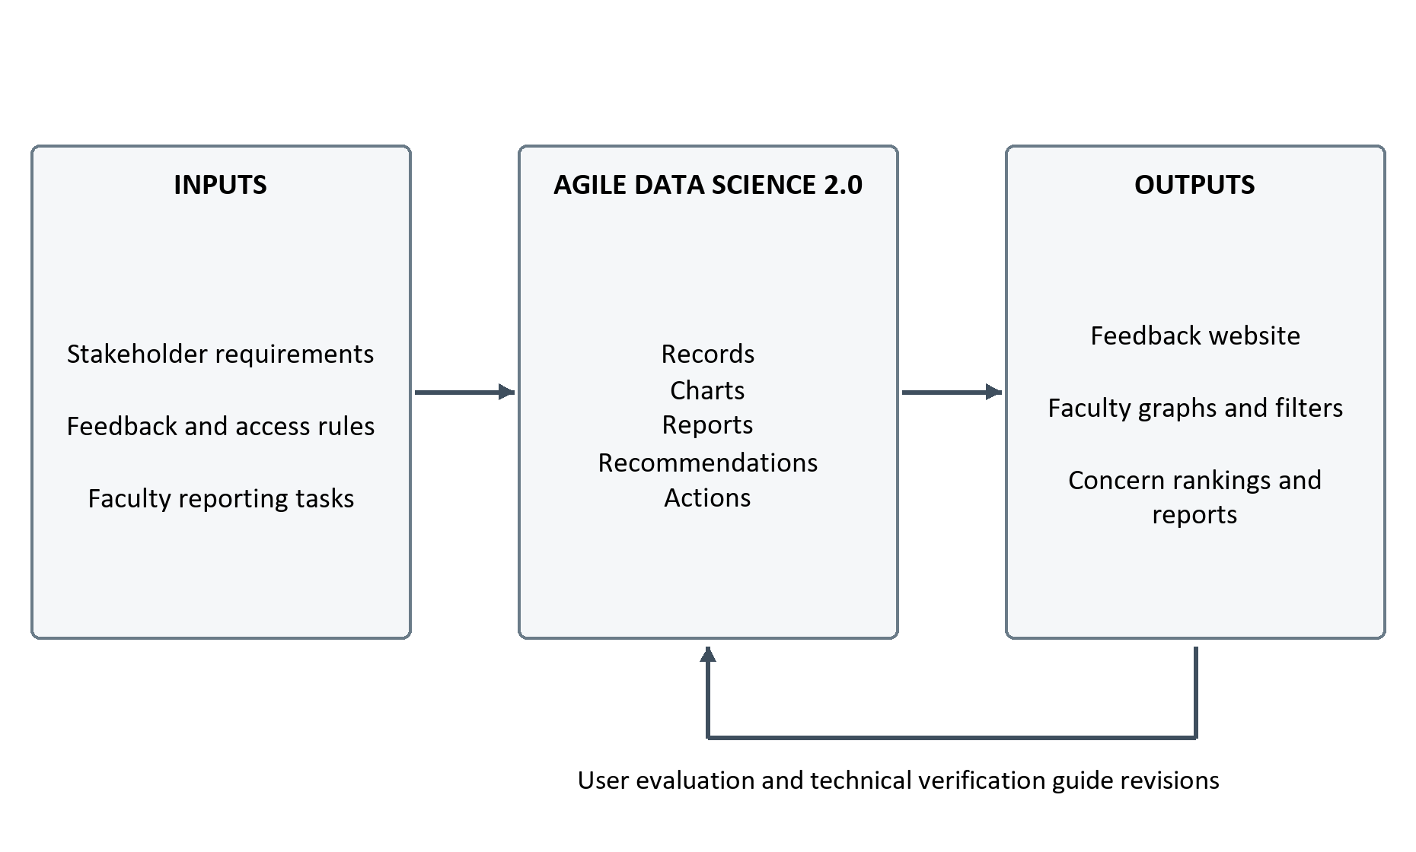
Figure 1 ResBack conceptual framework for website development

CHAPTER 3 METHODOLOGY

3.1 Project and Research Design
The study uses a software development approach with descriptive, task-based evaluation. Its main output is a web-based feedback management system and the documentation needed to explain, test, and maintain it. The development process retains Agile Data Science 2.0, adapted to the development of the feedback website. Requirements analysis, interface and database design, implementation, testing, and review recur as working features are developed. Evaluation concerns the operation of the website and the ability of intended users to perform feedback and reporting tasks.
Jurney's Agile Data Science 2.0 organizes the iterative construction of data applications, including the progression from stored records to charts and interactive reports [21]. ResBack retains its existing adaptation using Records, Charts, Reports, Recommendations, and Actions. These stages organize website deliverables and feedback from users. The Recommendations stage concerns the programmed concern-ranking display, while Actions refers to human review and development refinements. The adaptation does not require the research team to train a model or implement the book's complete technology stack.
No hypothesis about the superiority of a language model is tested. The project will report requirements coverage, observed functional results, usability observations, and measured performance under stated conditions. Improvements in teaching quality, satisfaction across CCIS, or institutional response cannot be inferred solely from a successful website demonstration.

3.2 Setting Participants and Requirements Gathering
The intended setting is the College of Computing and Information Sciences of Mariano Marcos State University. Students provide feedback about their experience of college services and facilities. Faculty review the graphical results and supporting comments. Administrators exercise the approved account and record-management functions. Permission, recruitment, and any operational pilot will follow the institution's applicable procedures.
The earlier manuscript records a preliminary Google Forms questionnaire answered by 25 student volunteers from September 24 to 29, 2026. It is treated as exploratory requirements evidence. Its questions concerning automated analysis belong to the earlier requirements exercise and will not be relabeled as measures of website usability. Detailed numerical findings should be reported from the retained questionnaire and response export using the original item wording and denominator. This preliminary sample is separate from the proposed evaluation sample, even if some individuals later participate in both.
Requirements validation will use a walkthrough of the feedback process, discussions with authorized faculty and administrators, and review of the website prototype. The researchers will record the role requesting a feature, the task it supports, the required data, the access restriction, the expected output, and the acceptance condition. Unverified problems will be recorded as issues to investigate rather than as established institutional failures.
The proposed usability sample retains the planning target of 30 CCIS students, five faculty members, and two administrators, subject to approval, consent, and availability. These are recruitment targets, not completed counts or a statistically representative sample. Purposive selection will seek participants who can perform the intended role tasks and variation in student year level and device experience. The final report will disclose the achieved sample, recruitment method, nonparticipation where known, and limitations of the small faculty and administrator groups.

3.3 Agile Data Science 2.0 Development Process
The development approach retains the five stage labels used in the existing methodology figure and project schedule. The team will identify requirements and acceptance conditions, design the interface and data relationships, implement a working feature, test it, and review the result within each relevant stage. Findings can return the team to an earlier stage. The stages organize the development of usable website features rather than a separate model-training study.

3.3.1 Records
The Records stage establishes how feedback enters the website, is stored, and can be retrieved by the appropriate user. Requirements include account access, input validation, identity protection in faculty views, duplicate and rate safeguards, processing status, and personal feedback history. The interface and database design will define the information needed for each task and the permitted account roles.
Implementation will connect the feedback form, server-side validation and authorization, database records, and history interface. Verification will check valid and invalid submissions, ownership, rejected records, and preservation of feedback when supporting processing fails. Deliverables include the data relationships, working submission and history features, and recorded acceptance checks.

3.3.2 Charts
The Charts stage develops the faculty dashboard from stored records and supporting result fields. Faculty reporting questions will guide graph selection, labels, date windows, and supporting counts. The implemented distribution graph, positive-versus-negative daily trend, and concern-score bars will be examined for readable measures and appropriate context. The language summary remains a list and a filter in the current interface.
The team will compare displayed values with independently prepared expectations from controlled records. Faculty walkthroughs will examine whether reviewers can identify the period, read the graph, and distinguish counts from calculated scores. Unclear labels or incorrect calculations will lead to revisions and another check. The deliverables are working graphs, defined measures, and their verification records.

3.3.3 Reports
The Reports stage connects graphical summaries, filter selections, supporting comments, and downloadable outputs. The team will implement and verify the date and language controls, paginated record view, Excel export, and PDF summary. Each output must make its coverage understandable; the PDF summary and full Excel record export have different levels of detail.
Tests will check record eligibility, selected boundaries, counts, processing states, and omission of identifying account fields. Empty results and failed processing will also be tested. Faculty will attempt to retrieve information and generate the requested outputs from the website. The deliverables are the working reporting interface, downloadable files, and records of reconciliation and user review.

3.3.4 Recommendations
The Recommendations stage presents concern information through a transparent programmed ranking rule. It does not generate binding institutional decisions. The development tasks are to group supporting records, calculate and display concern scores, retain evidence counts and examples, and explain the limits of the score.
The researchers will verify the scoring arithmetic, ordering, ties, low-evidence indicators, and filter behavior described in Section 3.5.4. Faculty tasks will examine whether the score and supporting examples can be interpreted appropriately. The deliverables are the working concern-ranking display, documented calculation rules, and verification findings.

3.3.5 Actions
The Actions stage connects the information presented by the website with authorized human review and the team's next development decisions. Faculty and administrators can inspect reported concerns and use existing institutional procedures to decide what follow-up is appropriate. The present website does not assign cases, record complete resolutions, or automate disciplinary or service decisions.
For website development, the team will record user observations, prioritize defects and requests, revise affected features, and repeat relevant tests. This stage also prepares the operating instructions, deployment checks, and maintenance responsibilities needed for an approved pilot. The outputs are a refined website, issue and retest records, and a documented handover. Institutional concern resolution is a separate responsibility and is not counted as an automatic software outcome.

3.3.6 Implementation Testing and Release Preparation Across Stages
The current implementation uses PHP and Laravel with Blade views, browser assets, and a relational database. Chart.js provides dashboard charts, PhpSpreadsheet generates Excel files, and Dompdf generates PDF summaries. The documented XAMPP arrangement uses MySQL or MariaDB. Software versions and configuration will be recorded for the build evaluated.
ResBack uses pretrained Gemma through the Google Gemini API to obtain supporting sentiment and text-analysis results. The research team does not train or fine-tune Gemma. The website validates and stores the returned fields for its reporting workflow. Integration tests will check usable and invalid responses, missing configuration, timeouts, and preservation of submission status. Deterministic test responses will isolate website aggregation and reporting behavior from external-service variability. Separately recorded integration checks can examine the live dependency under approved conditions.
Testing and stakeholder review will occur as each working feature is available, rather than only at the end. Defect records will identify the triggering steps, expected and observed behavior, corrective change, and retest outcome. The system diagrams in Appendices C to I document the design and its supporting dependencies; they remain part of the website documentation.
Deployment preparation will verify environment settings, access provisioning, database compatibility, persistent storage, backup and restoration procedures, external-service configuration, and operating instructions. Appendix I distinguishes the local environment from the proposed Render and Supabase architecture. The online design remains a target until implementation and operational evidence are available. Maintenance planning will identify the responsible role, change log, configuration handling, and regression checks.
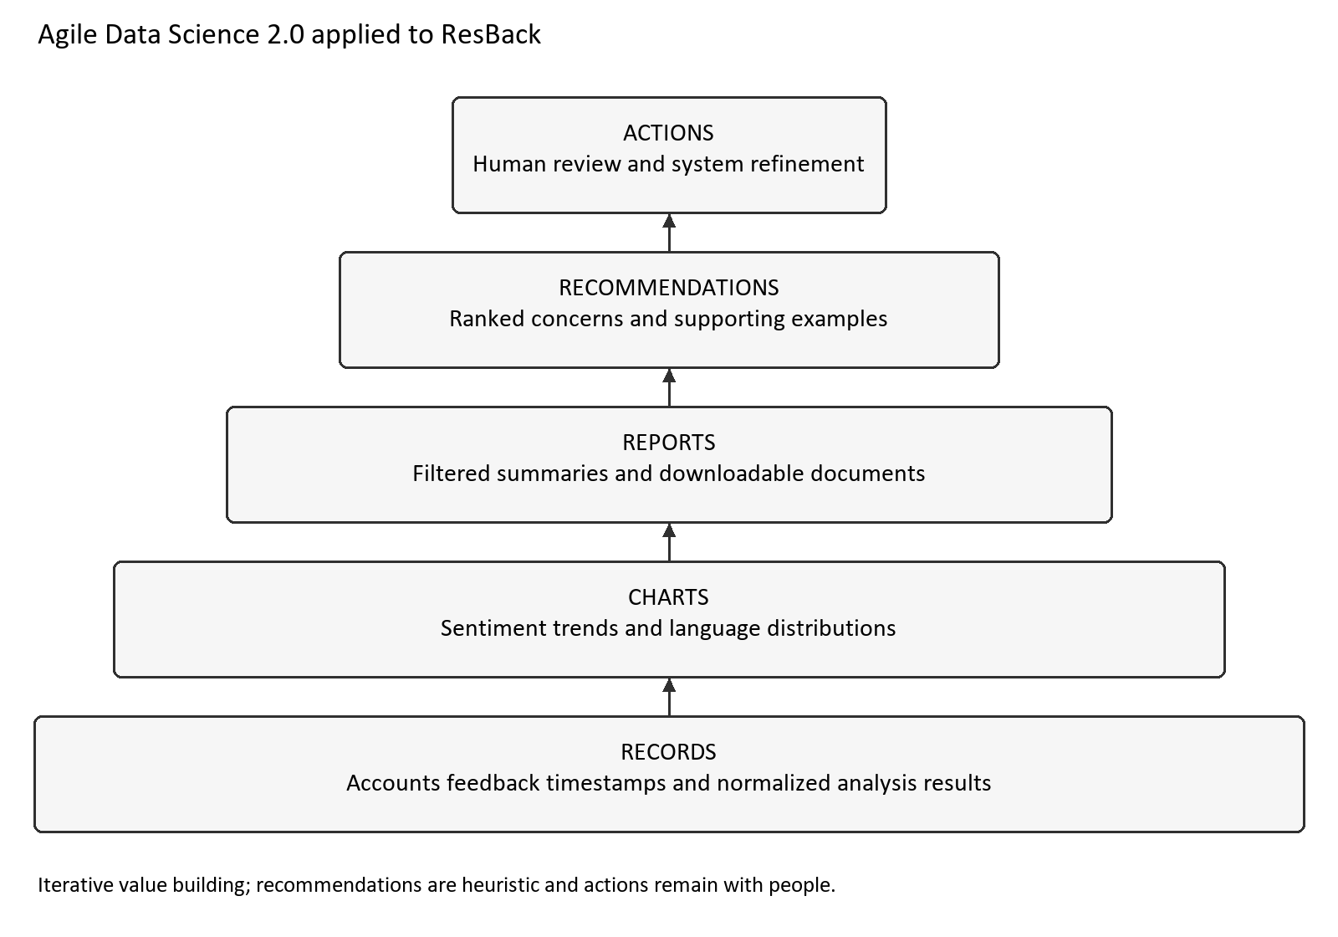
Figure 2 Agile Data Science 2.0 stages adapted to ResBack

3.4 System Requirements and Architecture
Table 2 links the specific objectives to testable system requirements. The implementation references identify where the current website supports the requirement; the acceptance checks describe evidence to collect, not results already achieved.
Table 2 Requirements and implementation traceability
ID | Requirement | Implementation and acceptance evidence
R1 | Account access and personal history | Authentication and role middleware; owner-only retrieval.
R2 | Feedback submission and protection | FeedbackController and guards; validation, duplicate, rate and rejected-state checks.
R3 | Reviewer identity suppression | Dashboard and export fields; no account identifiers in reviewer outputs.
R4 | Faculty graphs and filters | DashboardController; independently checked counts, series and date/language scope.
R5 | Concern ranking | ConcernRankingService; factor calculation, score, ties, examples and low-evidence checks.
R6 | Downloadable reports | Export and report controllers; XLSX record scope, PDF summaries and denominators.
R7 | Authorized administration | Account-management authorization; hierarchy and protected-account cases.
R8 | Processing failure handling | Stored statuses and messages; deterministic integration failure cases.
R9 | Usable and maintainable website | Role-based tasks, issue log, configuration and regression records.

The application follows a browser-to-server architecture. Laravel routes and middleware check access, controllers coordinate requests, services handle reusable rules, Eloquent models manage persistent data, and Blade views present the interface. The database stores account and feedback records. Chart and report generation use retrieved records and shared filtering rules where implemented.
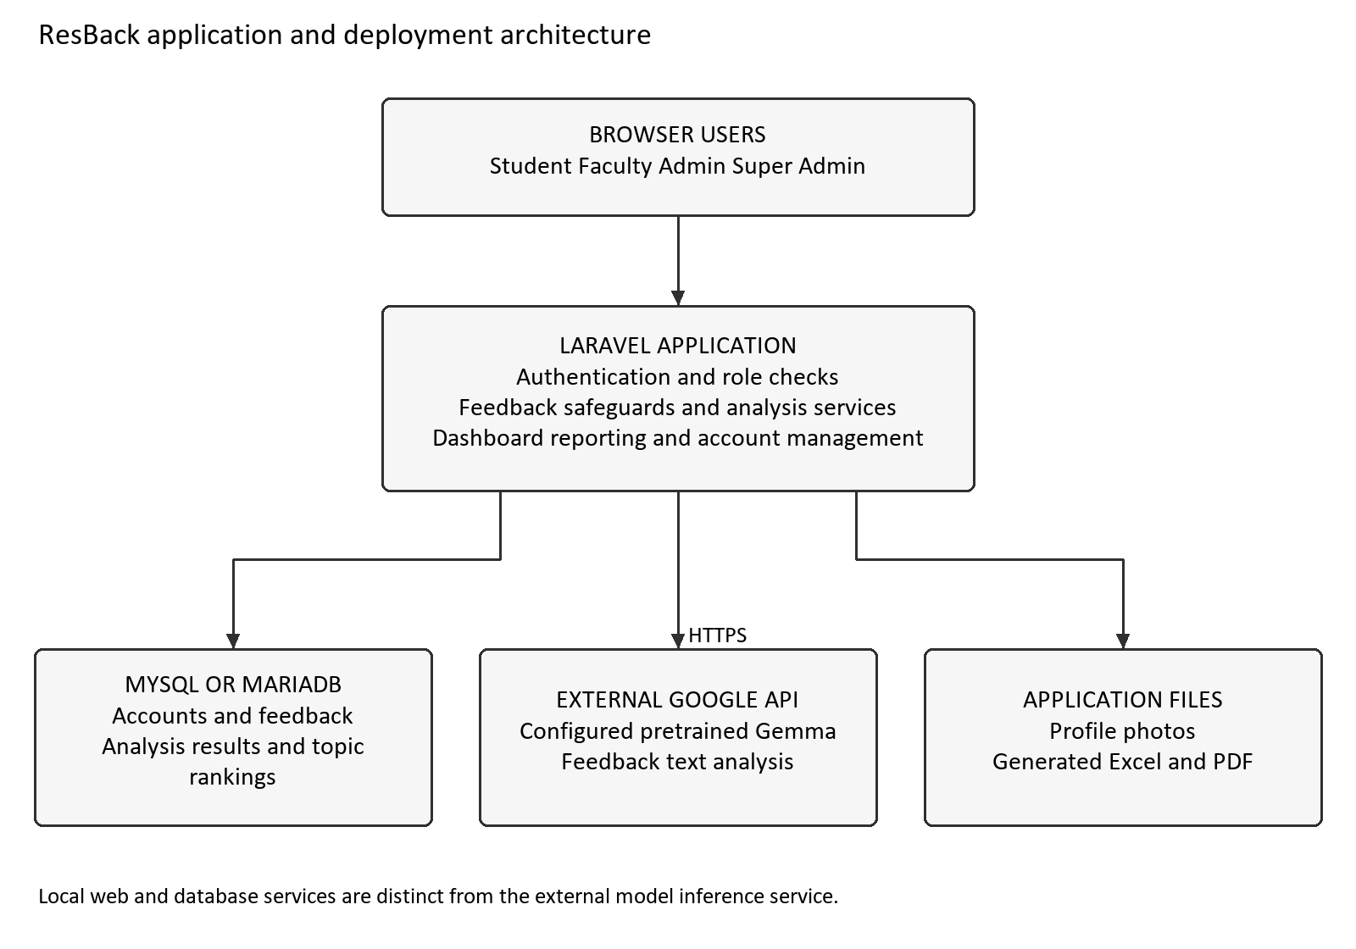
Figure 3 Local development architecture
Student and Faculty users can submit feedback and view their own history. Faculty, Admin, and Super Admin users can review the college-wide dashboard and reports. Admin and Super Admin users manage accounts and delete feedback within their permitted hierarchy. Role names are values on the User model rather than separate database entities. Registration does not independently verify institutional membership; the operating procedure must address that requirement.
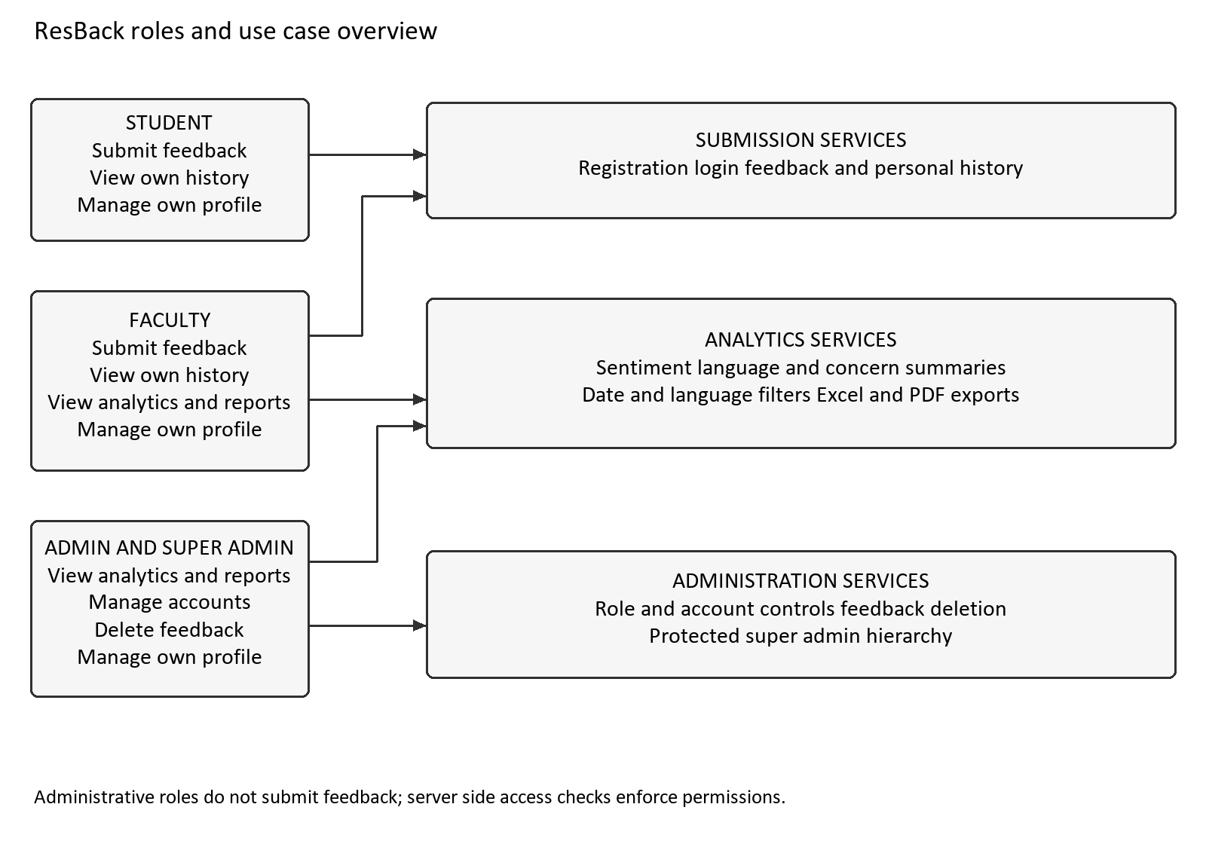
Figure 4 Roles and use case overview
The core entities are User, Category, Feedback, SentimentResult, and ConcernRanking. A feedback record normally links to its submitting account and category; retained records can have a null link after account or category deletion. Stored analysis and derived concern information support summaries. The original text and processing status are retained so that a processing failure is distinguishable from the absence of a submission.
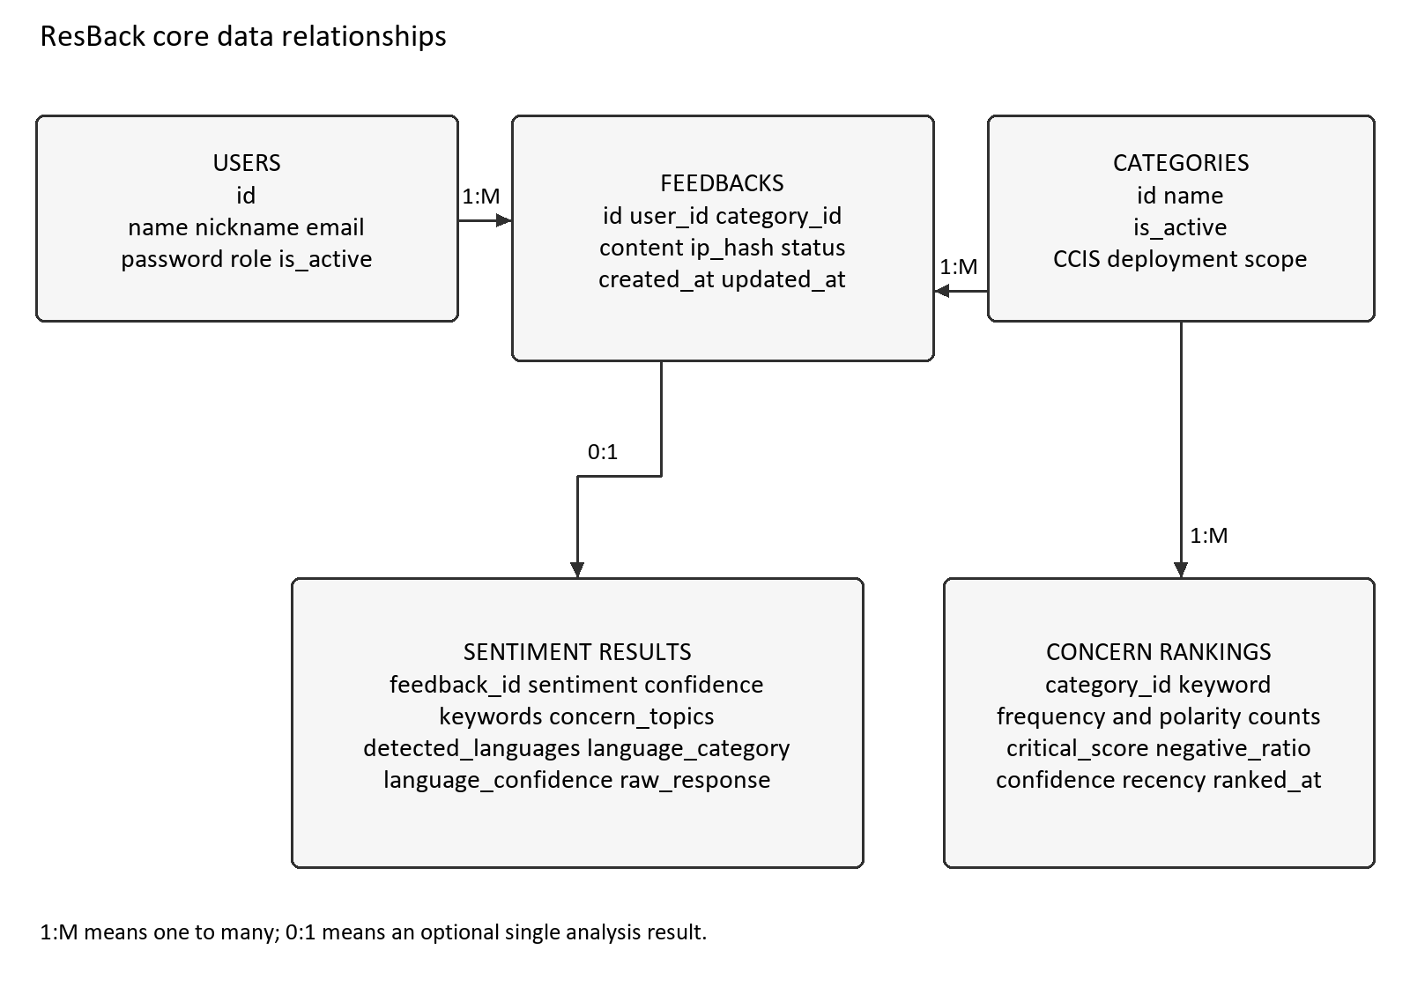
Figure 5 Core data relationships

3.5 Feedback Processing and Graphical Reporting

3.5.1 Submission and Record Handling
The server validates feedback for the active CCIS category and enforces the implemented length and submission safeguards. The current rule accepts 10 to 2,000 characters, checks normalized duplicate submissions within 24 hours for the same user and category, and limits submissions to five per account within ten minutes. These are configuration and implementation rules to be verified against the evaluated build.
Screening occurs before external processing. A screened submission can be stored as rejected and is excluded from faculty analytics and reports. An accepted submission is stored and processed synchronously. A usable result produces an analyzed status; unsuccessful processing leaves a failed status. Pending, analyzed, failed, and rejected are processing states, not indications that an institutional concern has been resolved.
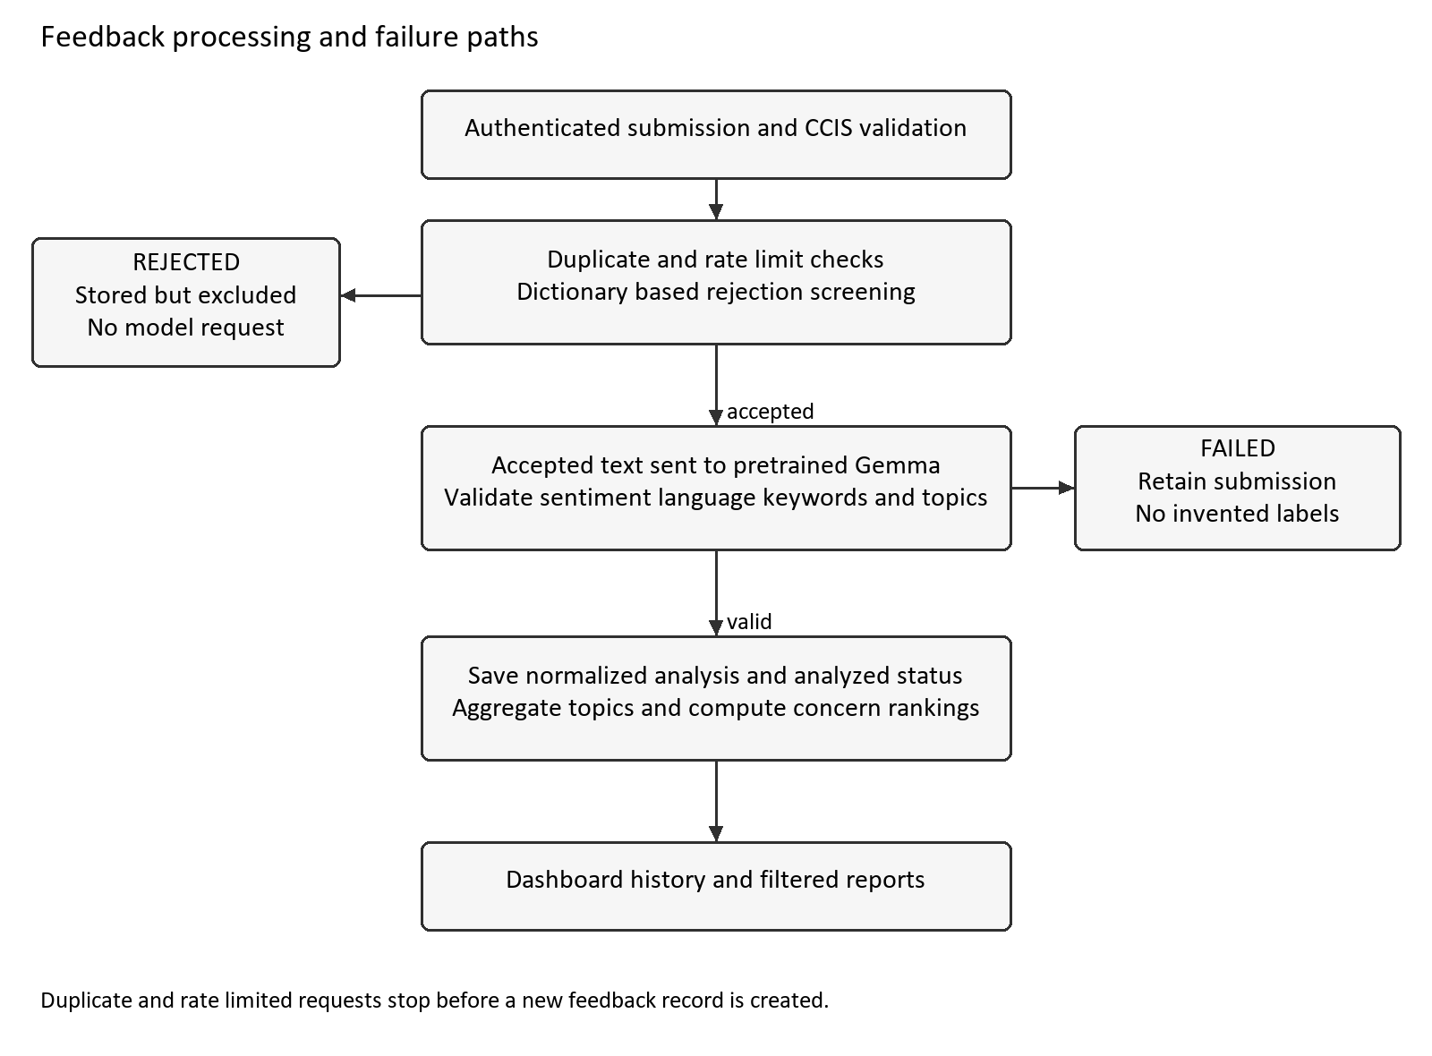
Figure 6 Feedback processing and failure paths

3.5.2 Definition of Graph Measures
The distribution graph counts stored positive, neutral, and negative analysis results associated with feedback. Its classified total can differ from the total-feedback card because accepted records with pending or failed analysis can contribute to the card without contributing to a sentiment slice. The graph must not imply that missing classifications are neutral. Reviewers should be able to identify this difference.
The daily trend graph displays positive and negative feedback counts. It does not display all submissions, because neutral records are not one of its plotted series. Without explicit dates, the current daily trend covers the most recent 30-day window; other dashboard summaries may use a broader scope. Verification will test this behavior and the clarity of the period labels. Matching graphs requires matching both the filter and the calculation window.
The concern chart displays up to ten concern scores calculated from the selected records with stored analysis results. A score is not a percentage of students, a count of confirmed incidents, or a measure of severity. Multiple topics can be associated with one comment, so topic counts may exceed the number of comments. The chart should be read with its topic counts and supporting examples. The programmed scoring procedure is described in Section 3.5.4 and will be checked through independent calculations and controlled examples.
Language information is a summary list and filter in the current interface. The term language chart will not be used unless such a chart is actually added and verified. These definitions prevent the evaluation from attributing features or measures to the website that it does not provide.

3.5.3 Filters and Report Consistency
Date and language selections will be verified against a controlled list of eligible record identifiers. Excel export will be checked for matching record coverage, field values, and exclusion of prohibited identity fields and rejected submissions. PDF verification will examine the stated reporting period, counts, concern summaries, and its selected negative-comment examples. The PDF and Excel outputs serve different purposes and are not expected to contain identical detail rows. The current PDF calculates each sentiment share using all reportable feedback, including pending and failed records. Its three shares may therefore total less than 100 percent, whereas the doughnut represents the distribution among classified records.
Consistency checks will separately compare accepted-record counts, classified-record counts, graph series, topic counts, and report examples. A single total will not be used to validate all measures. Tests will include no records, one record, date boundaries, missing analysis, mixed-language categories, and multiple topics. The expected values will be prepared independently from the presentation code.

3.5.4 Programmed Concern Ranking
Concern ranking is implemented as application logic. The service groups selected feedback by normalized concern topic, counts the stored classifications, calculates a score for each topic, and sorts the results for review. A comment associated with several topics contributes its single stored overall classification to each assigned topic. This grouping does not produce a separate classification for each aspect of the comment.
Four factors contribute to the existing rule. V is the logarithmically normalized volume of negative comments for the topic. R is the negative count divided by the topic's total classified count. C is the mean provider-reported confidence attached to the topic's negative comments. T is their mean recency factor, with a 30-day half-life. For V, the topic's log of one plus its negative count is divided by the log of one plus the largest negative-topic count in the selected scope, with a minimum denominator reference count of one. The recency factor decreases exponentially with non-negative comment age, and is averaged across the negative comments. C and T are zero if there are no negative comments.
$$S = 100 × (0.40V + 0.25R + 0.20C + 0.15T)$$
The weights are 40 percent for negative volume, 25 percent for negative ratio, 20 percent for the stored confidence field, and 15 percent for recency. They are project-defined assumptions, not weights learned from training data or weights established by the cited literature. Confidence is an external service field used by the existing rule; it is not treated as a verified probability that a classification is correct.
The score is rounded to one decimal place. Descending score determines order, followed by negative count and topic name when scores tie. Topics with fewer than three supporting comments are marked as having limited evidence. Because volume normalization depends on the selected comparison set, a score can change when filters or other topic counts change. A topic with no negative comments receives a score of zero under this rule.
Verification will fix the selected records and calculation time, compute all four factors independently, and compare the expected score and order with the service and chart. For V = 1.00, R = 0.75, C = 0.80, and T = 0.50, the expected rounded score is 82.3. This is an illustrative arithmetic case, not an observed institutional result. Tests will also cover zero-negative topics, ties, multiple topics, few supporting comments, and changes of filter. A small sensitivity check can show faculty how changes to weights or the recency setting affect the displayed order. Such checks support transparency of the software rule and do not validate its scores as measures of urgency [22].

3.6 Functional and Software Quality Evaluation
Selected quality areas will be informed by ISO/IEC 25010:2023: functional suitability, performance efficiency, compatibility, interaction capability, reliability, security, and maintainability. The study uses these areas to organize evidence and does not claim certification or a complete assessment of every characteristic. Usability is operationalized through effectiveness, efficiency, and satisfaction in the defined tasks, consistent with ISO 9241-11:2018. [29] [6]
Table 3 identifies the planned evidence. Functional and access-control cases will use a separate test database and test accounts. A test will be reported as passed only when its expected and observed outcomes agree in a recorded run. Screenshots alone will not establish correct filtering, identity protection, or database state.
Table 3 Planned system evaluation measures
Area | Measure | Evidence
Functional suitability | Expected versus actual results for applicable requirements | Test IDs, records, observed outcomes and retests.
Graphs and reports | Record selection, counts, denominators and displayed periods | Known fixtures; independently prepared expected results; output inspection.
Concern ranking | Scores, sort order, ties, low-evidence and filter behavior | Fixed records and clock; independent factor calculations.
Usability | Independent and assisted task completion, interpretation, time and ratings | Observer sheet, answer key, questionnaire version and valid denominators.
Performance and reliability | Observed latency, failures and preserved records | Repeated runs with device, network, dataset and service conditions.
Security and compatibility | Role and ownership restrictions; selected browser/accessibility checks | Authorization tests; recorded screens, browsers and criteria.
Maintainability | Traceable changes and repeatable checks | Requirement links, defect log, regression evidence and handover.

Functional acceptance requires all specified critical access, ownership, data-preservation, and reporting checks to pass, with no unresolved critical or high-severity defect in those flows. This is a project release criterion rather than a claim that all possible defects have been eliminated. Other unresolved issues will be documented and assessed before an operational pilot.
Performance measurements will record the device, browser, server configuration, database size, network conditions, and external-service behavior. At least 20 repetitions per selected operation and dataset condition are planned for a descriptive baseline; the actual number and any warm-up exclusions will be reported. The study will report the median, minimum, maximum, and observed failures for dashboard loading, submission, and exports. This small-run baseline will not be presented as a production capacity or concurrent-load guarantee. External-service delay will be identified separately where instrumentation permits.
Compatibility checks will cover the agreed desktop and mobile-browser configurations. Accessibility-oriented checks will include keyboard operation, visible focus, labels, contrast, and chart interpretation without relying only on color. These selected checks are informed by WCAG 2.2 and do not establish complete accessibility conformance. [30]

3.7 Usability Evaluation and Data Analysis
Participants will receive a brief explanation of the system and use assigned test data. They will complete the relevant tasks without step-by-step coaching. The observer will record independent completion, completion with assistance, unsuccessful completion, elapsed time, errors, and comments. Assistance will be recorded rather than counted as independent success. Test data will avoid genuine complaints about identifiable persons.
Faculty tasks will include identifying the reporting period, reading the largest sentiment category, explaining why the total-feedback count may differ from the classified count, interpreting the positive-versus-negative trend, applying a date filter, locating a supporting comment, and producing the corresponding report. An answer key based on the controlled data will determine interpretation accuracy. These tasks directly examine the intended use of the graphs.
After the tasks, participants will answer a short project-specific questionnaire concerning navigation, label clarity, action and error messages, processing status, understanding of identity protection, and task completion. Faculty items will additionally cover the reporting period, distinctions between counts and scores, filter use, supporting comments, and differences between report formats. Responses will use a five-point agreement scale from Strongly disagree to Strongly agree, with a Not applicable option. This researcher-developed instrument will not use System Usability Scale scoring or benchmarks. Adviser or expert review and a small pilot will be used to improve wording before formal administration; the instrument is not described as validated merely because it has been reviewed.
Task completion rate will be calculated as the number of independently completed applicable tasks divided by the number of attempted applicable tasks, multiplied by 100. Assisted completion will be reported separately. Graph interpretation accuracy will use correct answers divided by all applicable interpretation questions presented. A response of cannot interpret will count as incorrect; interrupted sessions and missing assessments will be reported separately. Task time will be summarized for completed tasks, with unsuccessful attempts reported separately. Counts and denominators will accompany all percentages.
For each five-point questionnaire item, the report will present response frequencies, the median, and the number of valid responses. Where an item mean is additionally provided, it will be described as a descriptive summary of ordinal responses. Not applicable and missing responses will be excluded from that item's denominator and reported. Student, faculty, and administrator results will be separated where their tasks differ; the five planned faculty participants will not be used to infer the preferences of all faculty.
Open-ended comments will be grouped into categories such as navigation, wording, graph labels, filters, access, and reports. The researchers will retain anonymized examples and an issue log connecting the observation, change, and retest. Results will support refinement of the website and will not be interpreted as causal evidence that ResBack improves teaching or resolves institutional concerns.

3.8 Ethical Procedures and Data Management
Participation will be voluntary, with an explanation of the study's purpose, procedures, expected duration, data recorded, and withdrawal arrangements. Participation or nonparticipation will not be used to determine grades or access to services. Faculty and administrative involvement will follow the institution's permission process. The team will document approval and consent when obtained rather than treating the proposed instruments as proof of approval.
Evaluation records will use participant codes and the minimum information needed for the research tasks. Consent and recruitment information will be separated from task observations. Access, storage location, retention period, deletion procedure, and responsible custodian will be specified in the approved data-management plan before collection. The same care will apply to exports and backups, which can duplicate sensitive information.
Participants will be informed that account links exist privately, that review outputs omit account identifiers, and that free text can disclose personal information. The current use of an external processing service must be disclosed and governed by approved arrangements before real feedback is processed in a pilot. Synthetic or consented, appropriately de-identified data will be used for development and evaluation. Compliance requires operational controls and institutional review in addition to software features. [5]

3.9 Documentation and Expected Outputs
The study will produce the website, requirements, system designs, test results, usability findings, operating instructions, and a record of limitations. Appendix A presents the candidate problem causes, Appendix B retains the project schedule, and Appendices C to I document the system workflows and architecture. These existing appendix materials remain part of the project documentation.
Table 4 links each research question to its corresponding objective and evaluation evidence. The final report will distinguish planned activities, implemented functions, recorded tests, and unresolved issues. Claims about institutional outcomes or automated classification accuracy require separate studies.
Table 4 Alignment of research questions objectives and evaluation
Question and objective | Development focus | Evidence to collect
RQ1 and SO1 | Identify stakeholder requirements | Requirements record and faculty walkthrough observations.
RQ2 and SO2 | Develop account and feedback workflows using the retained approach | Design artifacts, working versions, functional and role tests.
RQ3 and SO3 | Provide faculty graphs, filters, supporting records and reports | Known-record reconciliation and faculty reporting tasks.
RQ4 and SO4 | Implement the concern-ranking procedure | Independent scores and ordering; supporting evidence and interpretation tasks.
RQ5 and SO5 | Verify technical quality under defined conditions | Recorded functional, access, reliability and performance checks.
RQ6 and SO6 | Evaluate usability and refine the website | Task success, interpretation accuracy, time, ratings, issues and retests.

REFERENCES
[1] N. A. Setterington, S. McLean, A. Woods, "Design, implementation, and evaluation of Students as Partners interactive feedback model," Advances in Physiology Education, 47(2), 181–193, 2023. [Online]. Available: https://doi.org/10.1152/advan.00182.2022
[2] R. J. Kreitzer, J. Sweet-Cushman, "Evaluating student evaluations of teaching: A review of measurement and equity bias in SETs and recommendations for ethical reform," Journal of Academic Ethics, 20, 73–84, 2022. [Online]. Available: https://doi.org/10.1007/s10805-021-09400-w
[3] A. Sarikaya, M. Correll, L. Bartram, M. Tory, D. Fisher, "What do we talk about when we talk about dashboards?," IEEE Transactions on Visualization and Computer Graphics, 25(1), 682–692, 2019. [Online]. Available: https://doi.org/10.1109/TVCG.2018.2864903
[4] W. Matcha, N. A. Uzir, D. Gašević, A. Pardo, "A systematic review of empirical studies on learning analytics dashboards: A self-regulated learning perspective," IEEE Transactions on Learning Technologies, 13(2), 226–245, 2020. [Online]. Available: https://doi.org/10.1109/TLT.2019.2916802
[5] National Privacy Commission, "Implementing rules and regulations of the Data Privacy Act of 2012," 2016. [Online]. Available: https://privacy.gov.ph/implementing-rules-regulations-data-privacy-act-2012/
[6] International Organization for Standardization, "ISO 9241-11:2018: Ergonomics of human-system interaction — Part 11: Usability: Definitions and concepts," 2018. [Online]. Available: https://www.iso.org/standard/63500.html
[7] M. Nederhand, J. Auer, B. Giesbers, A. Scheepers, E. van der Gaag, "Improving student participation in SET: Effects of increased transparency on the use of student feedback in practice," Assessment & Evaluation in Higher Education, 48(1), 107–120, 2023. [Online]. Available: https://doi.org/10.1080/02602938.2022.2052800
[8] P. T. Lai, P. Vu, B. Wojcik, S. Alavi, "Online course evaluations in the digital age," Journal of Applied Educational and Policy Research, 5(1), 2020. [Online]. Available: https://doi.org/10.55370/jaepr.v5i1.975
[9] B. M. Stoesz, A. E. De Jaeger, M. Quesnel, D. Bhojwani, R. Los, "Bias in student ratings of instruction: A systematic review of research from 2012 to 2021," Canadian Journal of Educational Administration and Policy, 201, 39–62, 2022. [Online]. Available: https://journalhosting.ucalgary.ca/index.php/cjeap/article/view/73769
[10] P. B. Stark, R. Freishtat, "An evaluation of course evaluations," ScienceOpen Research, 2014. [Online]. Available: https://doi.org/10.14293/S2199-1006.1.SOR-EDU.AOFRQA.v1
[11] C. R. Drue, C. A. Bifulco, "Beyond the numbers: How directors and chairs interpret student feedback to equitably evaluate teaching," Journal of Academic Ethics, 23, 1499–1521, 2025. [Online]. Available: https://doi.org/10.1007/s10805-025-09611-5
[12] S. Cornes, D. Torre, T. B. Fulton, S. Oza, A. Teherani, H. C. Chen, "When students’ words hurt: 12 tips for helping faculty receive and respond constructively to student evaluations of teaching," Medical Education Online, 28(1), 2154768, 2023. [Online]. Available: https://doi.org/10.1080/10872981.2022.2154768
[13] J. M. Amboya, R. M. Francisco, R. J. Hernandez, J. S. Opeña, I. V. Samson, C. N. P. Olipas, "HighTeach: A web-based teacher evaluation system for a higher learning institution in the Philippines," African Journal of Advanced Pure and Applied Sciences, 1(4), 8–15, 2022. [Online]. Available: https://aaasjournals.com/index.php/ajapas/article/view/113
[14] I. T. Plata, J. M. Facun, "Development and implementation of web-based paperless student evaluation for teachers (PSET)," International Journal of Advanced Trends in Computer Science and Engineering, 9(1), 186–193, 2020. [Online]. Available: https://doi.org/10.30534/ijatcse/2020/28912020
[15] I. M. Taguiam, "Web-based faculty evaluation system of Apayao State College, Philippines," JPAIR Institutional Research, 7(1), 1–14, 2016. [Online]. Available: https://doi.org/10.7719/irj.v7i1.367
[16] C. O. Carpio, D. M. D. C. Meña, J. J. P. Malaza, Z. T. H. Toto, R. D. Sanson, "Assessing the effectiveness of online faculty evaluation system: A study of perceptions and practices in Basilan State College," International Journal of Multidisciplinary Research and Publications, 5(10), 99–102, 2023. [Online]. Available: https://ijmrap.com/wp-content/uploads/2023/04/IJMRAP-V5N10P75Y23.pdf
[17] M. Amjad, N. J. Linda, "A web based automated tool for course teacher evaluation system (TTE)," International Journal of Education and Management Engineering, 10(2), 11–19, 2020. [Online]. Available: https://doi.org/10.5815/ijeme.2020.02.02
[18] J. Guerra, M. Ortiz-Rojas, M. A. Zúñiga-Prieto, E. Scheihing, A. Jiménez, T. Broos, T. De Laet, K. Verbert, "Adaptation and evaluation of a learning analytics dashboard to improve academic support at three Latin American universities," British Journal of Educational Technology, 51(4), 973–1001, 2020. [Online]. Available: https://doi.org/10.1111/bjet.12950
[19] V. Rozhenkova, M. Eslami, C. Crooks, B. K. Sato, "From data to action: Perspectives on faculty use of student data dashboards for improving instruction," Journal of Computing in Higher Education. Advance online publication, 2026. [Online]. Available: https://doi.org/10.1007/s12528-026-09493-5
[20] L. Paulsen, E. Lindsay, "Learning analytics dashboards are increasingly becoming about learning and not just analytics—A systematic review," Education and Information Technologies, 29, 14279–14308, 2024. [Online]. Available: https://doi.org/10.1007/s10639-023-12401-4
[21] R. Jurney, "Agile Data Science 2.0: Building full-stack data analytics applications with Spark," O'Reilly Media, 2017. [Online]. Available: https://www.oreilly.com/library/view/agile-data-science/9781491960103/
[22] OECD, European Union, European Commission, Joint Research Centre, "Handbook on constructing composite indicators: Methodology and user guide," OECD Publishing, 2008. [Online]. Available: https://doi.org/10.1787/9789264043466-en
[23] Google, "View & manage form responses," n.d.. [Online]. Available: https://support.google.com/docs/answer/139706?hl=en
[24] Moodle, "Feedback activity," 2024. [Online]. Available: https://docs.moodle.org/405/en/Feedback_activity
[25] Moodle, "Feedback settings," 2024. [Online]. Available: https://docs.moodle.org/405/en/Feedback_settings
[26] Microsoft, "Check and share your form results," n.d.. [Online]. Available: https://support.microsoft.com/en-us/forms/check-and-share-your-form-results
[27] Watermark, "Course evaluation & survey software for higher education," n.d.. [Online]. Available: https://www.watermarkinsights.com/solutions/course-evaluation-survey-software/
[28] Watermark, "Project Results - Instructors," 2026. [Online]. Available: https://support-eu.watermarkinsights.com/hc/en-us/articles/48325431279889-Project-Results-Instructors
[29] International Organization for Standardization, International Electrotechnical Commission, "ISO/IEC 25010:2023: Systems and software engineering — Systems and software Quality Requirements and Evaluation (SQuaRE) — Product quality model," 2023. [Online]. Available: https://www.iso.org/standard/78176.html
[30] World Wide Web Consortium, "Web Content Accessibility Guidelines (WCAG) 2.2," 2024. [Online]. Available: https://www.w3.org/TR/2024/REC-WCAG22-20241212/

APPENDIX A FISHBONE DIAGRAM
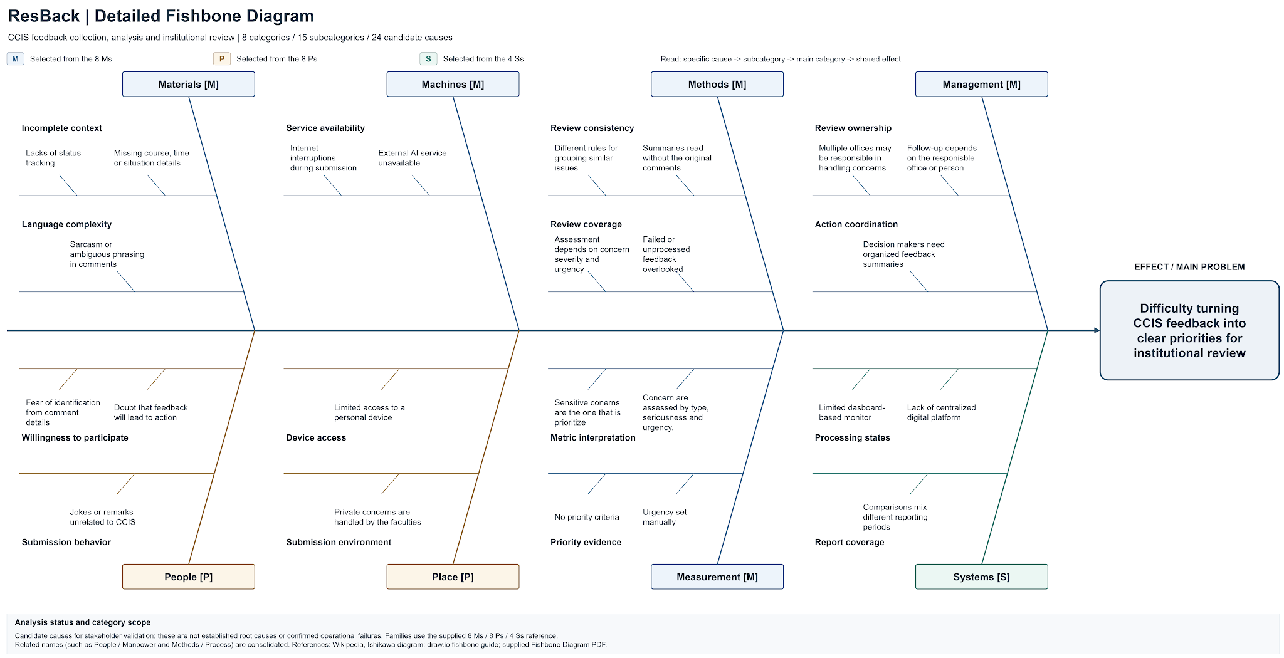
Figure 7 ResBack fishbone diagram
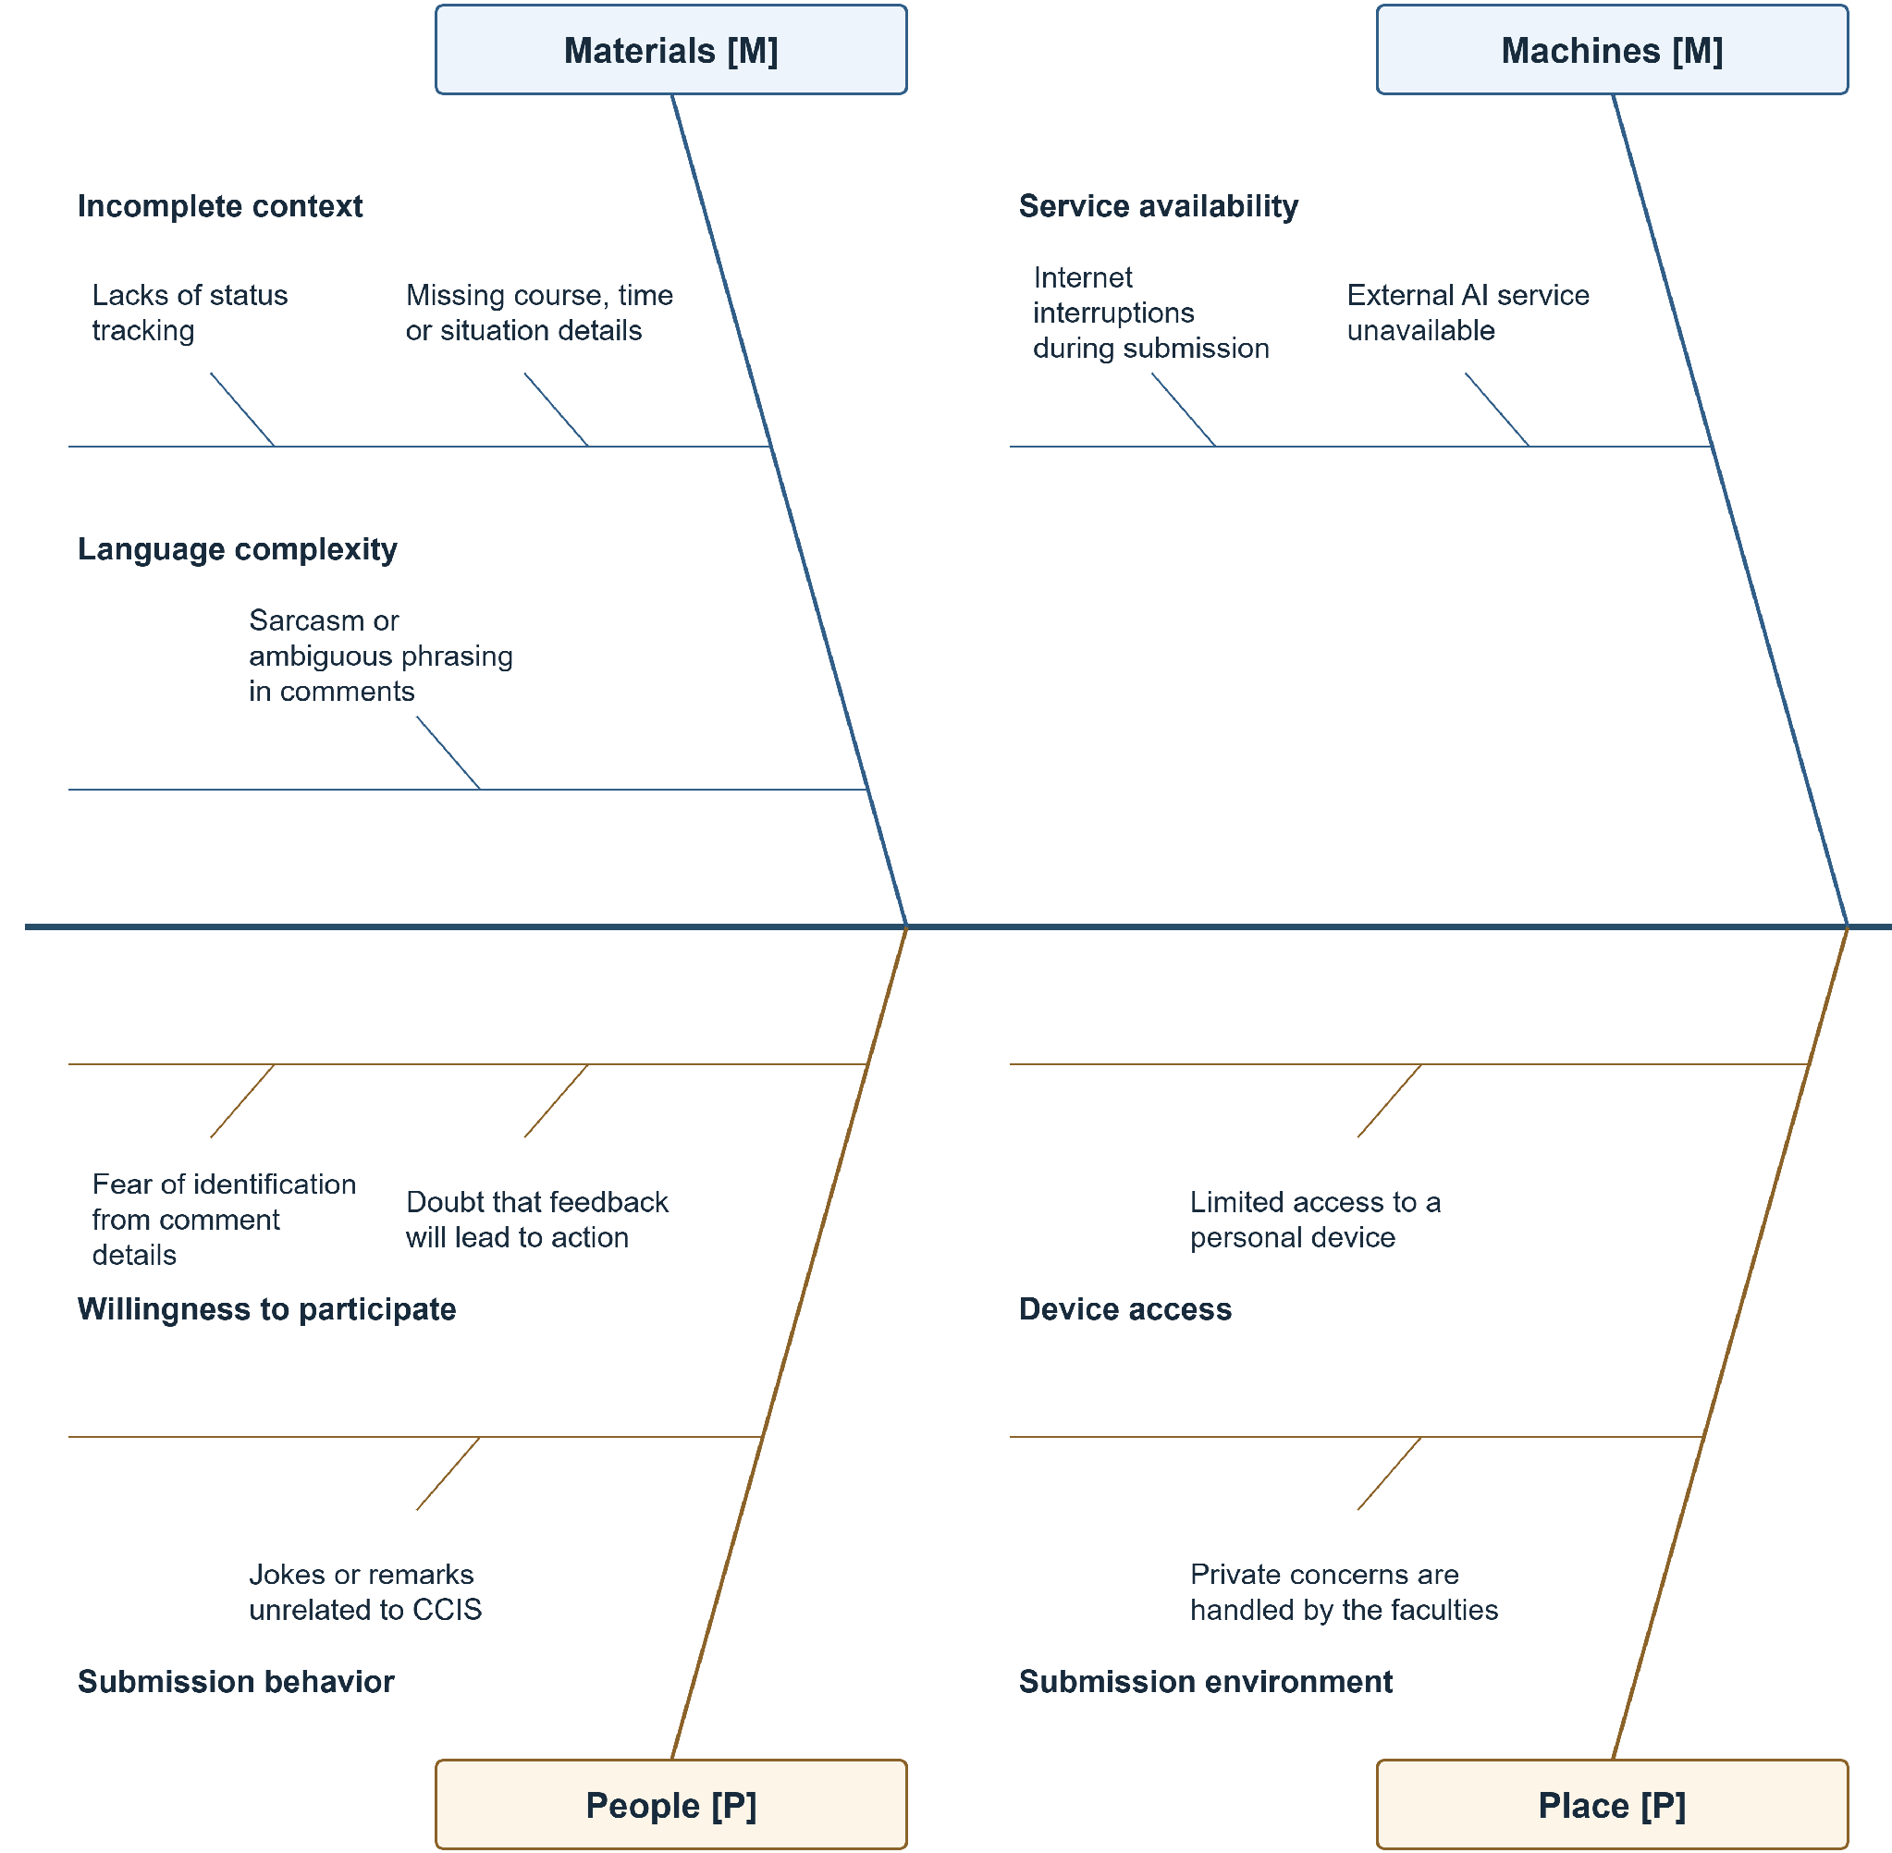
Figure 7 ResBack fishbone diagram enlarged continuation panel 1 of 2
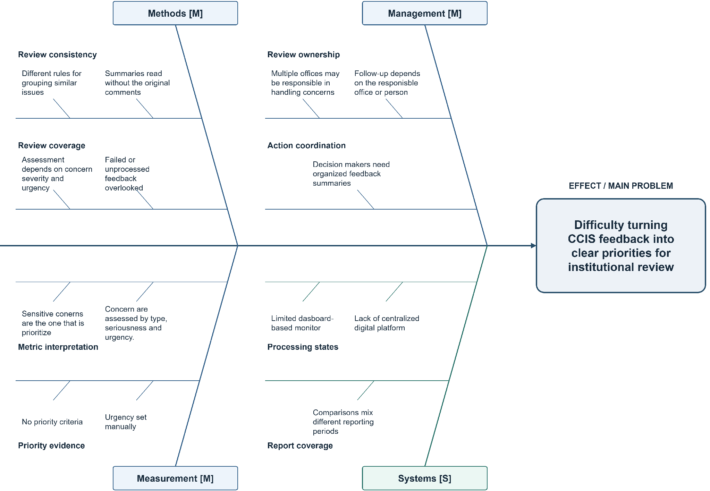
Figure 7 ResBack fishbone diagram enlarged continuation panel 2 of 2

APPENDIX B GANTT CHART
Figure 8 below shows the ResBack project schedule modified for use in Agile Data Science 2.0 framework. This project schedule contains all the task dates and the assigned team members from August 3 to October 31, 2026. The preparation stage assists in the completion of the following five stages of data value: Records, Charts, Reports, Recommendations, and Actions.
All task progress notations are made For confirmation. Bars for scheduling show planned task times and not actual completion. The chart uses the normal formatting of the template. Expanded continuation boxes list the tasks so that task descriptions can be aligned with their timeline and deliverables.
Week 1 is from August 3-9. All subsequent weeks start on a Monday; Week 5 starts on August 31, Week 9 starts on September 28, and Week 13 runs from October 26-31. The final partial week is included so that the end of all tasks can be shown until October 31.

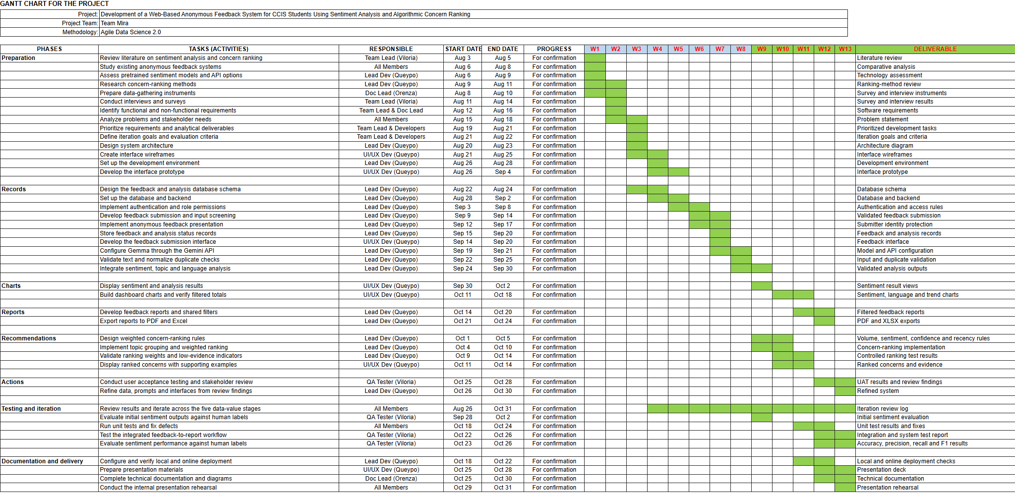
Figure 8 ResBack Gantt chart using Agile Data Science 2.0
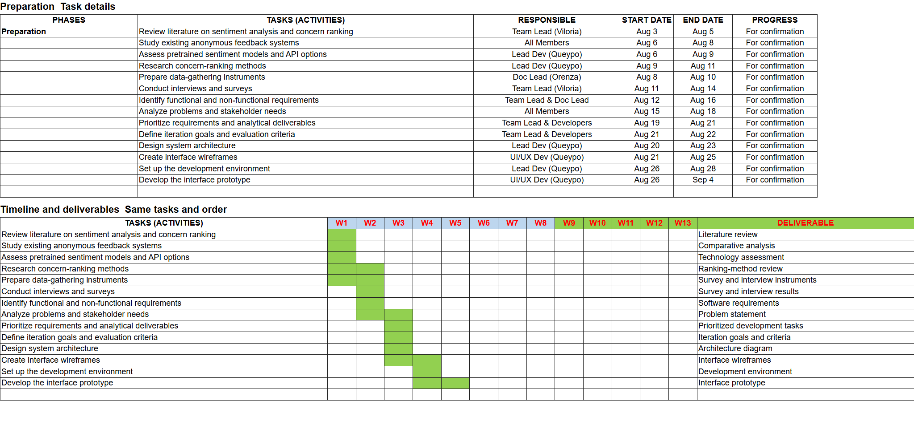
Figure 8 ResBack Gantt chart enlarged continuation panel 1 of 3
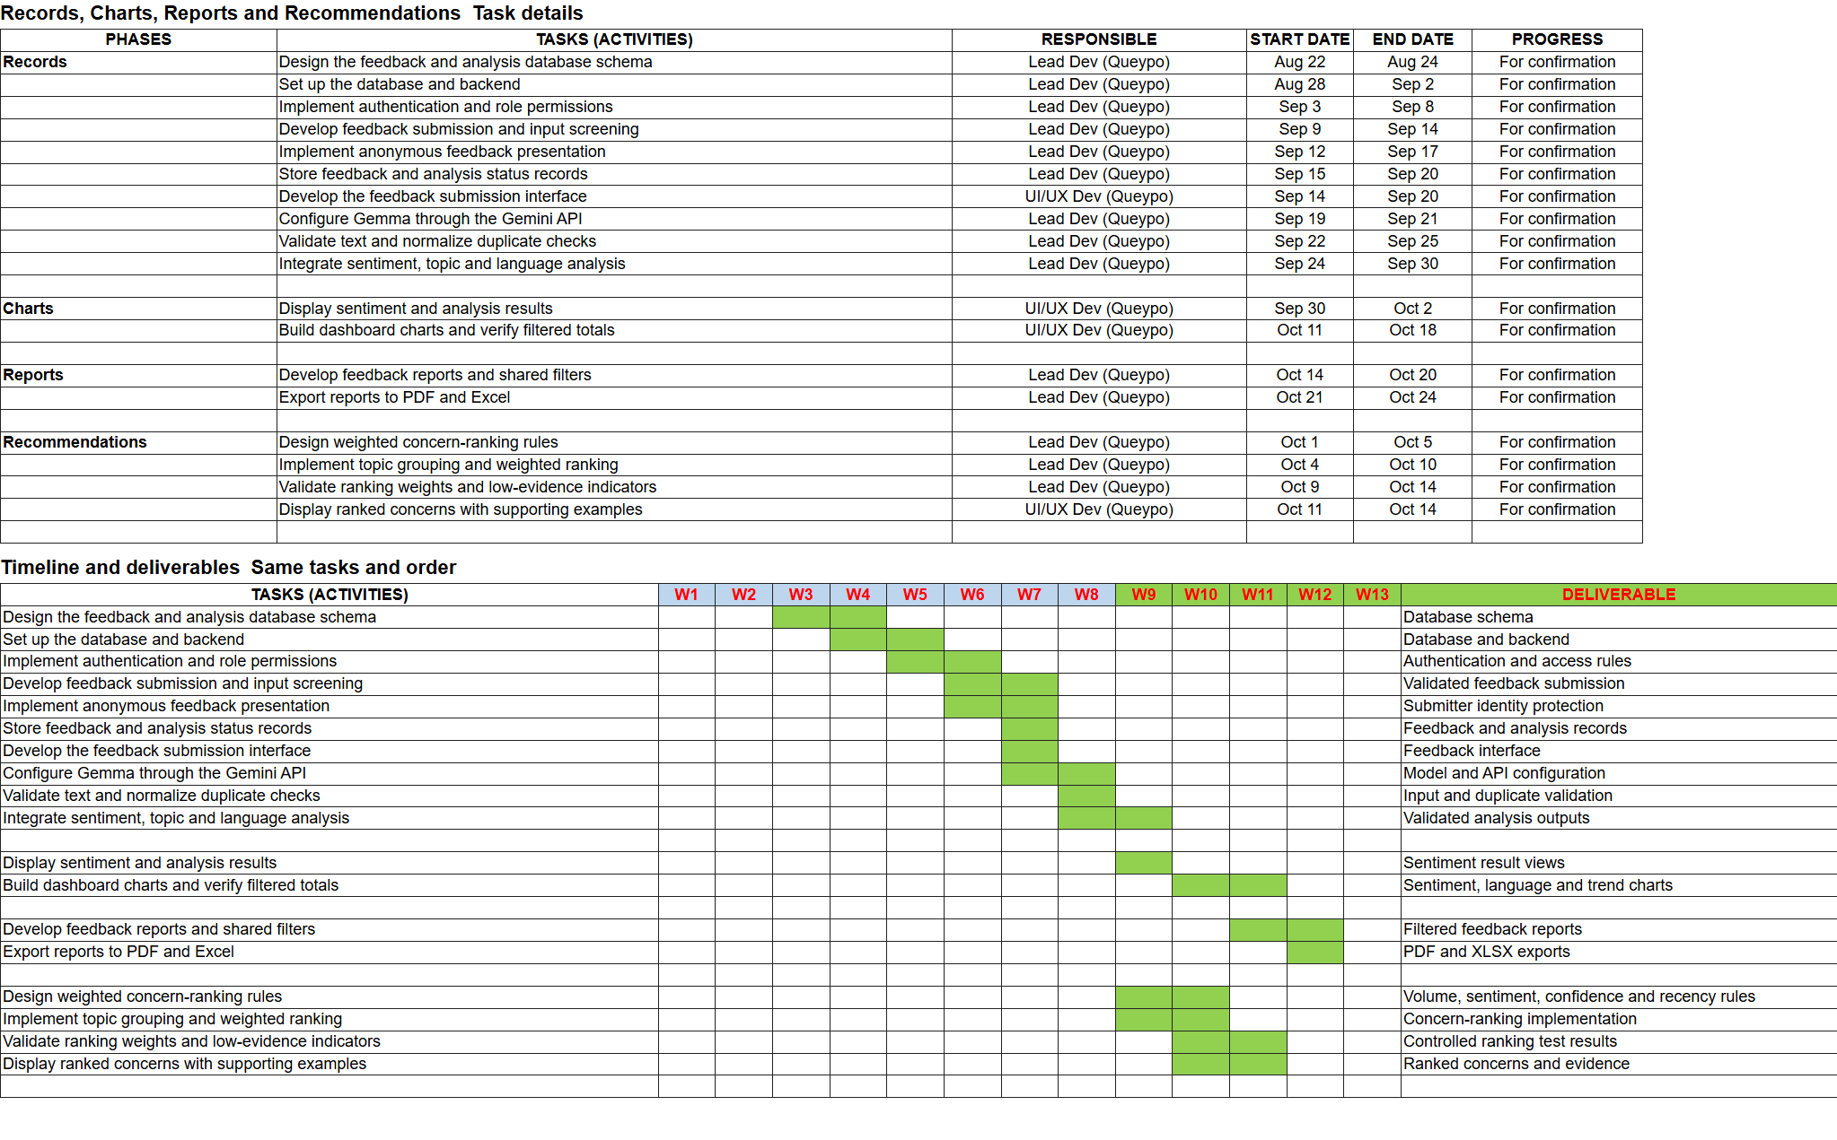
Figure 8 ResBack Gantt chart enlarged continuation panel 2 of 3
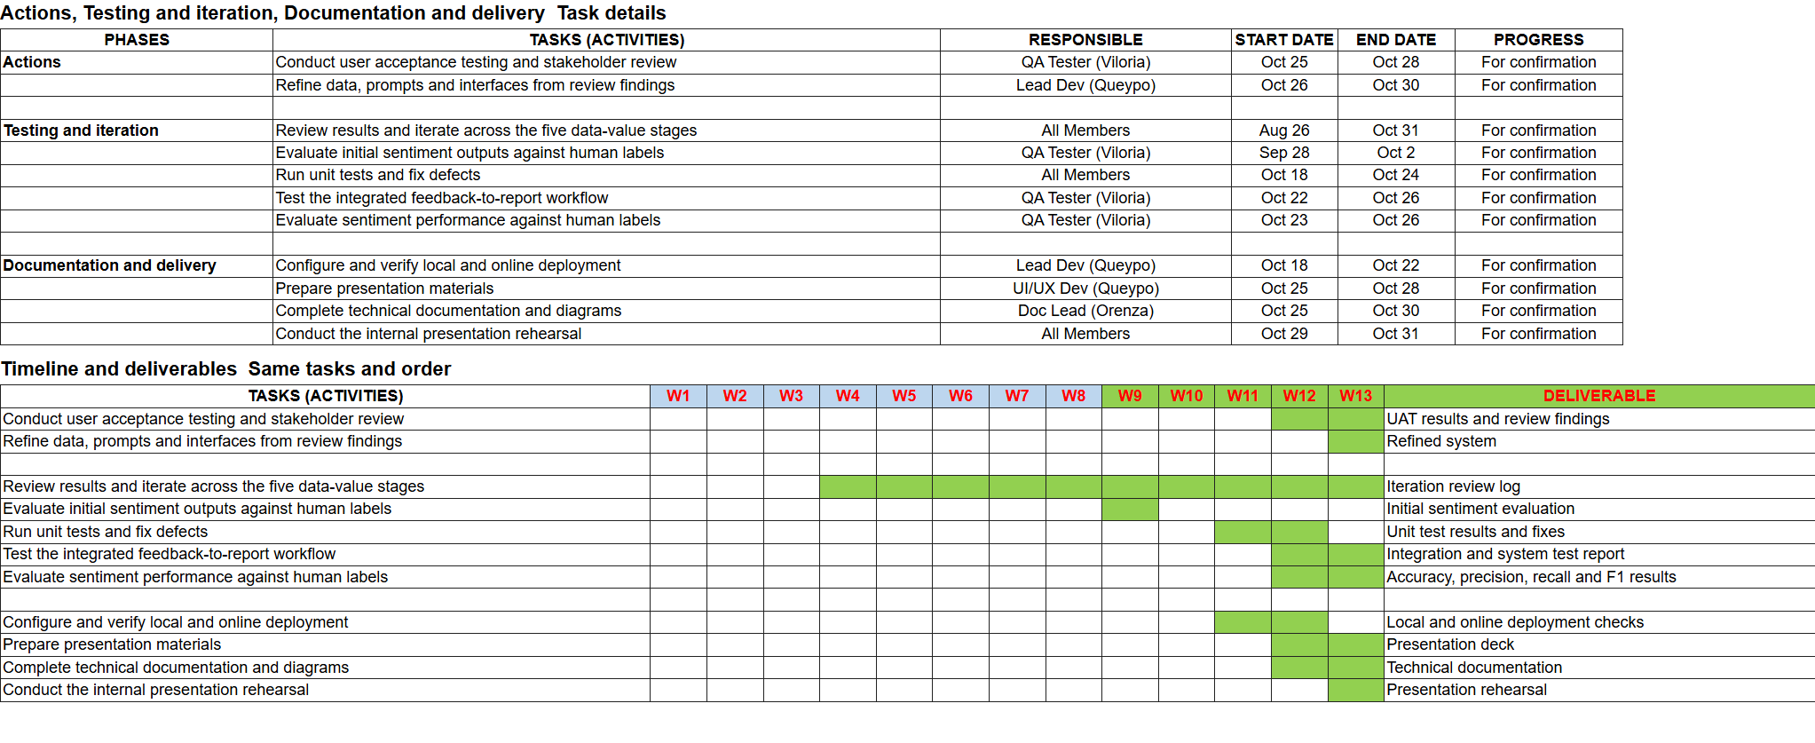
Figure 8 ResBack Gantt chart enlarged continuation panel 3 of 3

APPENDIX C USE CASE DIAGRAM
Figure 9 shows the 17 ResBack use cases and their actor associations, including Google Gemini API as the external supporting actor for accepted-feedback analysis. Student, Faculty, Admin, and Super Admin permissions are represented within the system boundary. Super Admin inherits administrative capabilities, while feedback screening and accepted-feedback analysis are associated with submission.
Appendix D provides the corresponding use case descriptions. Figure numbers identify each diagram’s position in this paper; labels within the source diagram sheets remain unchanged.
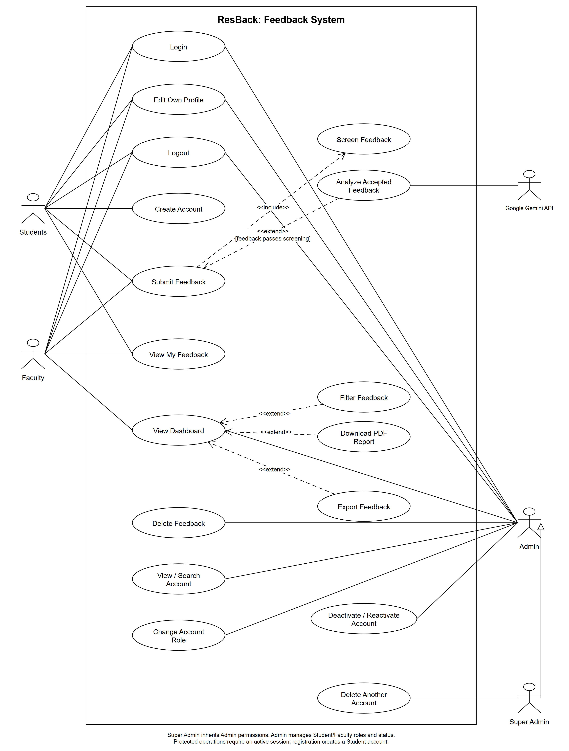
Figure 9 ResBack UML use case diagram

APPENDIX D USE CASE DESCRIPTIONS
The following 17 descriptions correspond to the use cases in Figure 9. Each table identifies the actors, preconditions, trigger, main steps, alternate and exception flows, postconditions, and non-functional requirements. The tables retain the previously prepared Lab 5 description format.
UC-01 Create Account
UC-02 Login
UC-03 Submit Feedback
UC-04 Screen Feedback
UC-05 Edit Own Profile
UC-06 Analyze Accepted Feedback
UC-07 View My Feedback
UC-08 View Dashboard
UC-09 Filter Feedback
UC-10 Download PDF Report
UC-11 Export Feedback
UC-12 Delete Feedback
UC-13 View / Search Account
UC-14 Delete Another Account
UC-15 Change Account Role
UC-16 Deactivate / Reactivate Account
UC-17 Logout
Table 5 UC-01 Create Account
Use Case Name | Create Account
Use Case ID | UC-01
Use Case Description | Allows a new Student to register an account and access the feedback submission form.
Primary Actor | Student registering a new account
Secondary Actor | None
Precondition | The Student is not signed in and can access the registration page.
Postcondition | A Student account is saved and an authenticated session opens the feedback form.
Normal Flow (Main Flow) | User Action | System Response
Normal Flow (Main Flow) | 1. Selects Create Account. | 2. Displays the registration form.
Normal Flow (Main Flow) | 3. Enters a nickname, email, password and password confirmation; submits the form. | 4. Validates the required fields, uniqueness and password confirmation.
Normal Flow (Main Flow) |  | 5. Saves the account with the Student role and a hashed password.
Normal Flow (Main Flow) |  | 6. Starts an authenticated session and displays the feedback form.
Alternate Flow | 1a. A Student who already has an account selects Login (UC-02) instead of registering again.
Exception Flow | 4a. Invalid or duplicate details prevent account creation. The system identifies the fields to correct. A storage failure prevents successful registration.
Non-Functional Requirements | Passwords must be hashed. Validation must not reveal stored passwords. The authenticated session must be regenerated.

Table 6 UC-02 Login
Use Case Name | Login
Use Case ID | UC-02
Use Case Description | Allows an existing user to access ResBack according to the account role.
Primary Actor | Student, Faculty, Admin or Super Admin
Secondary Actor | None
Precondition | The user has an active account and is not currently signed in.
Postcondition | The user is authenticated and reaches the feedback form or dashboard allowed for the role.
Normal Flow (Main Flow) | User Action | System Response
Normal Flow (Main Flow) | 1. Opens Login. | 2. Displays the email and password fields.
Normal Flow (Main Flow) | 3. Enters the registered email and password; selects Login. | 4. Validates the input, verifies the credentials and checks that the account is active.
Normal Flow (Main Flow) |  | 5. Starts an authenticated session and regenerates the session identifier.
Normal Flow (Main Flow) |  | 6. Opens the Student feedback form or the Faculty, Admin or Super Admin dashboard according to the account role.
Alternate Flow | 1a. A Student without an account selects Create Account (UC-01). Successful registration signs the Student in automatically.
Exception Flow | 4a. Incorrect credentials or an inactive account prevents login. Missing or invalid fields return validation errors.
Non-Functional Requirements | Password entry must be masked. Authentication errors must not expose stored credentials. Sessions must be protected from fixation.

Table 7 UC-03 Submit Feedback
Use Case Name | Submit Feedback
Use Case ID | UC-03
Use Case Description | Allows a Student or Faculty member to submit confidential CCIS feedback for screening and, when accepted, automatic analysis.
Primary Actor | Student or Faculty
Secondary Actor | None
Precondition | The submitter is signed in with an active Student or Faculty account and can access the active CCIS feedback category. Admin and Super Admin cannot submit feedback.
Postcondition | The feedback is saved with its screening and analysis result. The submitter receives the submission result.
Normal Flow (Main Flow) | User Action | System Response
Normal Flow (Main Flow) | 1. Opens Submit Feedback. | 2. Displays the CCIS feedback form.
Normal Flow (Main Flow) | 3. Enters feedback and selects Submit. | 4. Validates the content, category, duplicate submission and submission limit.
Normal Flow (Main Flow) |  | 5. Performs Screen Feedback (UC-04) and saves accepted feedback as pending.
Normal Flow (Main Flow) |  | 6. Performs Analyze Accepted Feedback (UC-06) and displays the stored status and available analysis.
Alternate Flow | 5a. If screening detects prohibited content, the system saves the feedback as rejected, displays the rejection result and skips UC-06.
Exception Flow | 4a. Invalid content/category, duplicate feedback or exceeding the submission limit prevents saving. 6a. Analysis failure leaves the saved feedback marked failed.
Non-Functional Requirements | Feedback history must remain private to its owner. The result must distinguish an unsaved submission from a saved record whose analysis failed.

Table 8 UC-04 Screen Feedback
Use Case Name | Screen Feedback
Use Case ID | UC-04
Use Case Description | Checks submitted feedback against configured prohibited-content rules before analysis.
Primary Actor | Student or Faculty through Submit Feedback (UC-03)
Secondary Actor | None
Precondition | Feedback has passed submission validation and duplicate and submission-limit checks.
Postcondition | The screening decision is returned to Submit Feedback; rejected content is excluded from AI analysis.
Normal Flow (Main Flow) | User Action | System Response
Normal Flow (Main Flow) |  | 1. Receives the validated feedback text from Submit Feedback (UC-03).
Normal Flow (Main Flow) |  | 2. Normalizes the text and configured blocked terms and their variants.
Normal Flow (Main Flow) |  | 3. Checks the normalized text for prohibited matches.
Normal Flow (Main Flow) |  | 4. Returns an accepted decision to UC-03 when no prohibited match is found; UC-03 saves the feedback as pending and continues to UC-06.
Alternate Flow | 3a. A prohibited match returns a rejected decision to UC-03. The system saves the record as rejected, displays the rejection result and skips UC-06.
Exception Flow | 2a/3a. A screening error prevents successful completion; the system must not report the submission as successfully analyzed.
Non-Functional Requirements | Screening must apply the configured rules consistently. It must preserve the original feedback text and keep rejected content out of dashboard reports.

Table 9 UC-05 Edit Own Profile
Use Case Name | Edit Own Profile
Use Case ID | UC-05
Use Case Description | Allows a signed-in user to update the user's own nickname and optional profile photo.
Primary Actor | Student, Faculty, Admin or Super Admin
Secondary Actor | None
Precondition | The user is signed in with an active account.
Postcondition | Valid profile changes are saved and a confirmation is displayed.
Normal Flow (Main Flow) | User Action | System Response
Normal Flow (Main Flow) | 1. Opens the profile page. | 2. Displays the current nickname and profile photo.
Normal Flow (Main Flow) | 3. Changes the nickname or selects a new photo; selects Save. | 4. Validates nickname uniqueness and the permitted photo type and size.
Normal Flow (Main Flow) |  | 5. Stores or removes the profile photo as requested and updates only the signed-in user's profile.
Normal Flow (Main Flow) |  | 6. Displays the updated profile and a confirmation message.
Alternate Flow | 3a. The user chooses to remove the existing photo before selecting Save. The user may leave the page without saving; existing details remain.
Exception Flow | 4a. A duplicate/invalid nickname or an invalid photo prevents the update. 5a. A photo-storage failure prevents successful completion.
Non-Functional Requirements | Users must only edit their own profiles. Nicknames protect real-name privacy. Photo uploads must be validated before storage.

Table 10 UC-06 Analyze Accepted Feedback
Use Case Name | Analyze Accepted Feedback
Use Case ID | UC-06
Use Case Description | Classifies accepted feedback by sentiment, language and concern topics using Gemma through the Gemini API.
Primary Actor | Student or Faculty through Submit Feedback (UC-03)
Secondary Actor | Google Gemini API (hosted Gemma inference service)
Precondition | Screen Feedback (UC-04) accepted the content; the feedback is saved as pending and the analysis service is configured.
Postcondition | A valid analysis result is saved, the feedback is marked analyzed and its category concern rankings are rebuilt.
Normal Flow (Main Flow) | User Action | System Response
Normal Flow (Main Flow) |  | 1. Starts analysis for the accepted feedback record saved as pending by UC-03.
Normal Flow (Main Flow) |  | 2. Sends the feedback to the Gemini API with the required classification instructions.
Normal Flow (Main Flow) |  | 3. Receives and validates the returned sentiment, confidence, keywords, topics and language data.
Normal Flow (Main Flow) |  | 4. Saves the result, marks the feedback analyzed and rebuilds the concern rankings; returns control to UC-03 to display the result.
Alternate Flow | 2a. A temporary request failure may trigger a retry before the final result is determined.
Exception Flow | 2a/3a. Missing configuration, connection failure, API error or unusable output marks the saved feedback failed; it does not create a successful analysis result.
Non-Functional Requirements | API credentials must remain confidential and transport must use TLS. Returned data must be validated. A service failure must preserve the submitted record.

Table 11 UC-07 View My Feedback
Use Case Name | View My Feedback
Use Case ID | UC-07
Use Case Description | Allows a submitter to review only the feedback records belonging to the signed-in account.
Primary Actor | Student or Faculty
Secondary Actor | None
Precondition | The Student or Faculty member is signed in with an active account. Feedback history is restricted to the account owner.
Postcondition | The user sees the personal feedback history with processing status and available analysis.
Normal Flow (Main Flow) | User Action | System Response
Normal Flow (Main Flow) | 1. Selects View My Feedback. | 2. Checks that the signed-in user is permitted to access personal feedback history.
Normal Flow (Main Flow) |  | 3. Retrieves only the user's feedback records with their categories and available analysis, newest first.
Normal Flow (Main Flow) |  | 4. Displays the personal feedback history, processing statuses and available analysis in a paginated list.
Normal Flow (Main Flow) | 5. Selects the next or previous history page when available. | 6. Displays the requested page of the same user's records.
Alternate Flow | 3a. If the user has no submissions, the system displays an empty history. 4a. Records without analysis show their current status.
Exception Flow | 1a. An expired session requires Login (UC-02). A retrieval failure prevents the history from being displayed.
Non-Functional Requirements | History queries must enforce ownership. Pagination must not expose another user's records. Status labels must distinguish rejected, pending, failed and analyzed feedback.

Table 12 UC-08 View Dashboard
Use Case Name | View Dashboard
Use Case ID | UC-08
Use Case Description | Allows authorized users to review CCIS feedback summaries, sentiment and language distributions, trends and ranked concerns.
Primary Actor | Faculty, Admin or Super Admin
Secondary Actor | None
Precondition | The user is signed in with an active account and a role permitted to access the dashboard.
Postcondition | The dashboard displays the available reportable feedback and analytics for the current scope.
Normal Flow (Main Flow) | User Action | System Response
Normal Flow (Main Flow) | 1. Opens View Dashboard. | 2. Checks dashboard access and retrieves reportable CCIS feedback.
Normal Flow (Main Flow) |  | 3. Calculates feedback counts, sentiment and language distributions and trends.
Normal Flow (Main Flow) |  | 4. Builds the leading concern rankings and retrieves the paginated feedback list.
Normal Flow (Main Flow) |  | 5. Displays the dashboard summaries, charts, concerns and feedback, with Filter Feedback (UC-09), Download PDF Report (UC-10) and Export Feedback (UC-11).
Alternate Flow | 2a. With no reportable records, the dashboard shows zero totals and an empty list. After step 5, the user may activate UC-09, UC-10 or UC-11.
Exception Flow | 1a. A Student or other unauthorized user is denied dashboard access. Invalid scope values or a retrieval failure prevent the requested view.
Non-Functional Requirements | Access must be role controlled. Rejected feedback must be excluded from reports. Dashboard records must not disclose submitters' email addresses or real names.

Table 13 UC-09 Filter Feedback
Use Case Name | Filter Feedback
Use Case ID | UC-09
Use Case Description | Narrows dashboard feedback and analytics by supported language and date-range criteria.
Primary Actor | Faculty, Admin or Super Admin
Secondary Actor | None
Precondition | View Dashboard (UC-08) is open and the user has dashboard permission.
Postcondition | Dashboard records and analytics reflect the selected valid filter criteria.
Normal Flow (Main Flow) | User Action | System Response
Normal Flow (Main Flow) | 1. Opens the dashboard filter controls. | 2. Displays supported language and date-range options for CCIS.
Normal Flow (Main Flow) | 3. Selects the desired criteria and applies the filters. | 4. Validates the selected criteria.
Normal Flow (Main Flow) |  | 5. Retrieves matching reportable feedback and recalculates analytics for the selected scope.
Normal Flow (Main Flow) |  | 6. Displays the filtered feedback and analytics; retains the scope for PDF and spreadsheet downloads.
Alternate Flow | 3a. The user clears optional filters to restore the default CCIS view. 5a. No matching records produces an empty result.
Exception Flow | 4a. Unsupported language/category values or invalid date ranges prevent applying the requested filter. A retrieval failure prevents refreshed results.
Non-Functional Requirements | The same criteria must be applied consistently to records, analytics and downloads. Filter use must not bypass access restrictions.

Table 14 UC-10 Download PDF Report
Use Case Name | Download PDF Report
Use Case ID | UC-10
Use Case Description | Produces a downloadable PDF containing CCIS feedback summaries, concern rankings and reportable feedback for the selected scope.
Primary Actor | Faculty, Admin or Super Admin
Secondary Actor | None
Precondition | The user has dashboard permission and the requested language and date filters are valid.
Postcondition | A PDF report is generated and returned for download.
Normal Flow (Main Flow) | User Action | System Response
Normal Flow (Main Flow) | 1. Selects Download PDF Report for the current dashboard scope. | 2. Checks access and validates the requested language and date filters.
Normal Flow (Main Flow) |  | 3. Retrieves matching reportable CCIS feedback and calculates summaries and concern rankings.
Normal Flow (Main Flow) |  | 4. Renders the PDF report with the selected scope and page numbering.
Normal Flow (Main Flow) |  | 5. Returns the PDF for download with a descriptive filename.
Alternate Flow | 1a. With no optional filters, the report uses the default CCIS scope. 3a. With no matching feedback, the report contains the available zero/empty summaries.
Exception Flow | 2a. Invalid filters or unauthorized access prevents download. 3a/4a. A retrieval or PDF-generation failure prevents a completed report.
Non-Functional Requirements | The PDF must be readable with consistent pagination. It must reflect the selected scope, exclude rejected feedback and avoid submitters' identifying account data.

Table 15 UC-11 Export Feedback
Use Case Name | Export Feedback
Use Case ID | UC-11
Use Case Description | Exports matching reportable CCIS feedback and available analysis to an Excel spreadsheet.
Primary Actor | Faculty, Admin or Super Admin
Secondary Actor | None
Precondition | The user has dashboard permission and the requested filters are valid.
Postcondition | An XLSX spreadsheet is generated and returned for download.
Normal Flow (Main Flow) | User Action | System Response
Normal Flow (Main Flow) | 1. Selects Export Feedback for the current dashboard scope. | 2. Checks access and validates the requested language and date filters.
Normal Flow (Main Flow) |  | 3. Retrieves matching reportable CCIS feedback and available analysis.
Normal Flow (Main Flow) |  | 4. Writes feedback, dates, statuses and analysis into an XLSX spreadsheet with column headings and formatted values.
Normal Flow (Main Flow) |  | 5. Returns the XLSX file for download with a descriptive filename.
Alternate Flow | 1a. With no optional filters, the export uses the default CCIS scope. 3a. No matching feedback produces a spreadsheet containing the column headings.
Exception Flow | 2a. Invalid filters or unauthorized access prevents export. 3a/4a. A retrieval or spreadsheet-generation failure prevents a completed download.
Non-Functional Requirements | The export must preserve the selected scope and exclude rejected feedback and identifying account fields. Feedback text must be written as text rather than executable spreadsheet formulas.

Table 16 UC-12 Delete Feedback
Use Case Name | Delete Feedback
Use Case ID | UC-12
Use Case Description | Allows an administrator to permanently remove a selected feedback record and its associated analysis.
Primary Actor | Admin or Super Admin
Secondary Actor | None
Precondition | The administrator is signed in with an active account and the selected feedback exists.
Postcondition | The feedback and associated analysis are removed; the dashboard displays a deletion confirmation.
Normal Flow (Main Flow) | User Action | System Response
Normal Flow (Main Flow) | 1. Locates a feedback record on the dashboard. | 2. Displays the record and the permitted delete control.
Normal Flow (Main Flow) | 3. Selects Delete Feedback. | 4. Presents the deletion confirmation.
Normal Flow (Main Flow) | 5. Confirms deletion. | 6. Checks administrator permission and permanently deletes the record and associated analysis.
Normal Flow (Main Flow) |  | 7. Displays confirmation and the remaining feedback records.
Alternate Flow | 5a. The administrator cancels confirmation; the feedback remains unchanged.
Exception Flow | 6a. A Faculty or Student user cannot delete feedback. A missing record or database failure prevents successful deletion.
Non-Functional Requirements | Deletion must enforce administrator authorization and request protection. Confirmation must make the permanent effect clear. Associated analysis must not remain orphaned.

Table 17 UC-13 View / Search Account
Use Case Name | View / Search Account
Use Case ID | UC-13
Use Case Description | Allows an administrator to view registered accounts and search them by nickname.
Primary Actor | Admin or Super Admin
Secondary Actor | None
Precondition | The administrator is signed in with an active account and has account-management access.
Postcondition | The account list or nickname search results are displayed.
Normal Flow (Main Flow) | User Action | System Response
Normal Flow (Main Flow) | 1. Opens View / Search Account. | 2. Displays accounts with nickname, role, status and registration date.
Normal Flow (Main Flow) | 3. Enters a nickname or part of a nickname and submits the search. | 4. Validates the search text.
Normal Flow (Main Flow) |  | 5. Retrieves accounts matching the nickname search.
Normal Flow (Main Flow) |  | 6. Displays the paginated results while retaining the search criteria.
Alternate Flow | 3a. An empty search displays the full paginated list. 5a. No matching nickname displays an empty result. After step 6, the administrator may select another result page or an authorized account action (UC-14, UC-15 or UC-16).
Exception Flow | 1a. An unauthorized user is denied access. Invalid search input or a retrieval failure prevents the requested result.
Non-Functional Requirements | Account lists must use nicknames and omit email addresses and real names. Search must enforce administrator access and validate input.

Table 18 UC-14 Delete Another Account
Use Case Name | Delete Another Account
Use Case ID | UC-14
Use Case Description | Allows a Super Admin to permanently delete an account other than the currently signed-in account.
Primary Actor | Super Admin
Secondary Actor | None
Precondition | The Super Admin is signed in with an active account; the target account exists and belongs to another user.
Postcondition | The target account is deleted and the updated account list shows a confirmation.
Normal Flow (Main Flow) | User Action | System Response
Normal Flow (Main Flow) | 1. Finds the target using View / Search Account (UC-13). | 2. Displays the account and its permitted delete control.
Normal Flow (Main Flow) | 3. Selects Delete Another Account. | 4. Presents confirmation identifying the target by nickname.
Normal Flow (Main Flow) | 5. Confirms the deletion. | 6. Verifies Super Admin permission and checks that the target is not the signed-in account.
Normal Flow (Main Flow) |  | 7. Deletes the target account and displays the updated account list with a success message.
Alternate Flow | 5a. The Super Admin cancels confirmation; the target account remains unchanged.
Exception Flow | 6a. A regular Admin or any other role cannot delete accounts. Self-deletion is blocked. A missing target or database failure prevents successful completion.
Non-Functional Requirements | Super Admin authorization and request protection must be enforced. Confirmation must make permanent deletion clear without exposing email addresses or real names.

Table 19 UC-15 Change Account Role
Use Case Name | Change Account Role
Use Case ID | UC-15
Use Case Description | Allows an administrator to assign a permitted role to another registered account.
Primary Actor | Admin or Super Admin
Secondary Actor | None
Precondition | The administrator is signed in with an active account and has opened View / Search Account (UC-13). The target account exists and is not the signed-in account.
Postcondition | The permitted role is saved for the target account and a confirmation is displayed.
Normal Flow (Main Flow) | User Action | System Response
Normal Flow (Main Flow) | 1. Opens View / Search Account (UC-13). | 2. Displays account nicknames, current roles, statuses and permitted role controls.
Normal Flow (Main Flow) | 3. Selects another account, chooses a permitted role and selects Save. | 4. Checks administrator authority and blocks self-role changes. Admin may manage only Student/Faculty targets; Super Admin may also manage administrator targets.
Normal Flow (Main Flow) |  | 5. Validates the selected role. Admin may assign Student or Faculty; Super Admin may also assign Admin or Super Admin.
Normal Flow (Main Flow) |  | 6. Updates the target account role and displays confirmation.
Alternate Flow | 3a. The administrator leaves the page without saving; the current role remains unchanged.
Exception Flow | 4a. Self-role changes or unauthorized management of an administrator account are blocked. 5a. An invalid or disallowed role prevents the update. A missing target or database failure prevents successful completion.
Non-Functional Requirements | Authorization must be enforced on the server. Requests must be protected against forgery. Account controls must identify users by nickname and protect the signed-in account.

Table 20 UC-16 Deactivate / Reactivate Account
Use Case Name | Deactivate / Reactivate Account
Use Case ID | UC-16
Use Case Description | Allows an administrator to deactivate or reactivate another account within the administrator's authority.
Primary Actor | Admin or Super Admin
Secondary Actor | None
Precondition | The administrator is signed in with an active account and has opened View / Search Account (UC-13). The target account exists and is not the signed-in account.
Postcondition | The target account status is changed and a confirmation is displayed. Deactivated accounts cannot log in or access operations that require an active account.
Normal Flow (Main Flow) | User Action | System Response
Normal Flow (Main Flow) | 1. Opens View / Search Account (UC-13). | 2. Displays account nicknames, roles, statuses and permitted status controls.
Normal Flow (Main Flow) | 3. Selects Deactivate for an active target or Reactivate for an inactive target. | 4. Checks administrator authority and blocks changes to the signed-in account. Admin may manage only Student/Faculty targets; Super Admin may also manage administrator targets.
Normal Flow (Main Flow) |  | 5. Changes the target's active status to the opposite state and saves it.
Normal Flow (Main Flow) |  | 6. Displays the updated status and a confirmation message.
Alternate Flow | 3a. For an inactive account, Reactivate restores active status. For an active account, Deactivate removes active status.
Exception Flow | 4a. Changing the signed-in account's status or unauthorized management of an administrator account is blocked. A missing target or database failure prevents successful completion.
Non-Functional Requirements | Status updates must enforce role restrictions and request protection. Active-account checks must prevent a deactivated user from accessing protected operations.

Table 21 UC-17 Logout
Use Case Name | Logout
Use Case ID | UC-17
Use Case Description | Allows a signed-in actor to end the current authenticated session.
Primary Actor | Student, Faculty, Admin or Super Admin
Secondary Actor | None
Precondition | The actor has an authenticated session.
Postcondition | The actor is signed out, the session is invalidated and the Login page is displayed.
Normal Flow (Main Flow) | User Action | System Response
Normal Flow (Main Flow) | 1. Selects Logout. | 2. Ends authentication for the current session.
Normal Flow (Main Flow) |  | 3. Invalidates the session and clears its stored data.
Normal Flow (Main Flow) |  | 4. Regenerates the request-protection token.
Normal Flow (Main Flow) |  | 5. Redirects the actor to Login (UC-02).
Alternate Flow | 1a. If the session has already expired, access to the authenticated logout route redirects the actor to Login.
Exception Flow | 2a. An invalid request-protection token prevents the logout request from being processed; the actor must reload the page and submit a valid request.
Non-Functional Requirements | Logout must use a protected POST request. Invalidated sessions must not authorize further access to authenticated pages.

APPENDIX E ACTIVITY DIAGRAMS
Figures 10–21 show the twelve ResBack activities. Swimlanes separate user and system responsibilities. Every activity has one final endpoint; additional exits in the corrected diagrams loop back to an action. Larger workflows include continuation panels for readability.
Figure 10. Registration validates account details, handles duplicate values, creates an active Student account, and starts an authenticated session.
Figure 11. Login checks credentials and account status before routing the user according to role. Extra endings return to an action through a loop.
Figure 12. Submission covers confirmation, validation, duplicate and rate checks, screening, storage, and accepted or rejected results.
Figure 13. Personal feedback history displays the signed-in user’s submissions, processing status, and pagination.
Figure 14. Dashboard review validates date and language filters, retrieves matching feedback, summarizes sentiment, and ranks concerns.
Figure 15. Account management covers search, protected-account checks, role and status changes, and permitted account deletion. Disallowed or canceled actions return to the relevant action.
Figure 16. Analysis performs synchronous Gemma inference, validates the response, normalizes language and concern topics, stores results, and rebuilds rankings. Failed analysis remains visible as a failed status.
Figure 17. Excel export applies the selected filters and downloads feedback without submitter identities or rejected submissions.
Figure 18. PDF reporting uses the same filters and presents summaries and supporting feedback, including an empty state when appropriate.
Figure 19. Feedback deletion checks permission and the selected record. Cancellation preserves the record and returns to the previous action.
Figure 20. Profile editing validates the nickname and photo, handles photo replacement or removal, and saves permitted changes.
Figure 21. Logout invalidates the authenticated session, refreshes the CSRF token, and redirects the user.
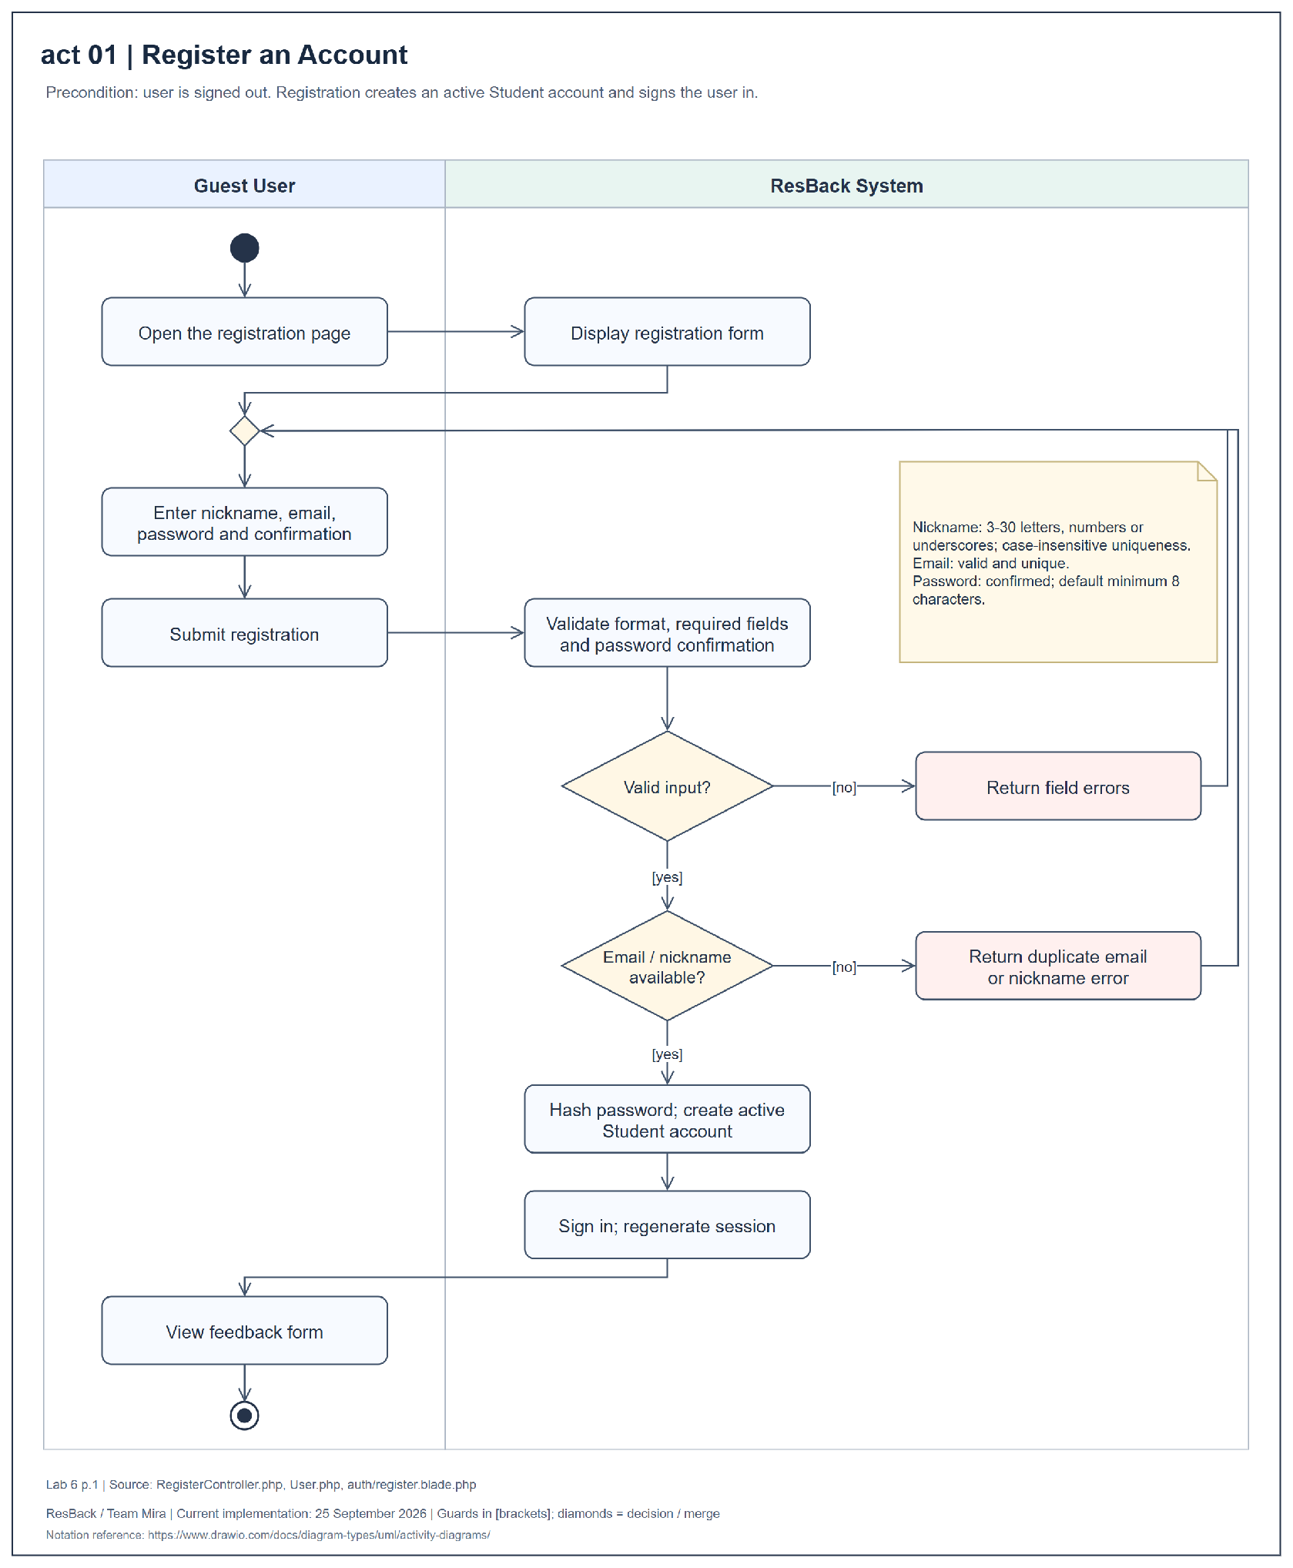
Figure 10 Activity diagram for register an account
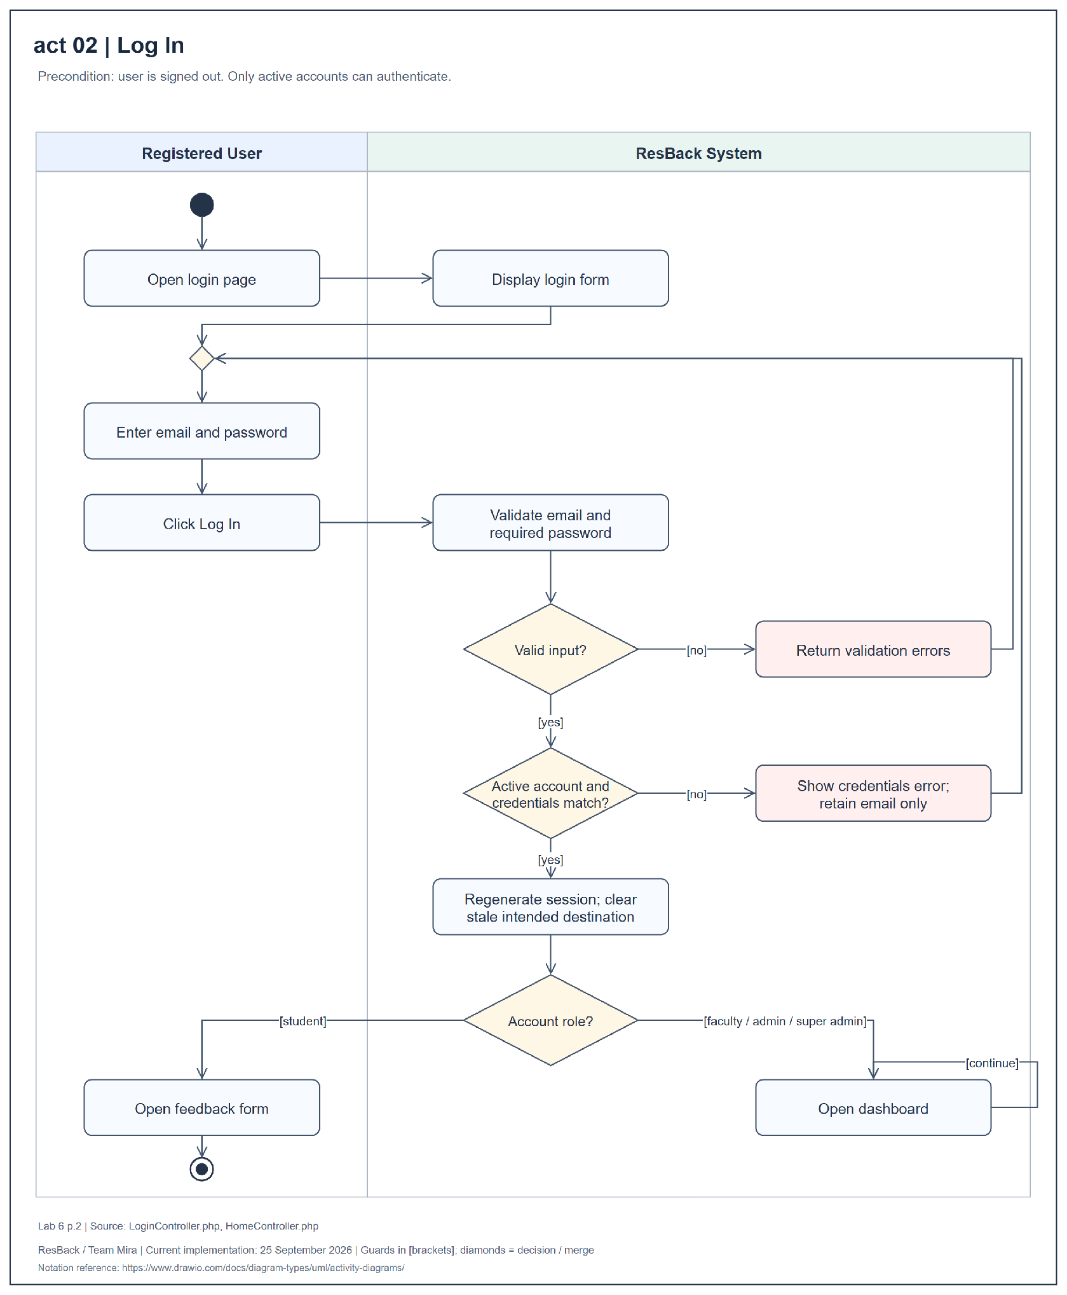
Figure 11 Activity diagram for log in
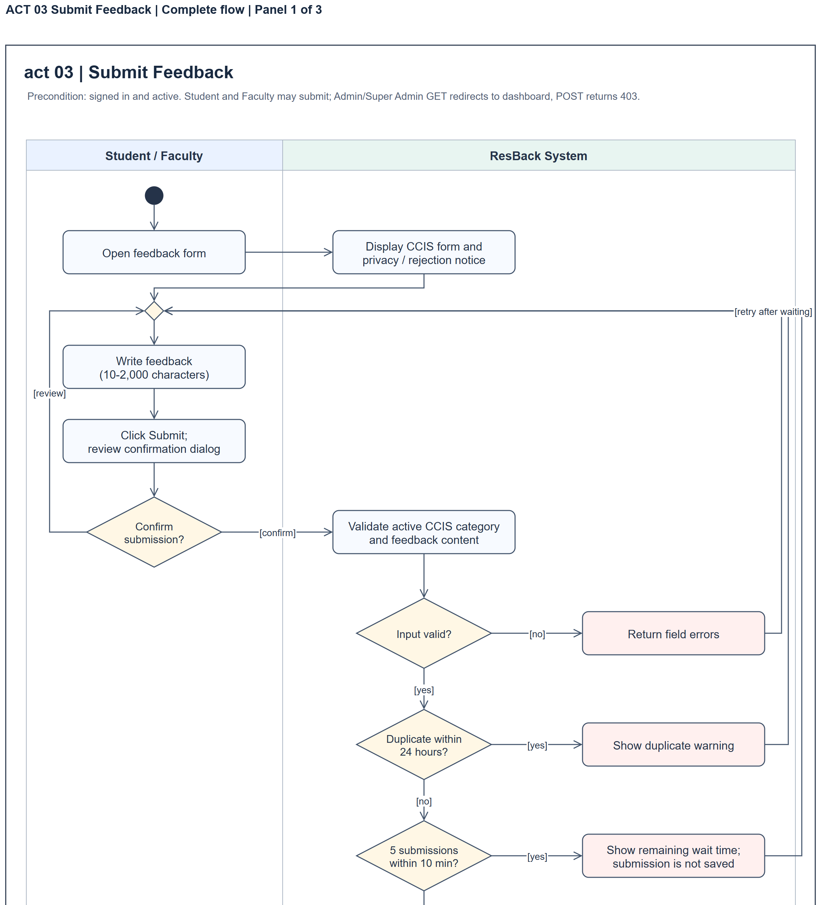
Figure 12 Activity diagram for submit feedback complete flow panel 1 of 3
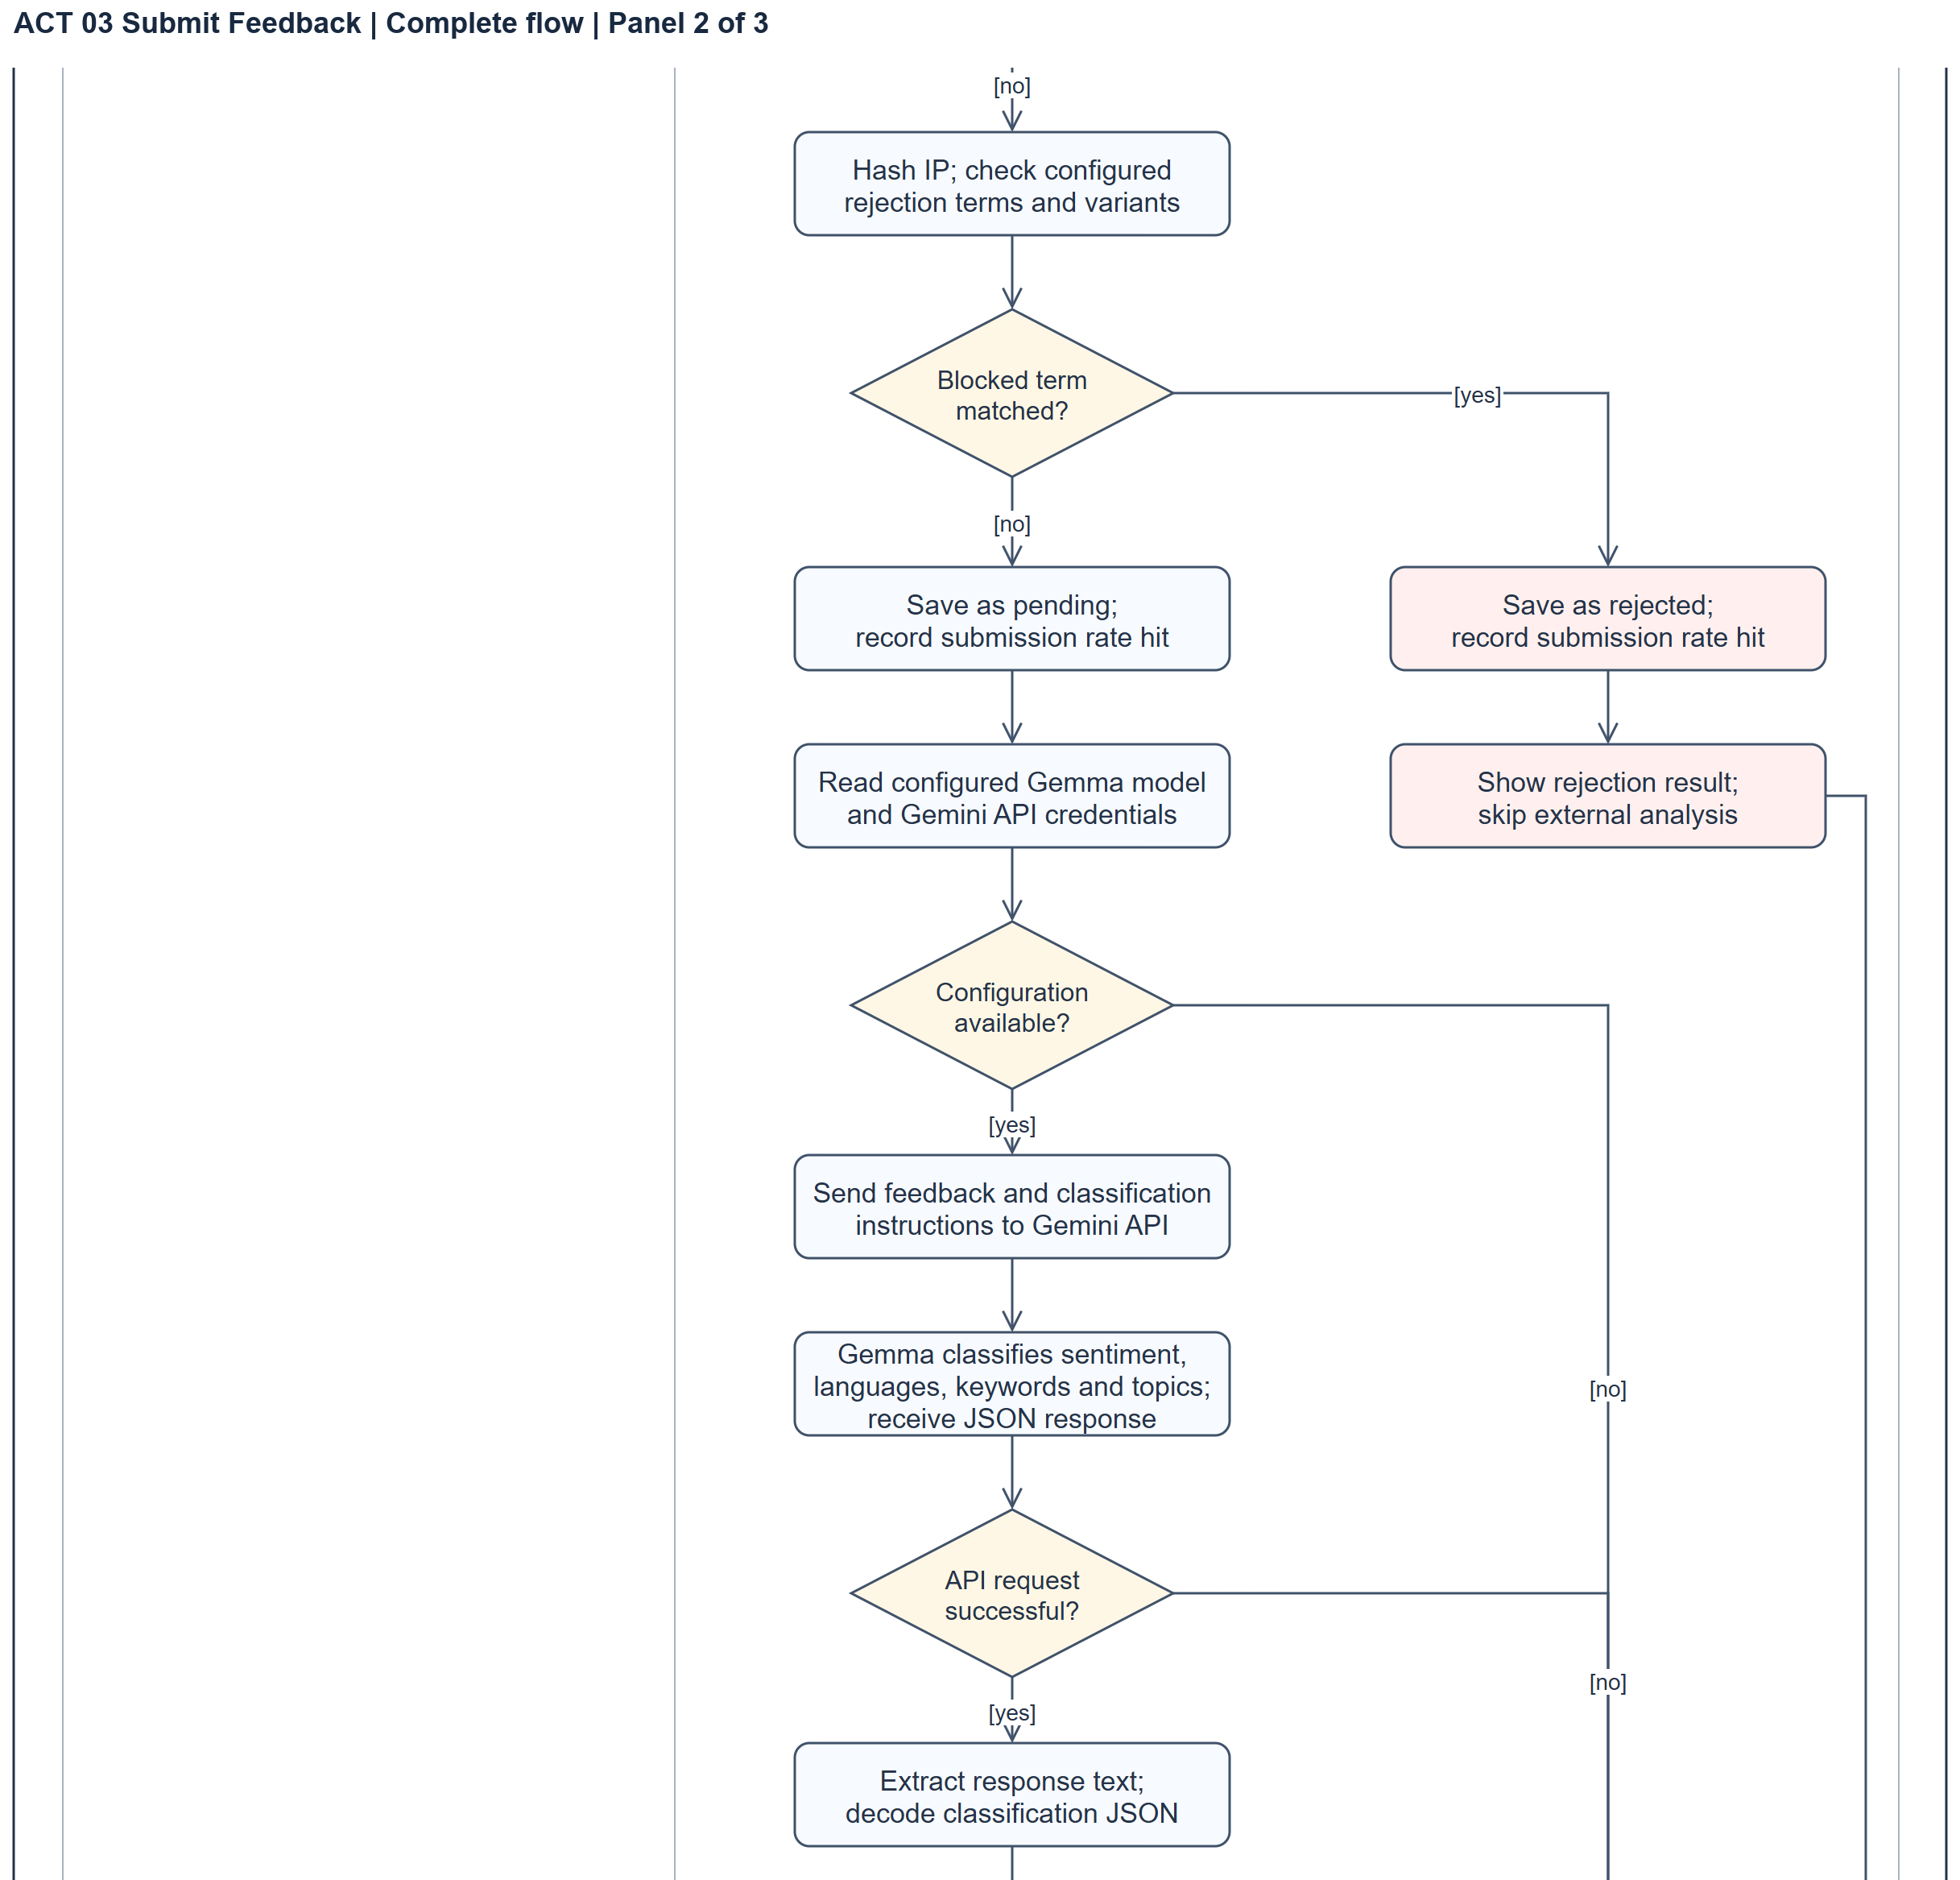
Figure 12 Activity diagram for submit feedback complete flow panel 2 of 3
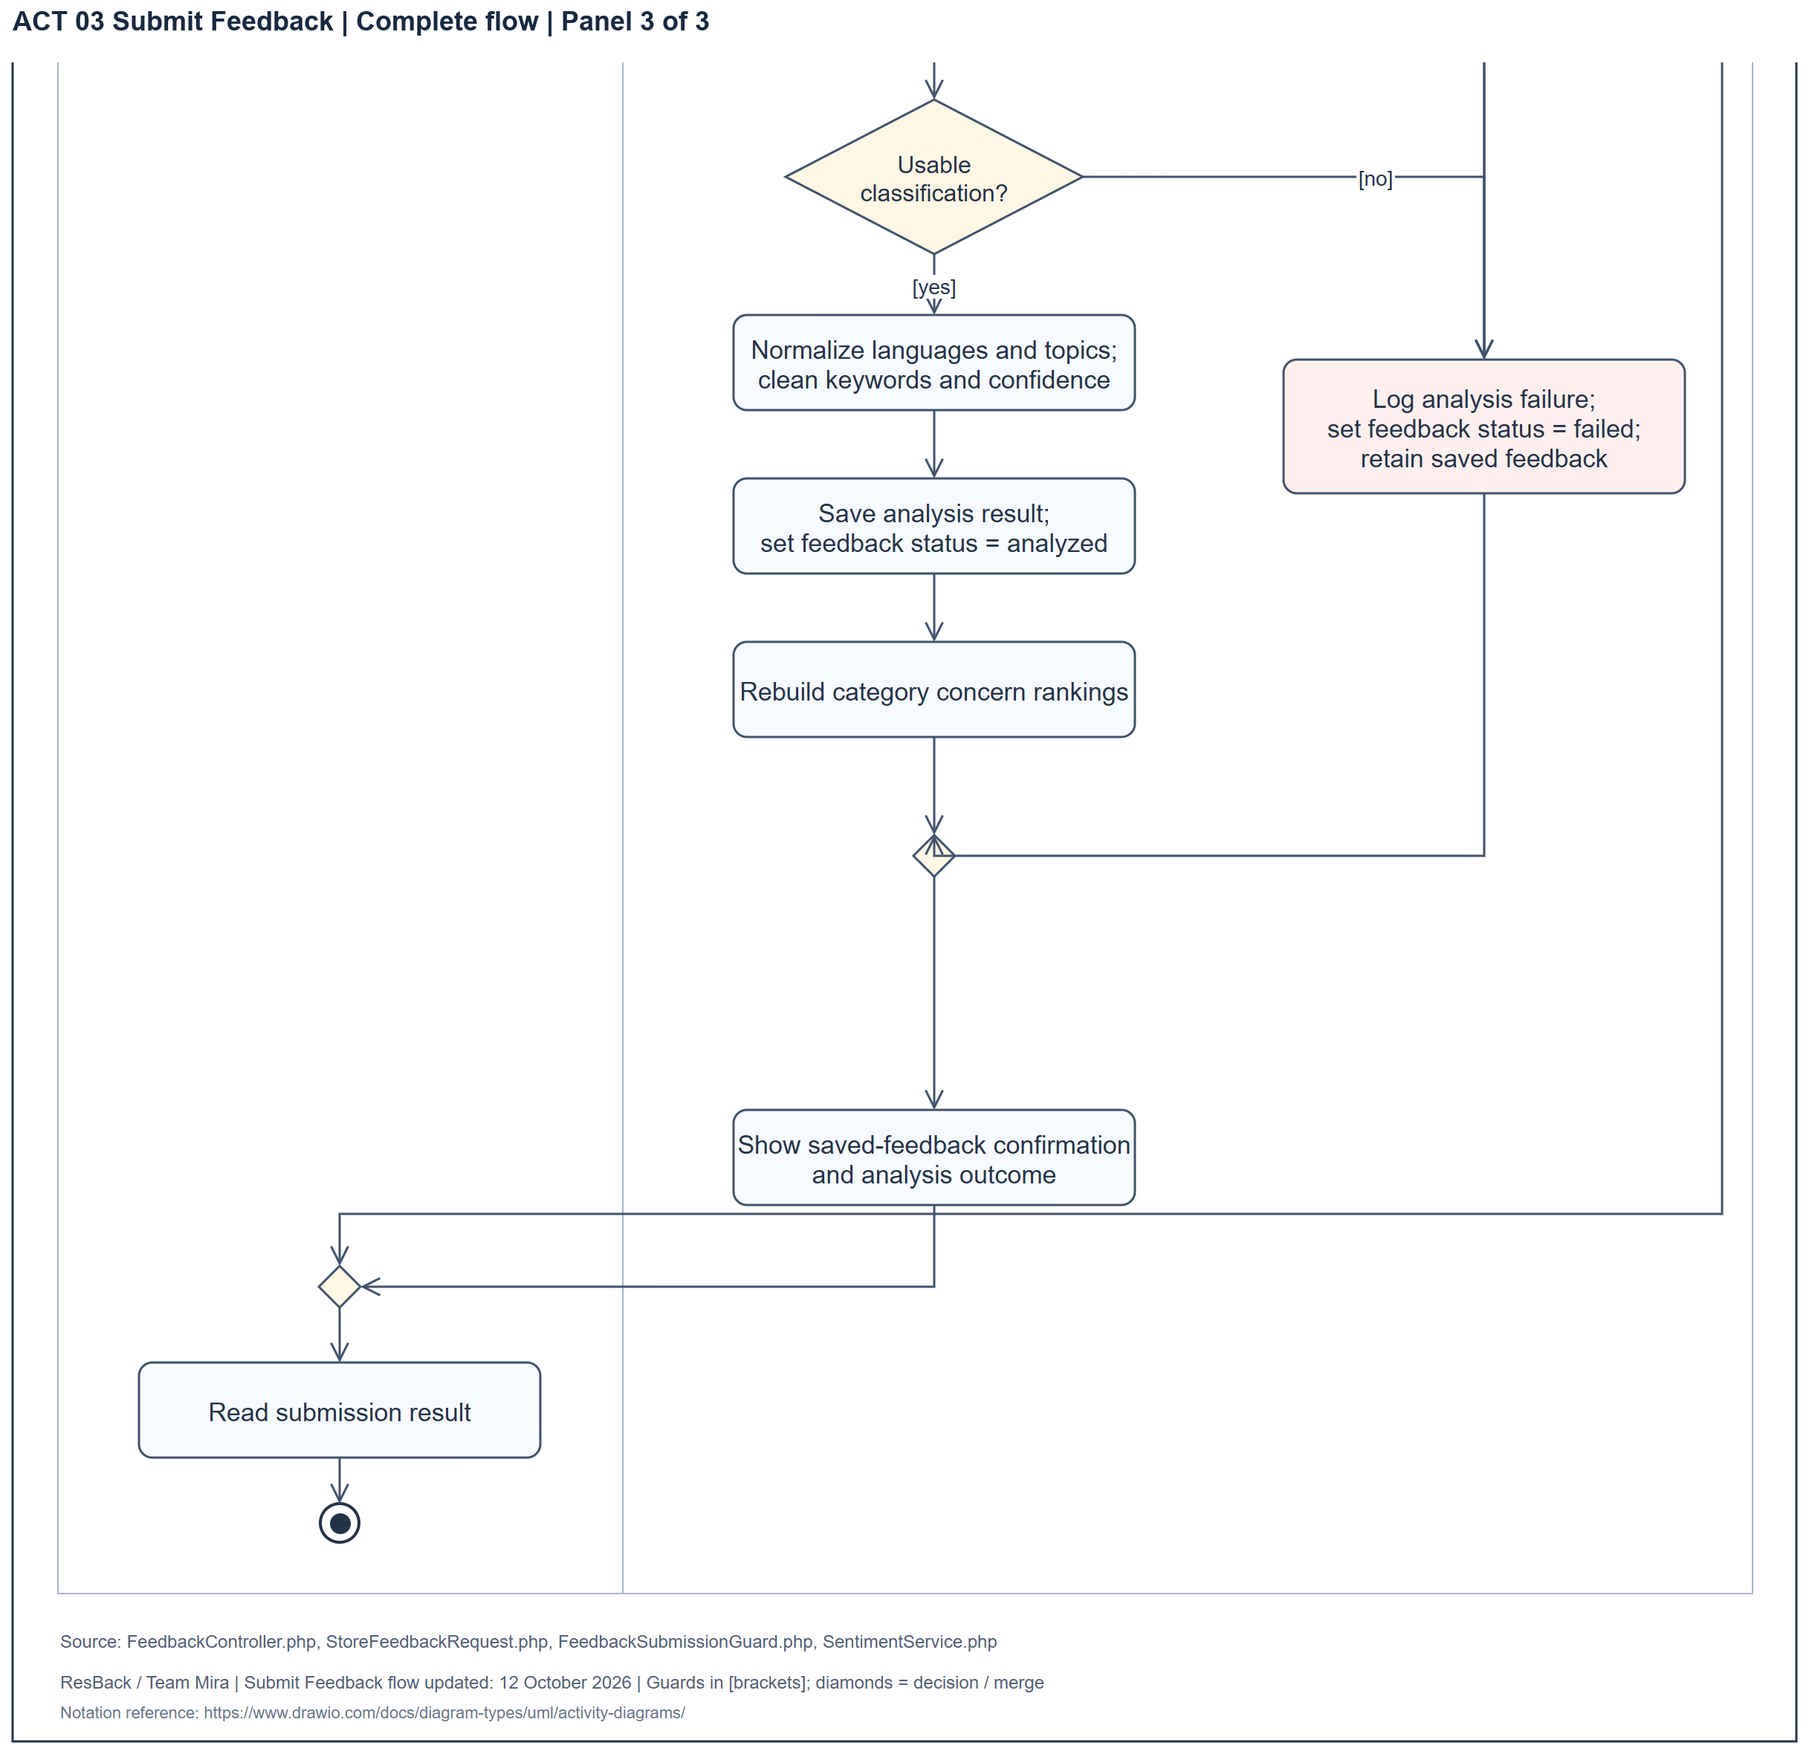
Figure 12 Activity diagram for submit feedback complete flow panel 3 of 3
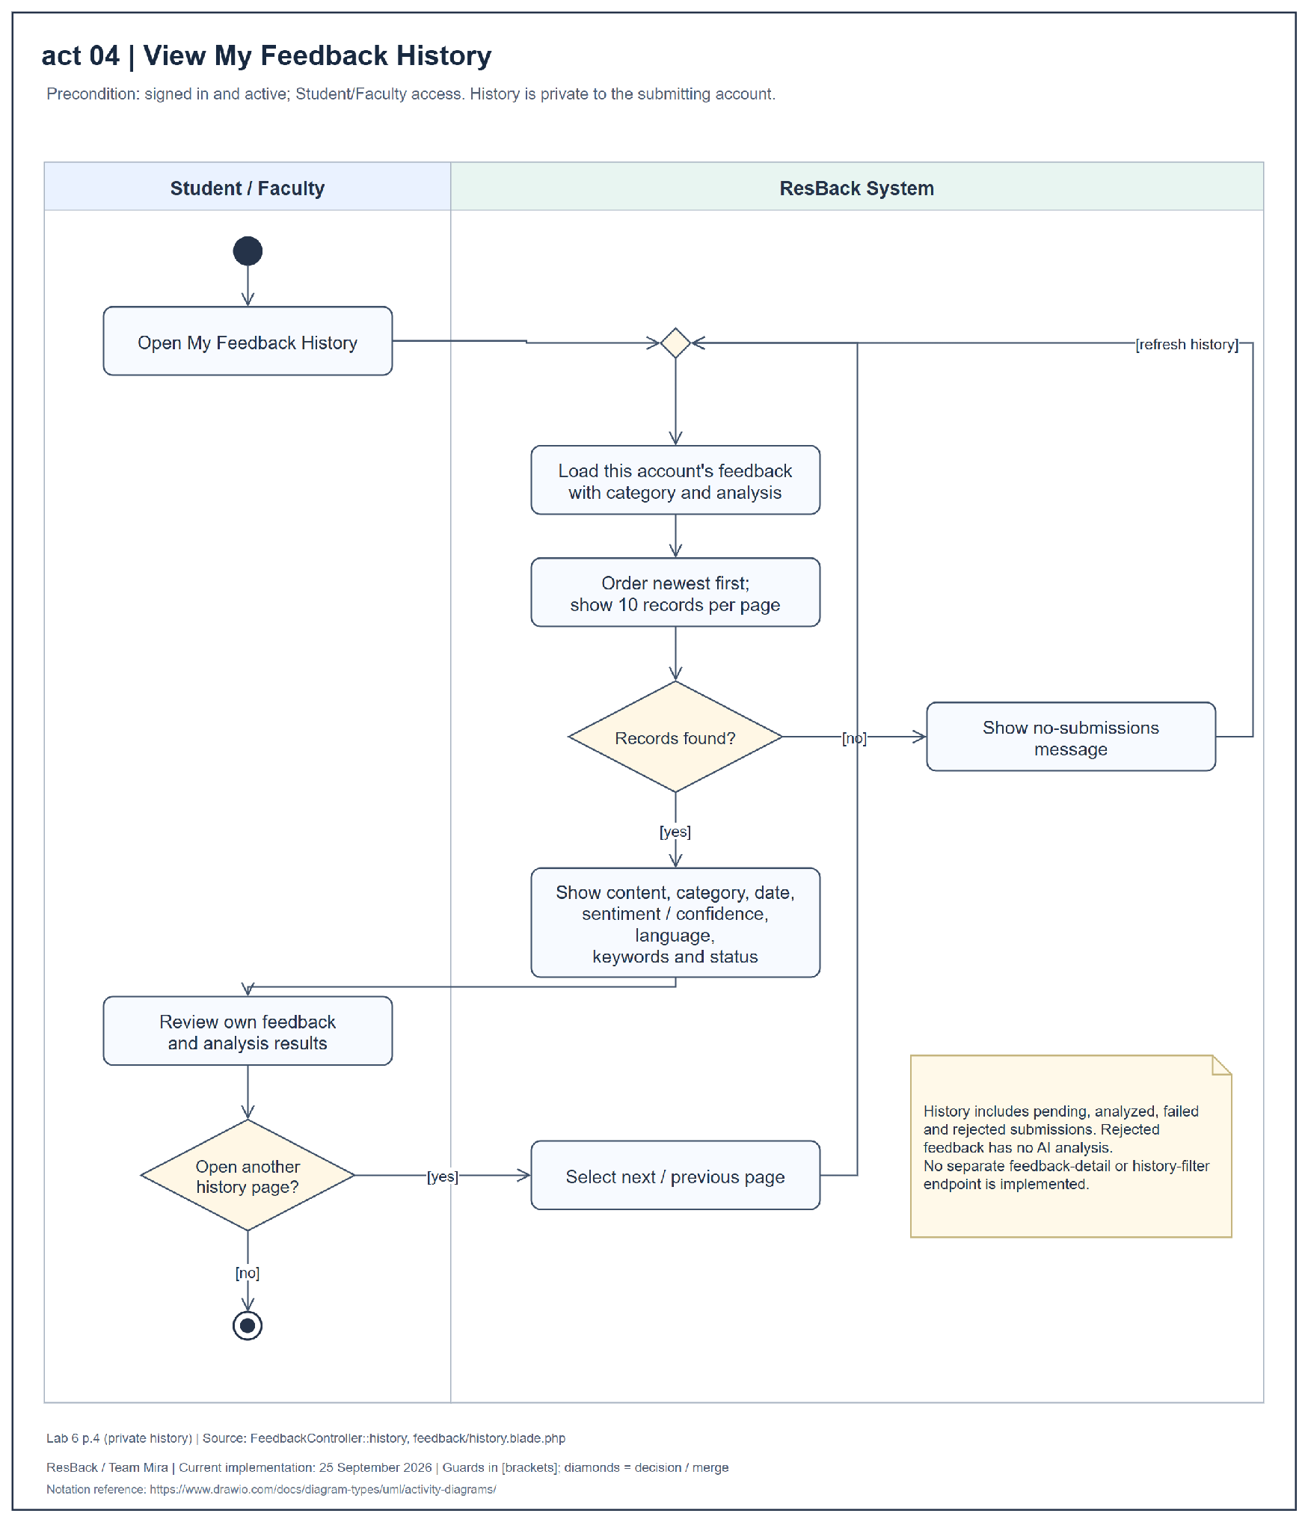
Figure 13 Activity diagram for view my feedback history
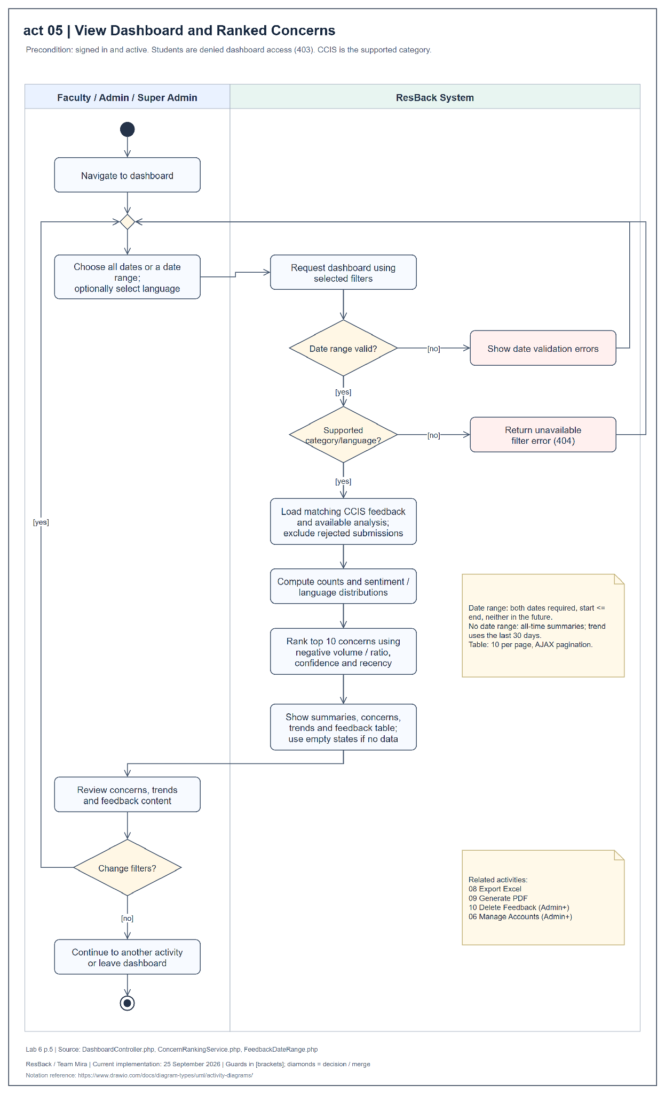
Figure 14 Activity diagram for view dashboard and ranked concerns
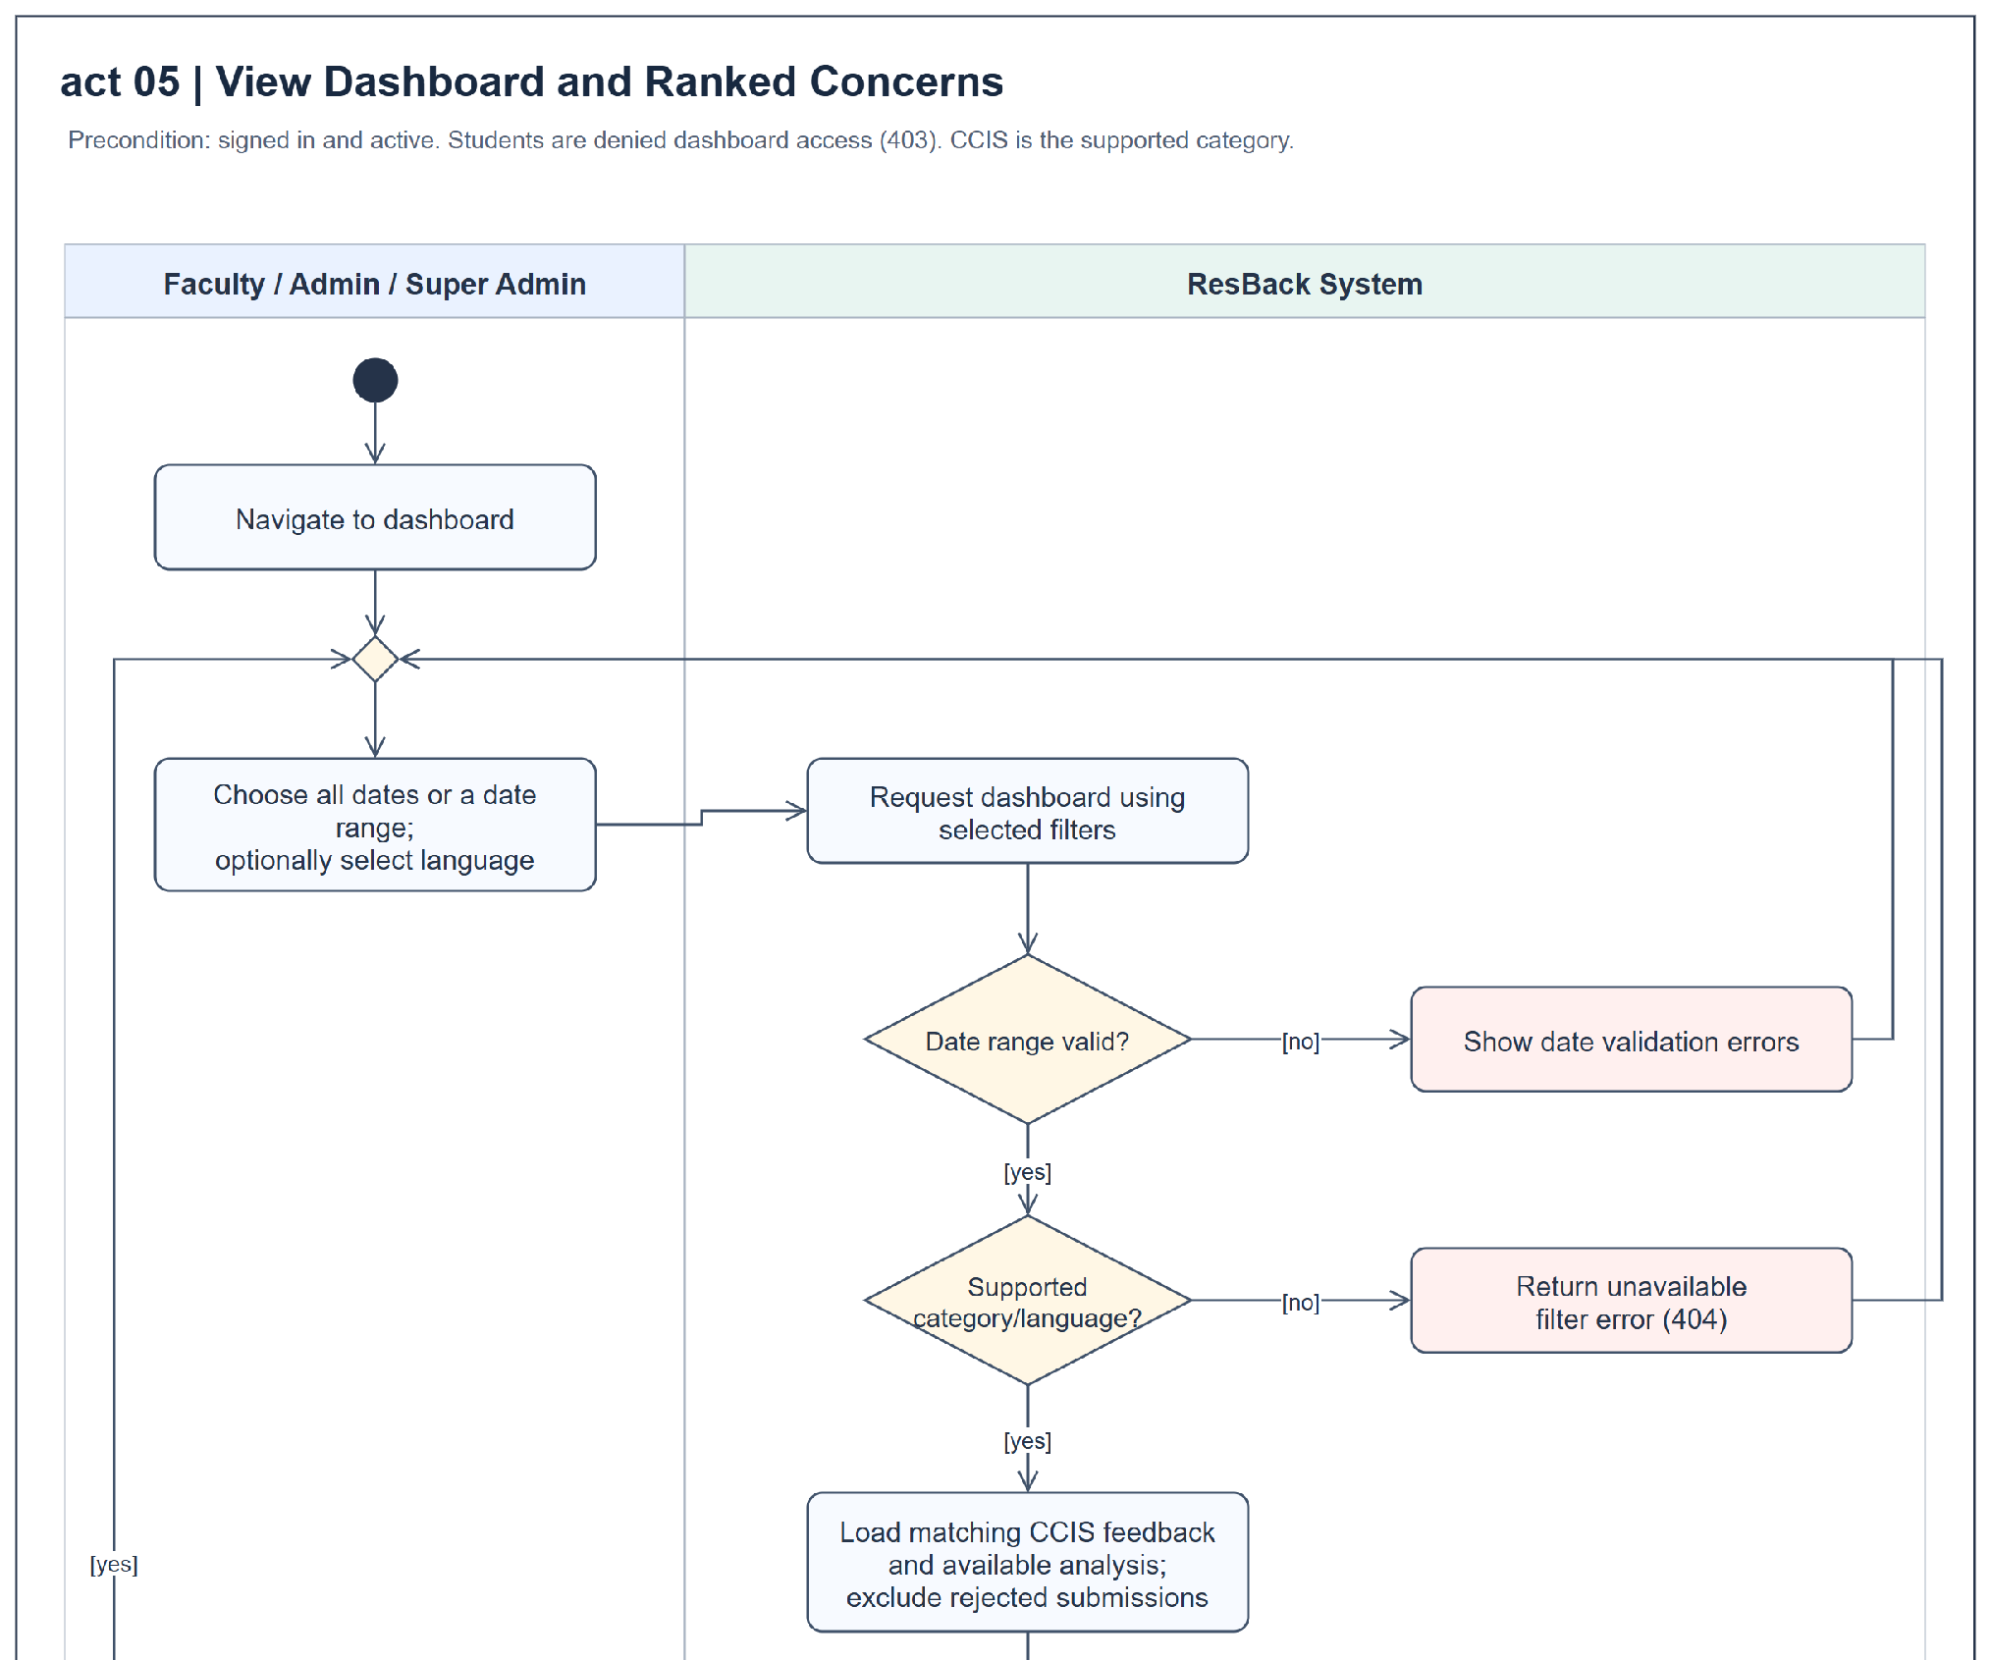
Figure 14 Activity diagram for view dashboard and ranked concerns enlarged continuation panel 1 of 2
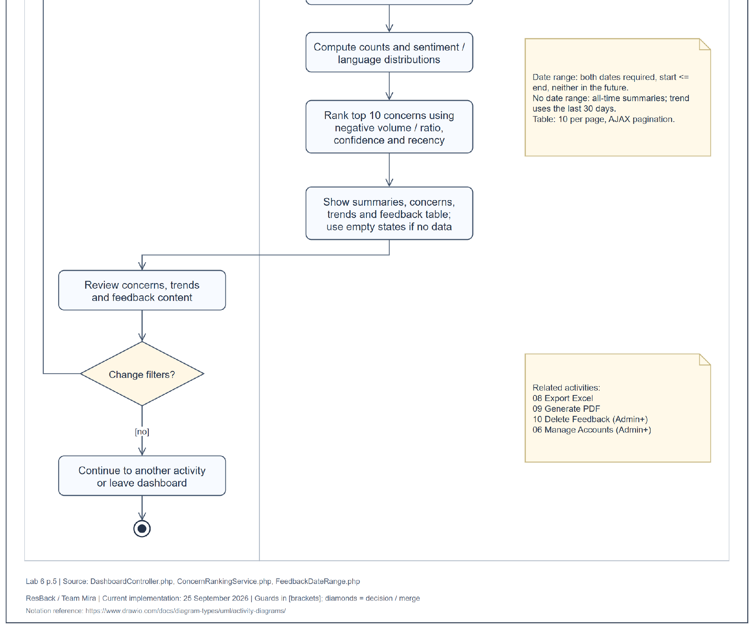
Figure 14 Activity diagram for view dashboard and ranked concerns enlarged continuation panel 2 of 2
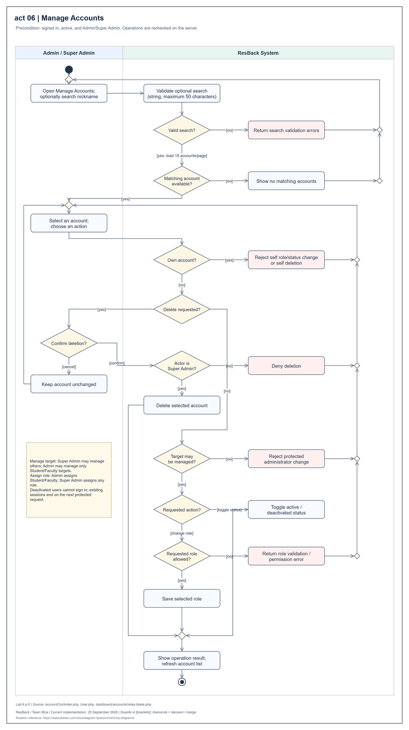
Figure 15 Activity diagram for manage accounts
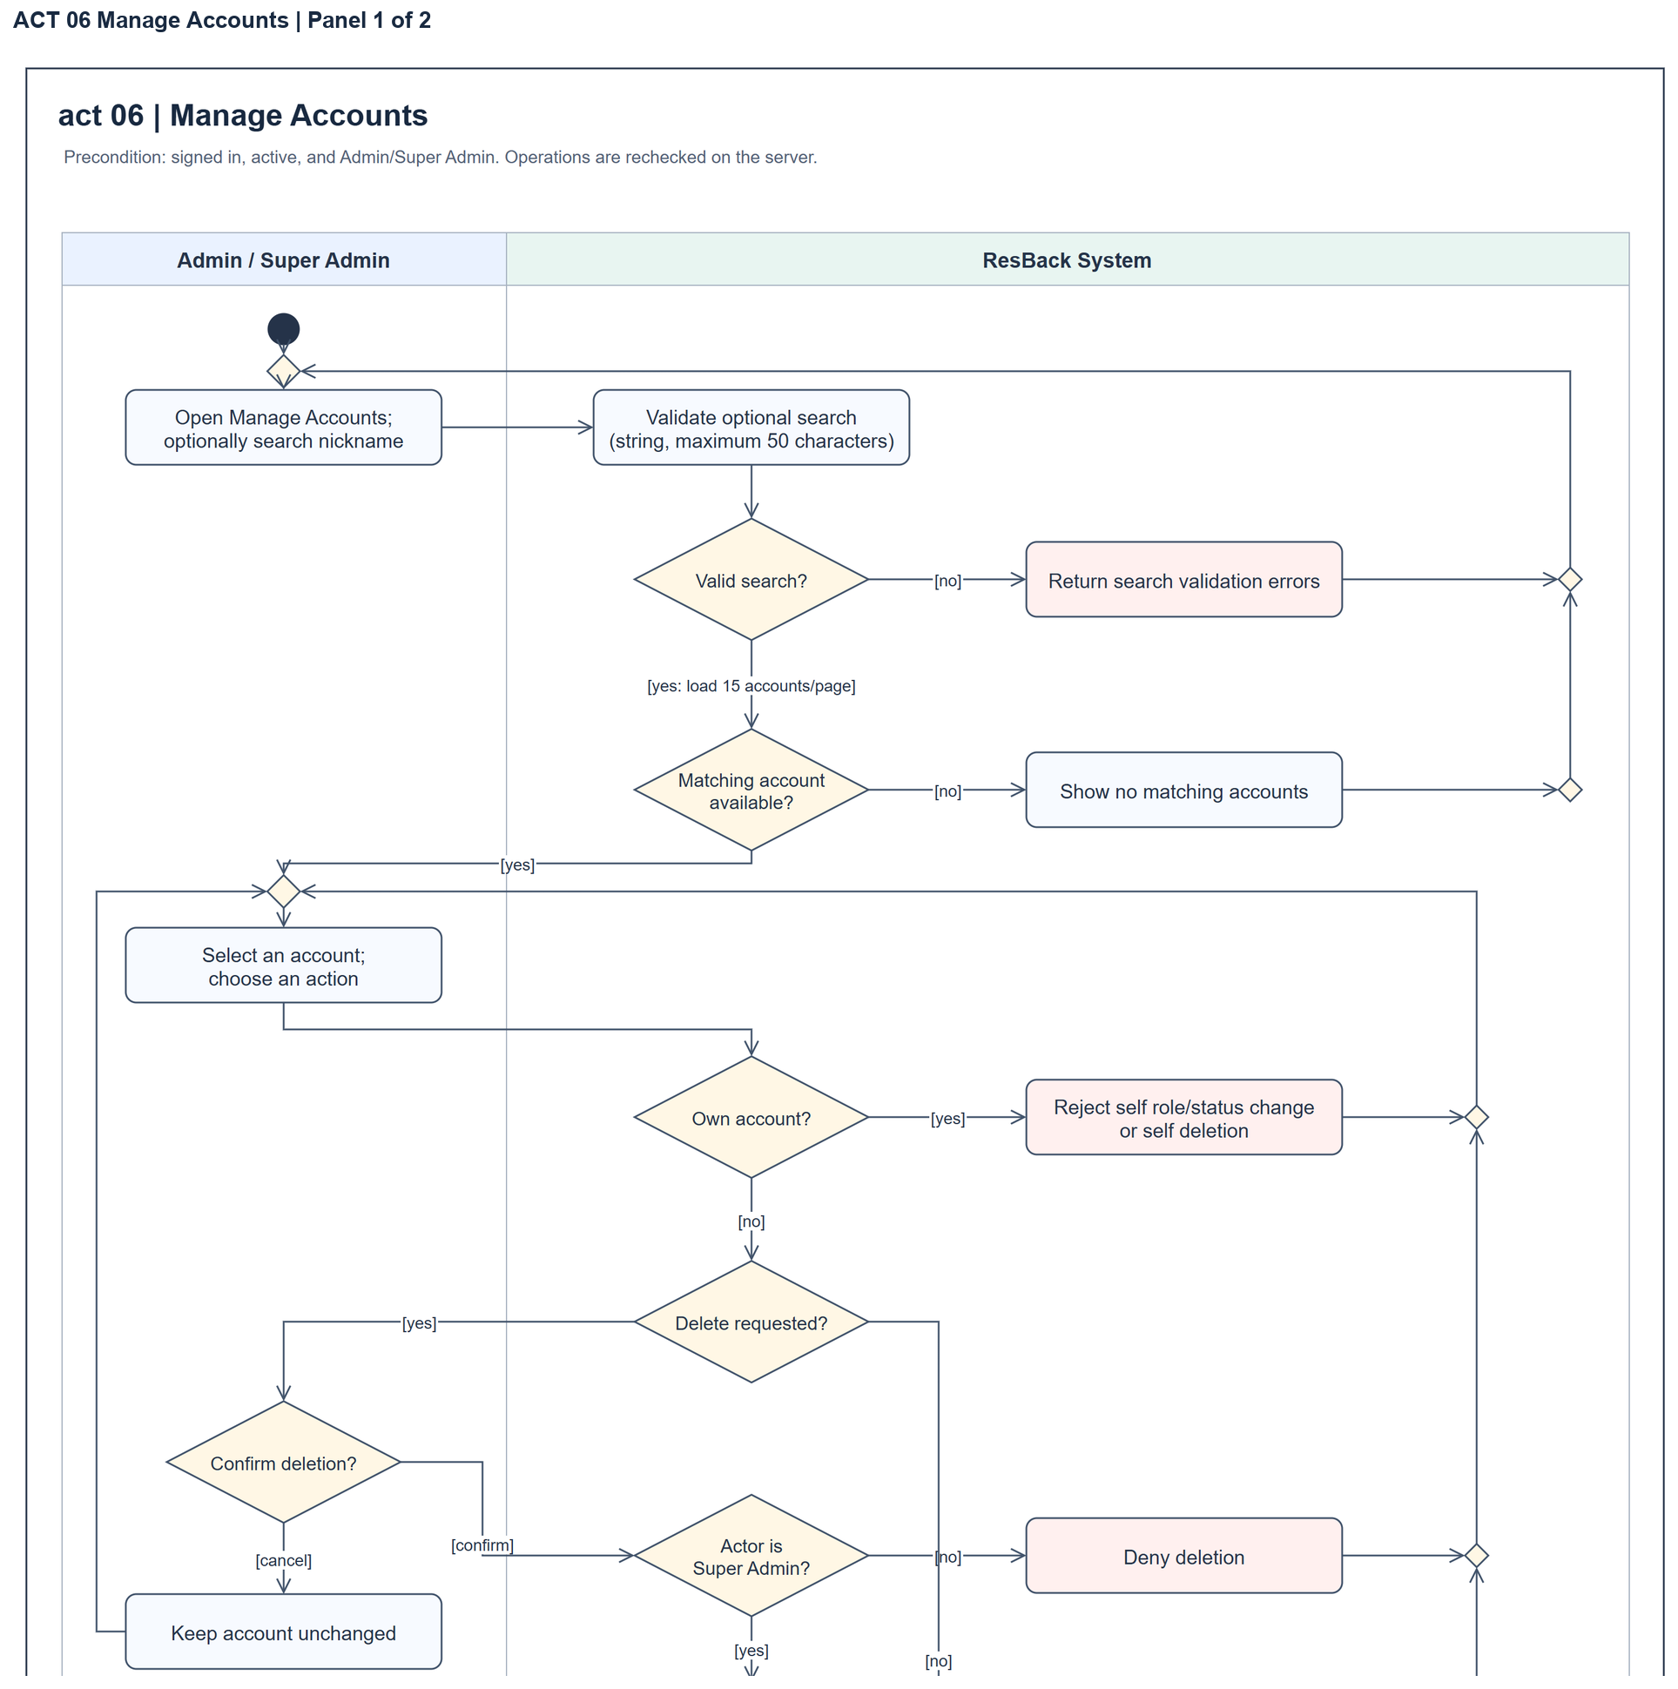
Figure 15 Activity diagram for manage accounts enlarged continuation panel 1 of 2
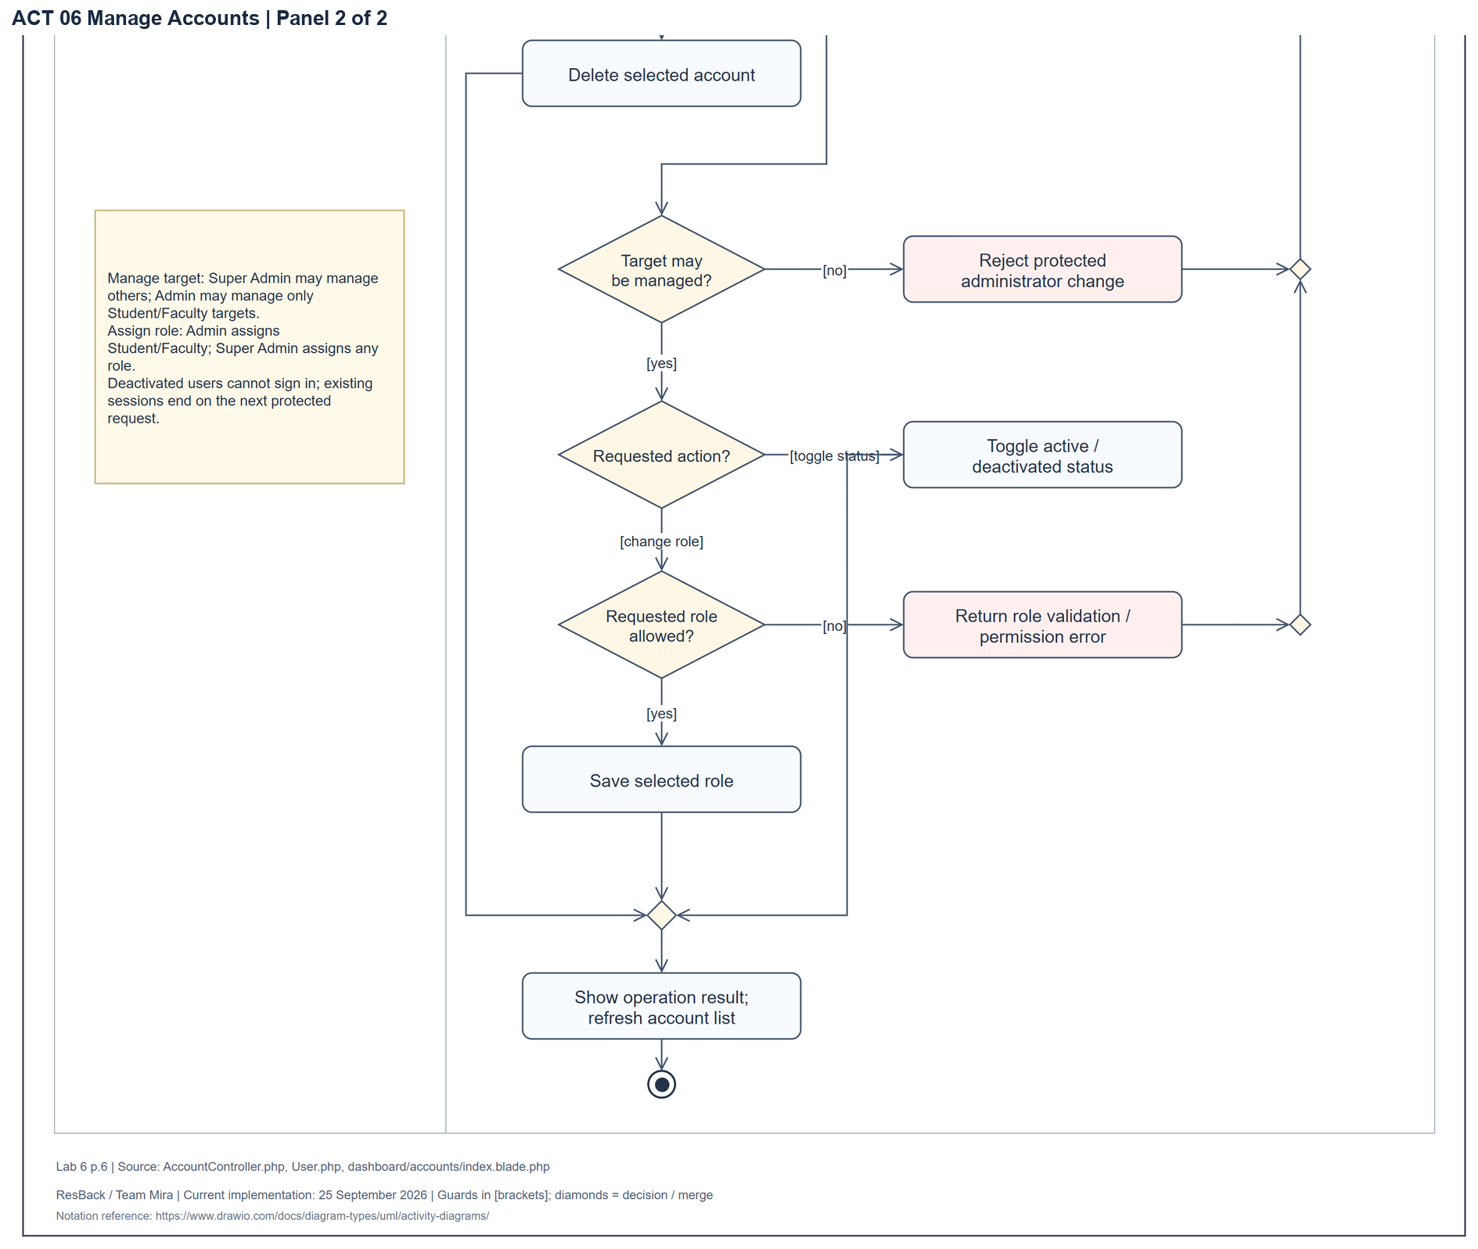
Figure 15 Activity diagram for manage accounts enlarged continuation panel 2 of 2
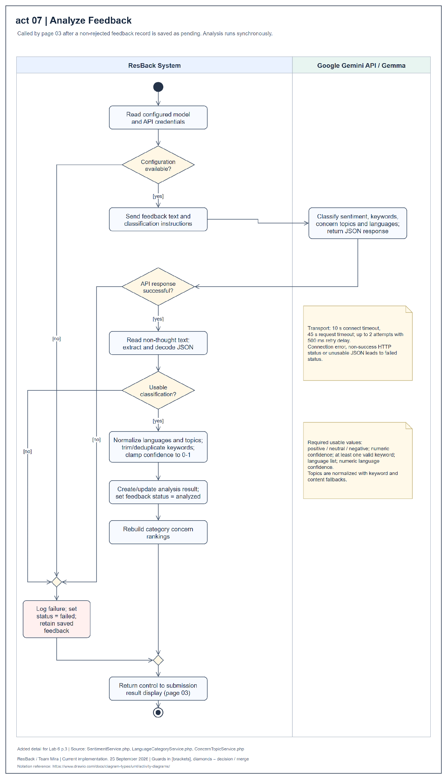
Figure 16 Activity diagram for analyze feedback
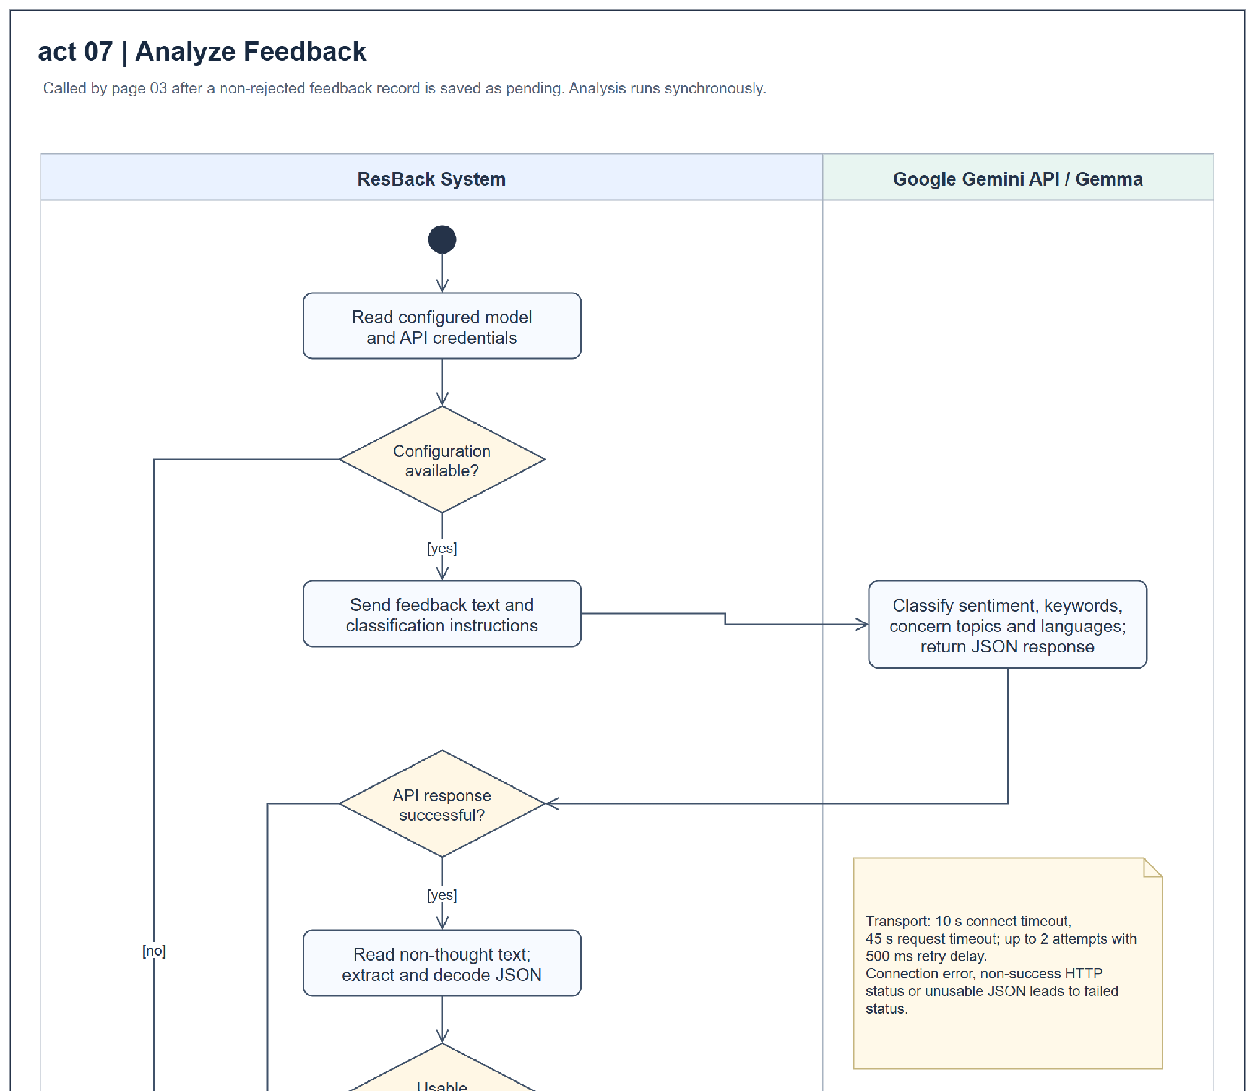
Figure 16 Activity diagram for analyze feedback enlarged continuation panel 1 of 2
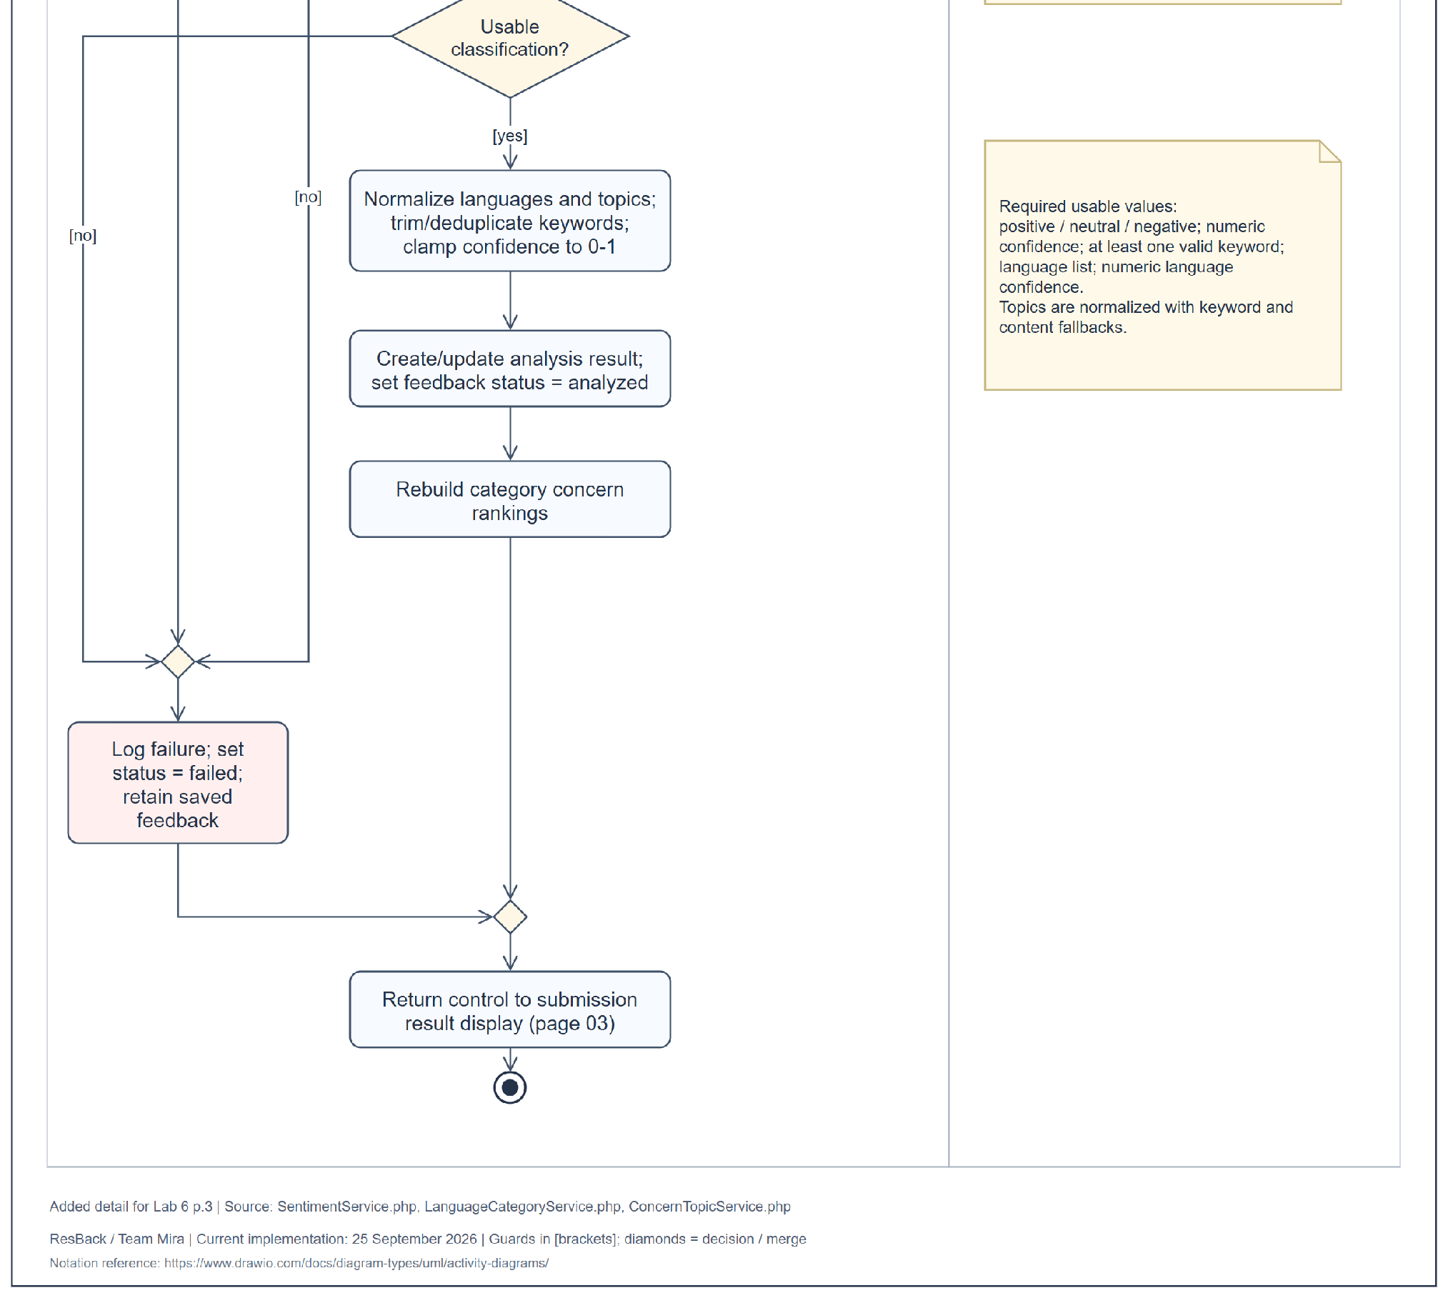
Figure 16 Activity diagram for analyze feedback enlarged continuation panel 2 of 2
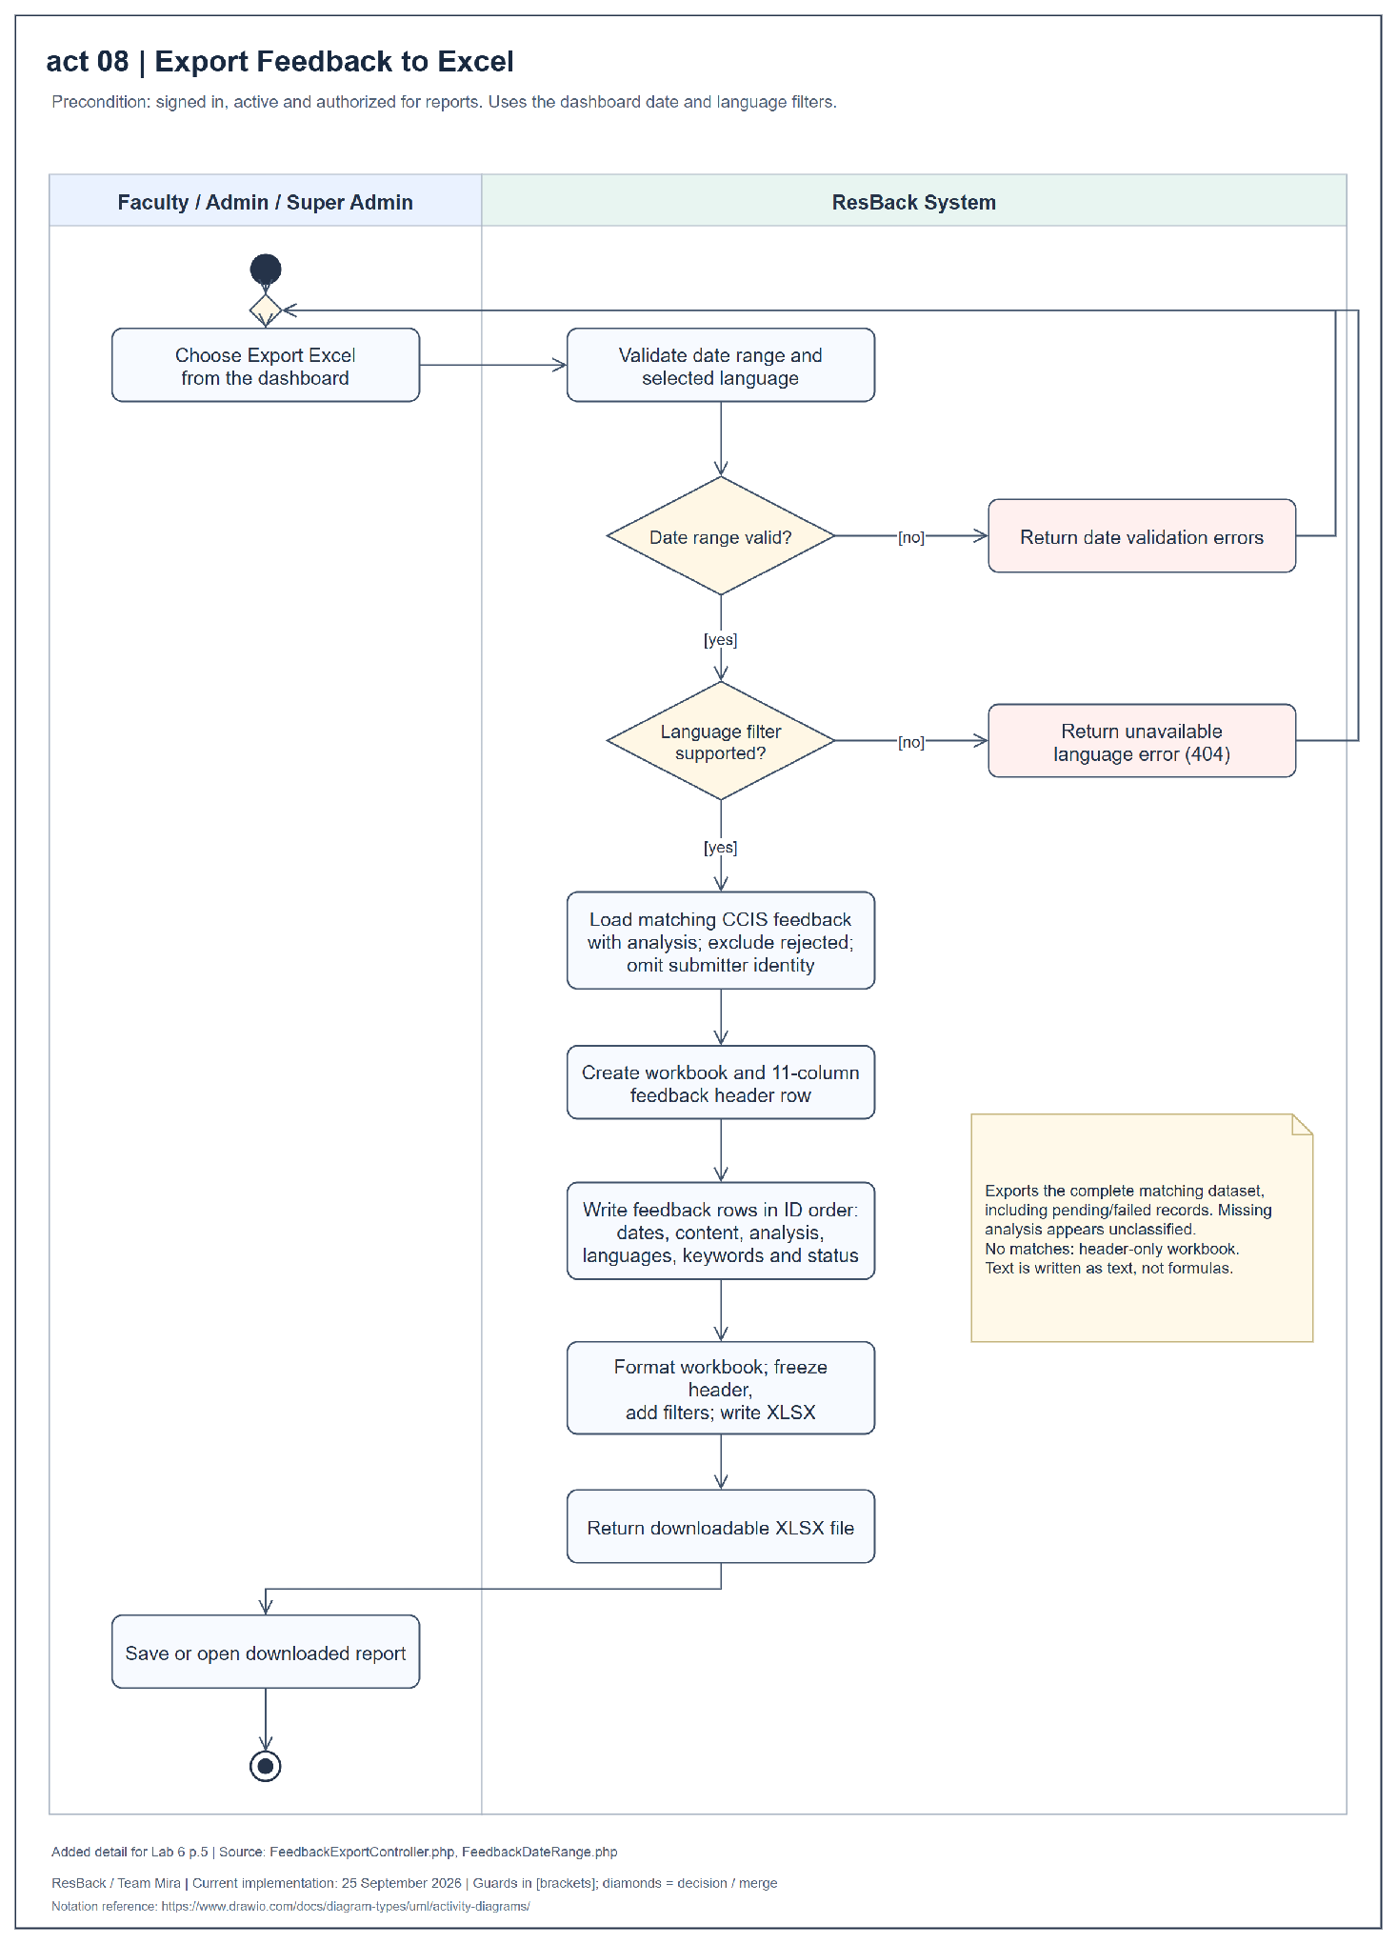
Figure 17 Activity diagram for export feedback to Excel
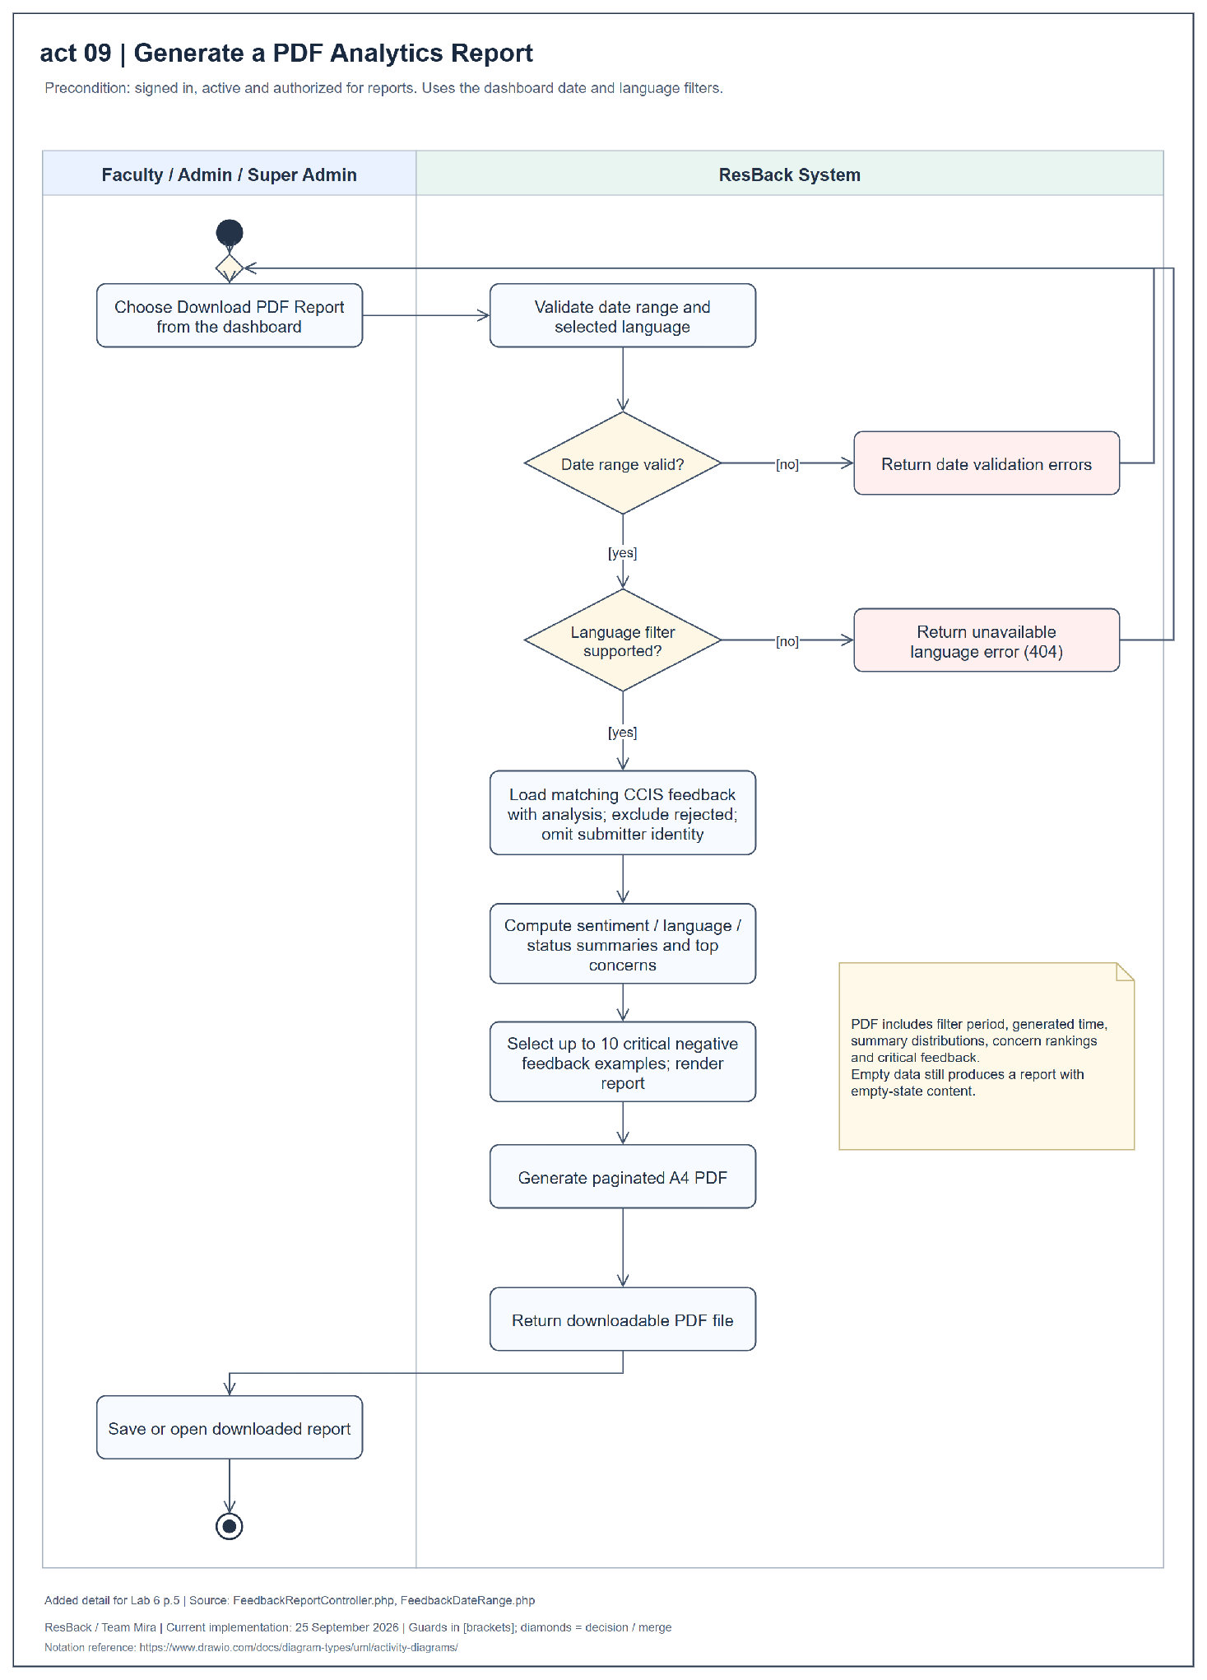
Figure 18 Activity diagram for generate a PDF analytics report
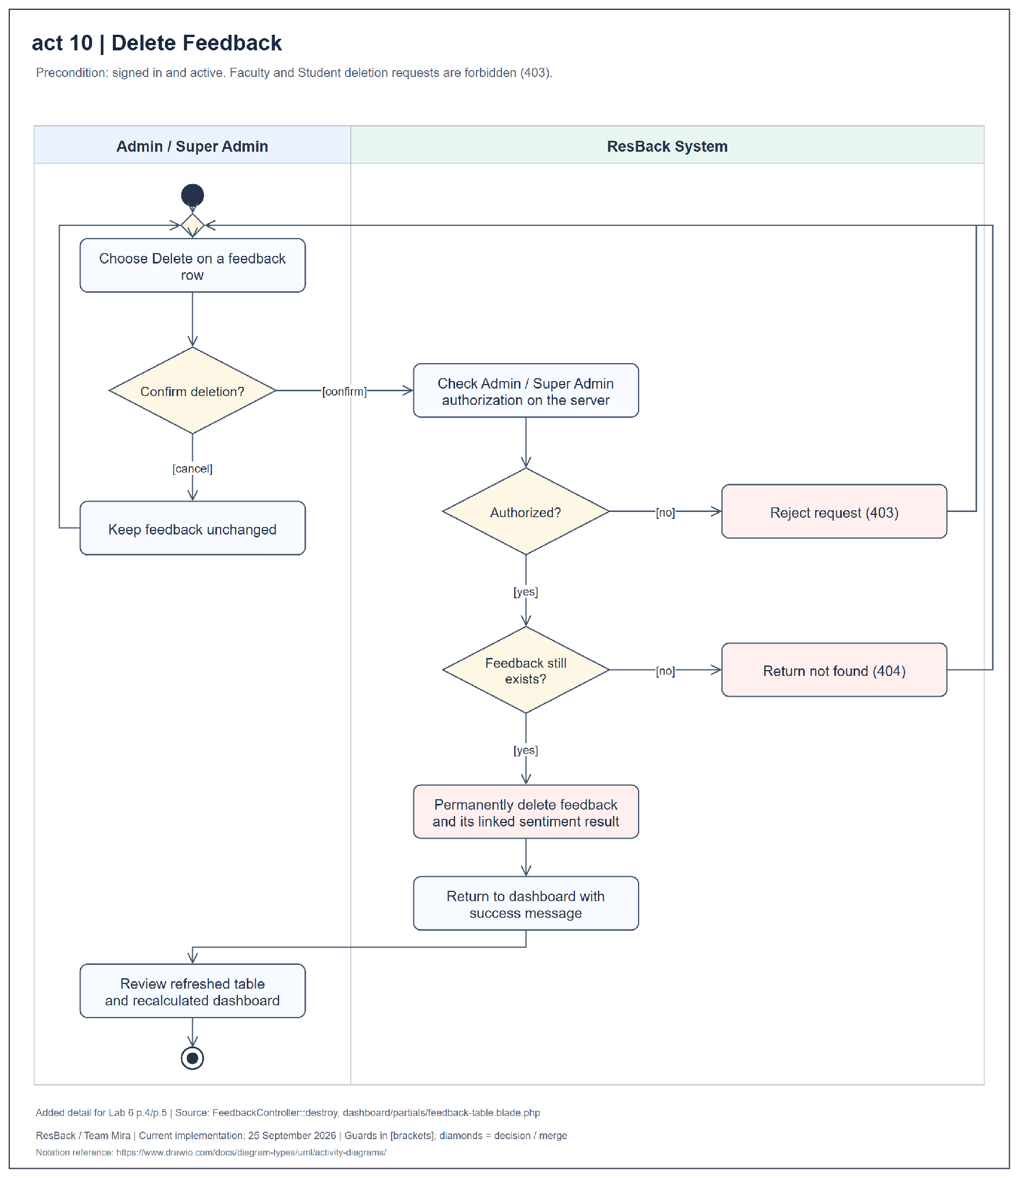
Figure 19 Activity diagram for delete feedback
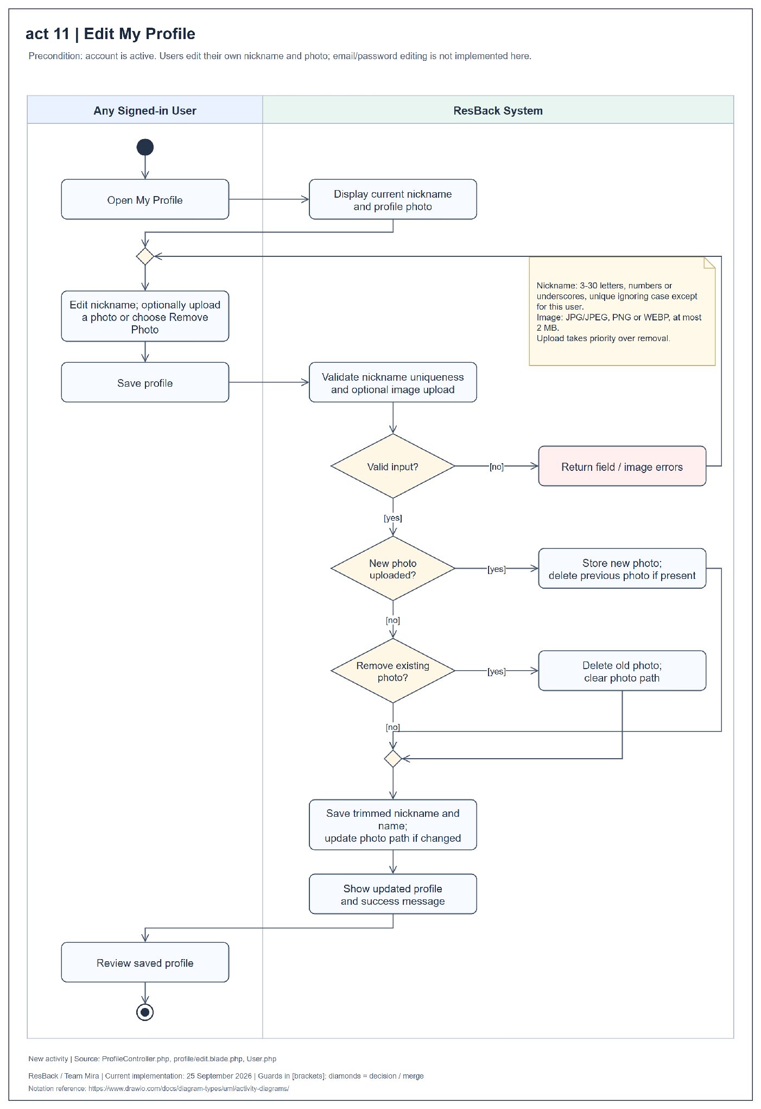
Figure 20 Activity diagram for edit my profile
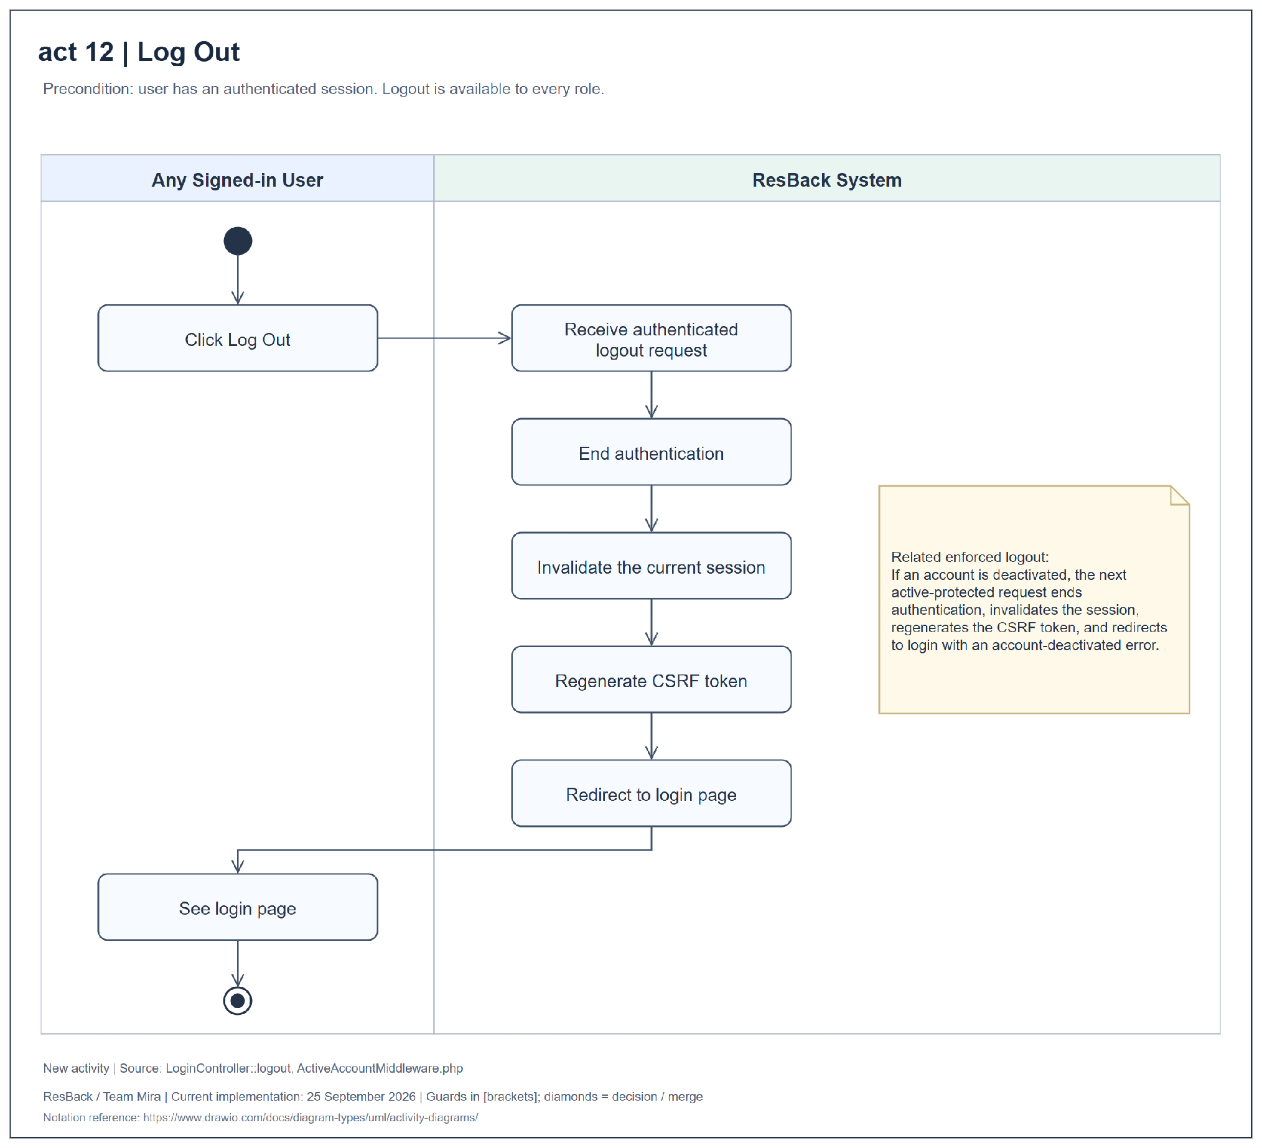
Figure 21 Activity diagram for log out

APPENDIX F CLASS DIAGRAMS
Figures 22–27 present six class views. Plus, hash, and minus symbols identify public, protected, and private members. The source sheets retain their original 01–06 labels.
Figure 22. The core domain model shows record attributes, operations, ownership, analysis relationships, and deletion behavior. User roles are stored values rather than subclasses.
Figure 23. Authentication, accounts, and profiles connect registration, login, routing, account administration, and profile editing to the User model.
Figure 24. Feedback submission and protection connect validation, rate limiting, duplicate detection, screening, and analysis. Screening occurs before external inference.
Figure 25. Sentiment analysis and concern ranking connect model-output normalization, language and topic categories, optional date boundaries, and ranking reconstruction.
Figure 26. Dashboard and report generation share filters, ranked concerns, models, and export utilities. Review outputs omit submitter identification and rejected feedback.
Figure 27. Account-access middleware checks authentication, active status, and roles. Controller authorization adds account-management restrictions.
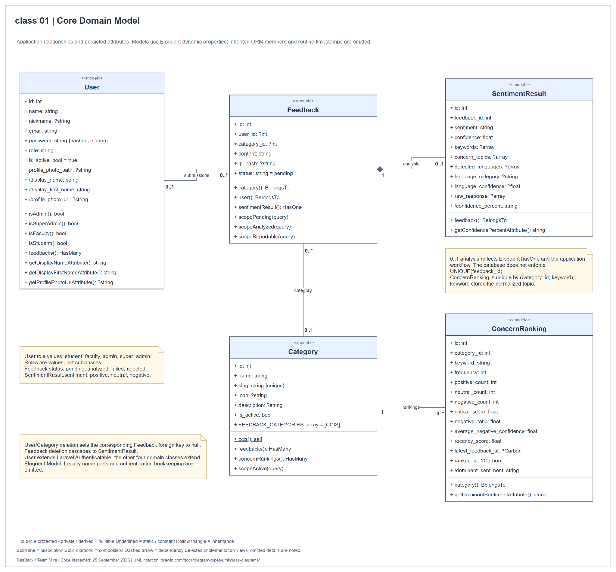
Figure 22 Class diagram for core domain model
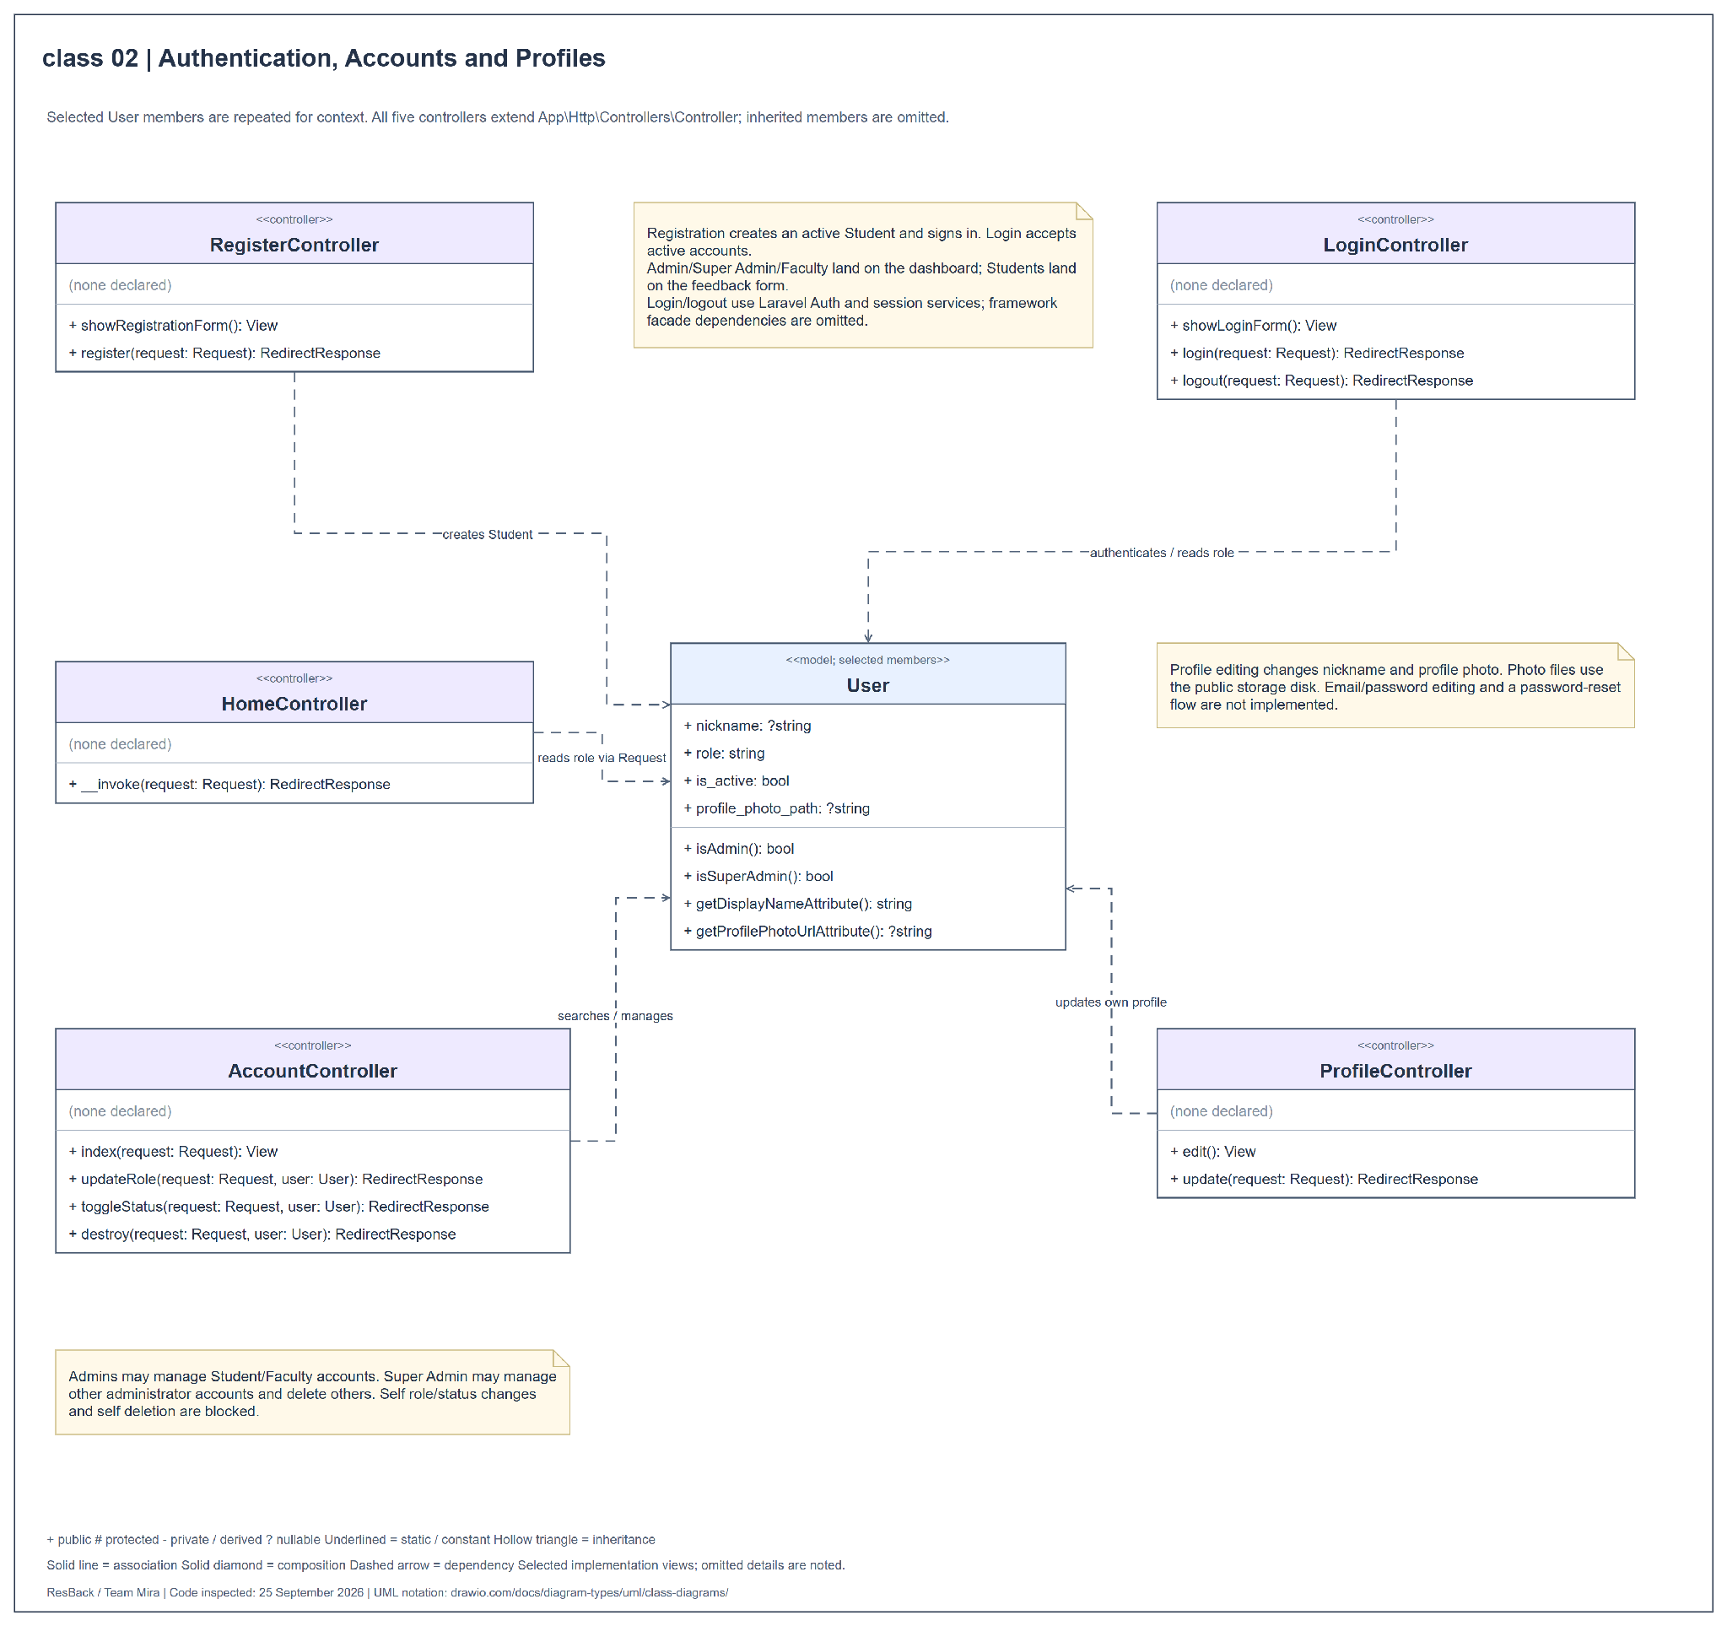
Figure 23 Class diagram for authentication accounts and profiles
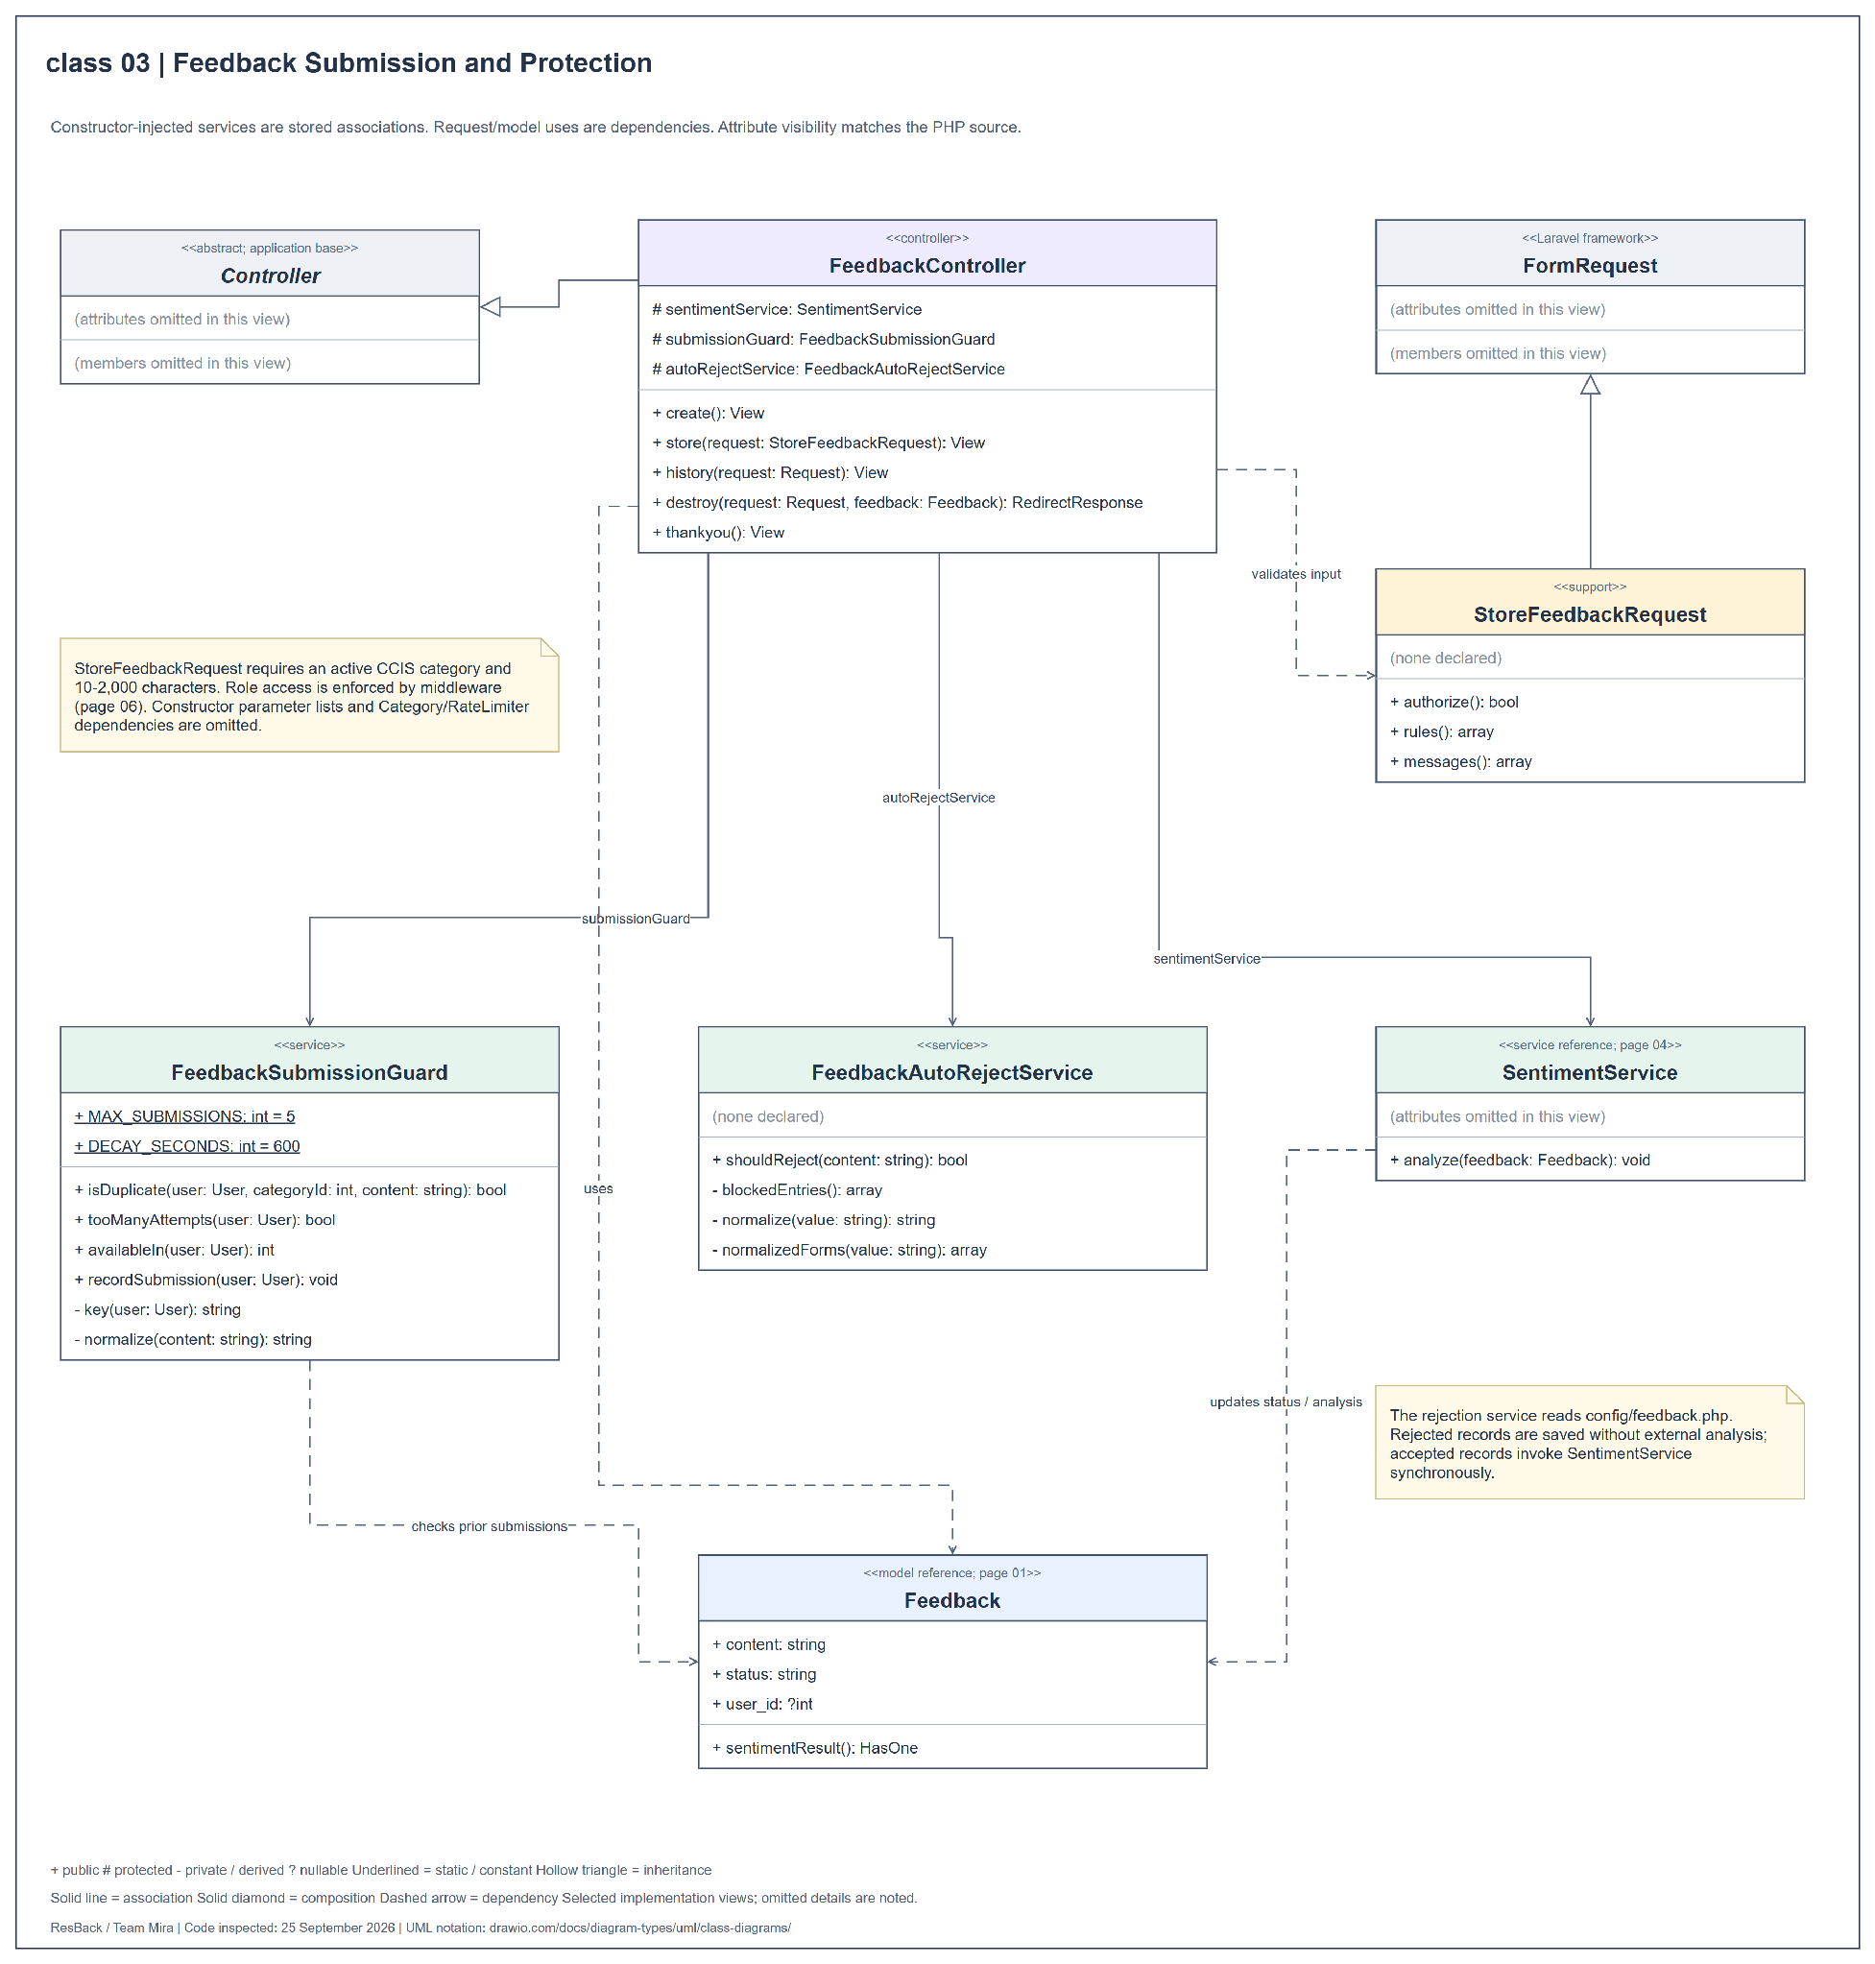
Figure 24 Class diagram for feedback submission and protection
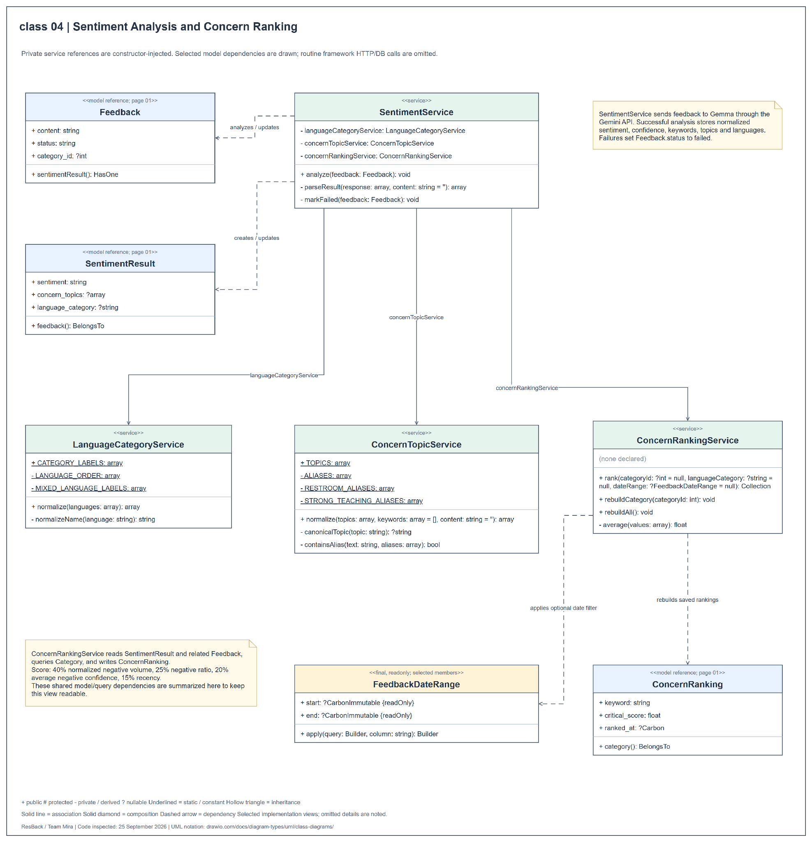
Figure 25 Class diagram for sentiment analysis and concern ranking
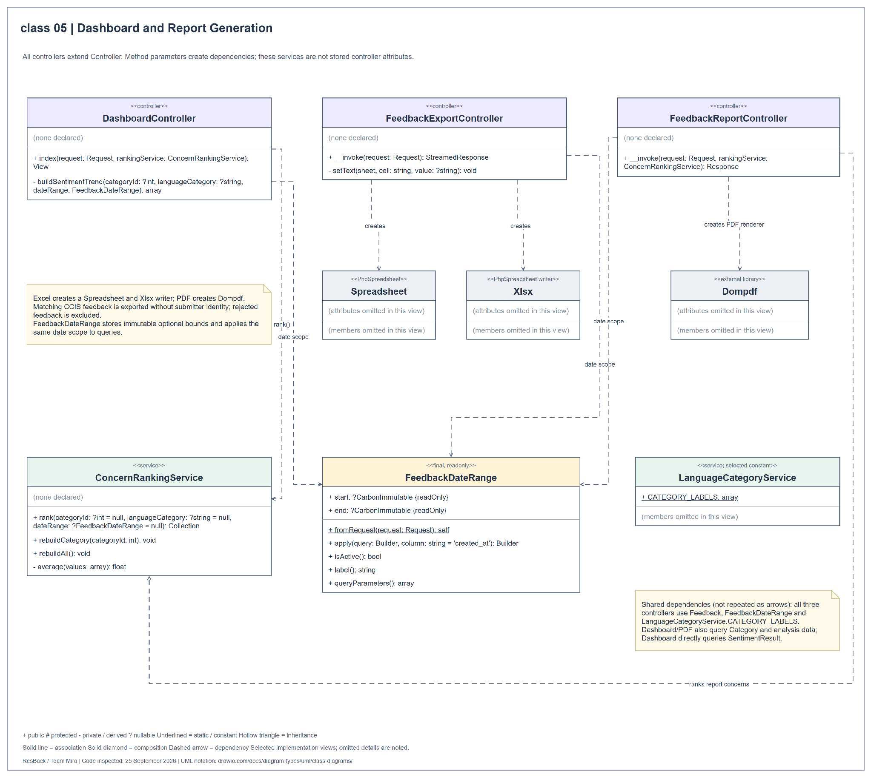
Figure 26 Class diagram for dashboard and report generation
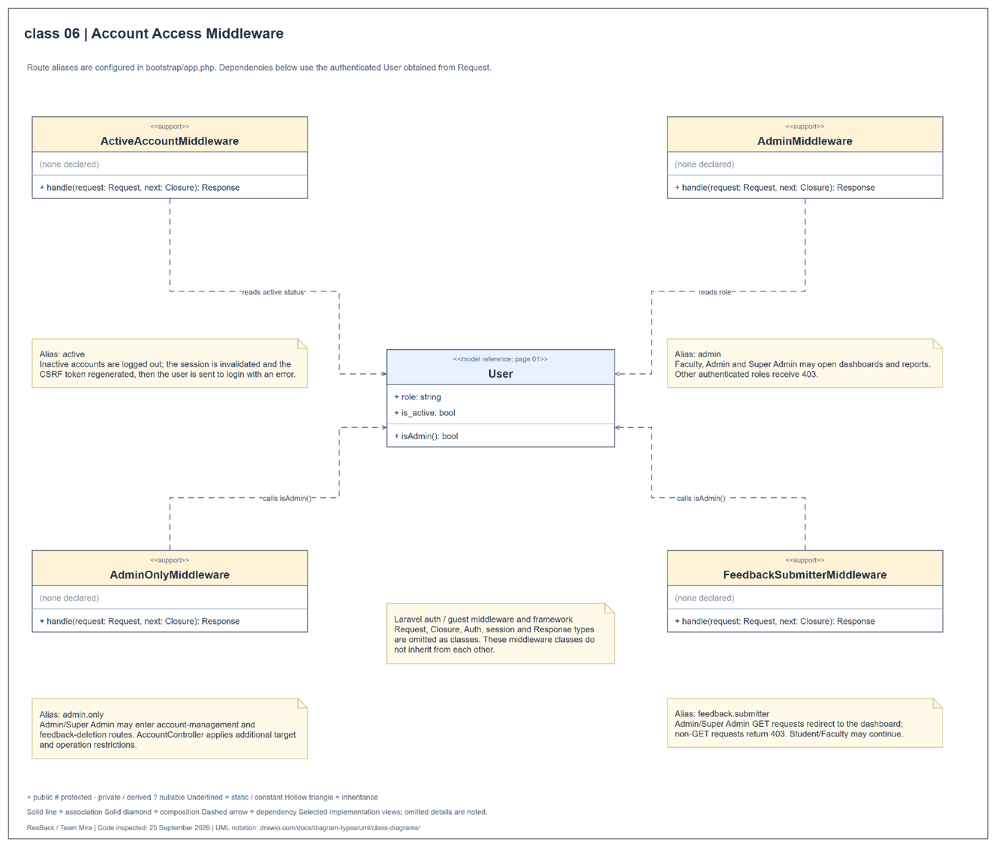
Figure 27 Class diagram for account access middleware

APPENDIX G COMPONENT DIAGRAM
Figure 28 shows the logical modules inside the Laravel application: Web Presentation, Identity and Accounts, Feedback Management, Sentiment Analysis, Concern Ranking, and Dashboard and Reporting. These are logical components of the existing application rather than separately deployed services.
Provided and required interfaces identify service contracts. Delegation connectors link application boundaries to internal components. The diagram also includes external inference, relational storage, profile-photo storage, and report libraries.
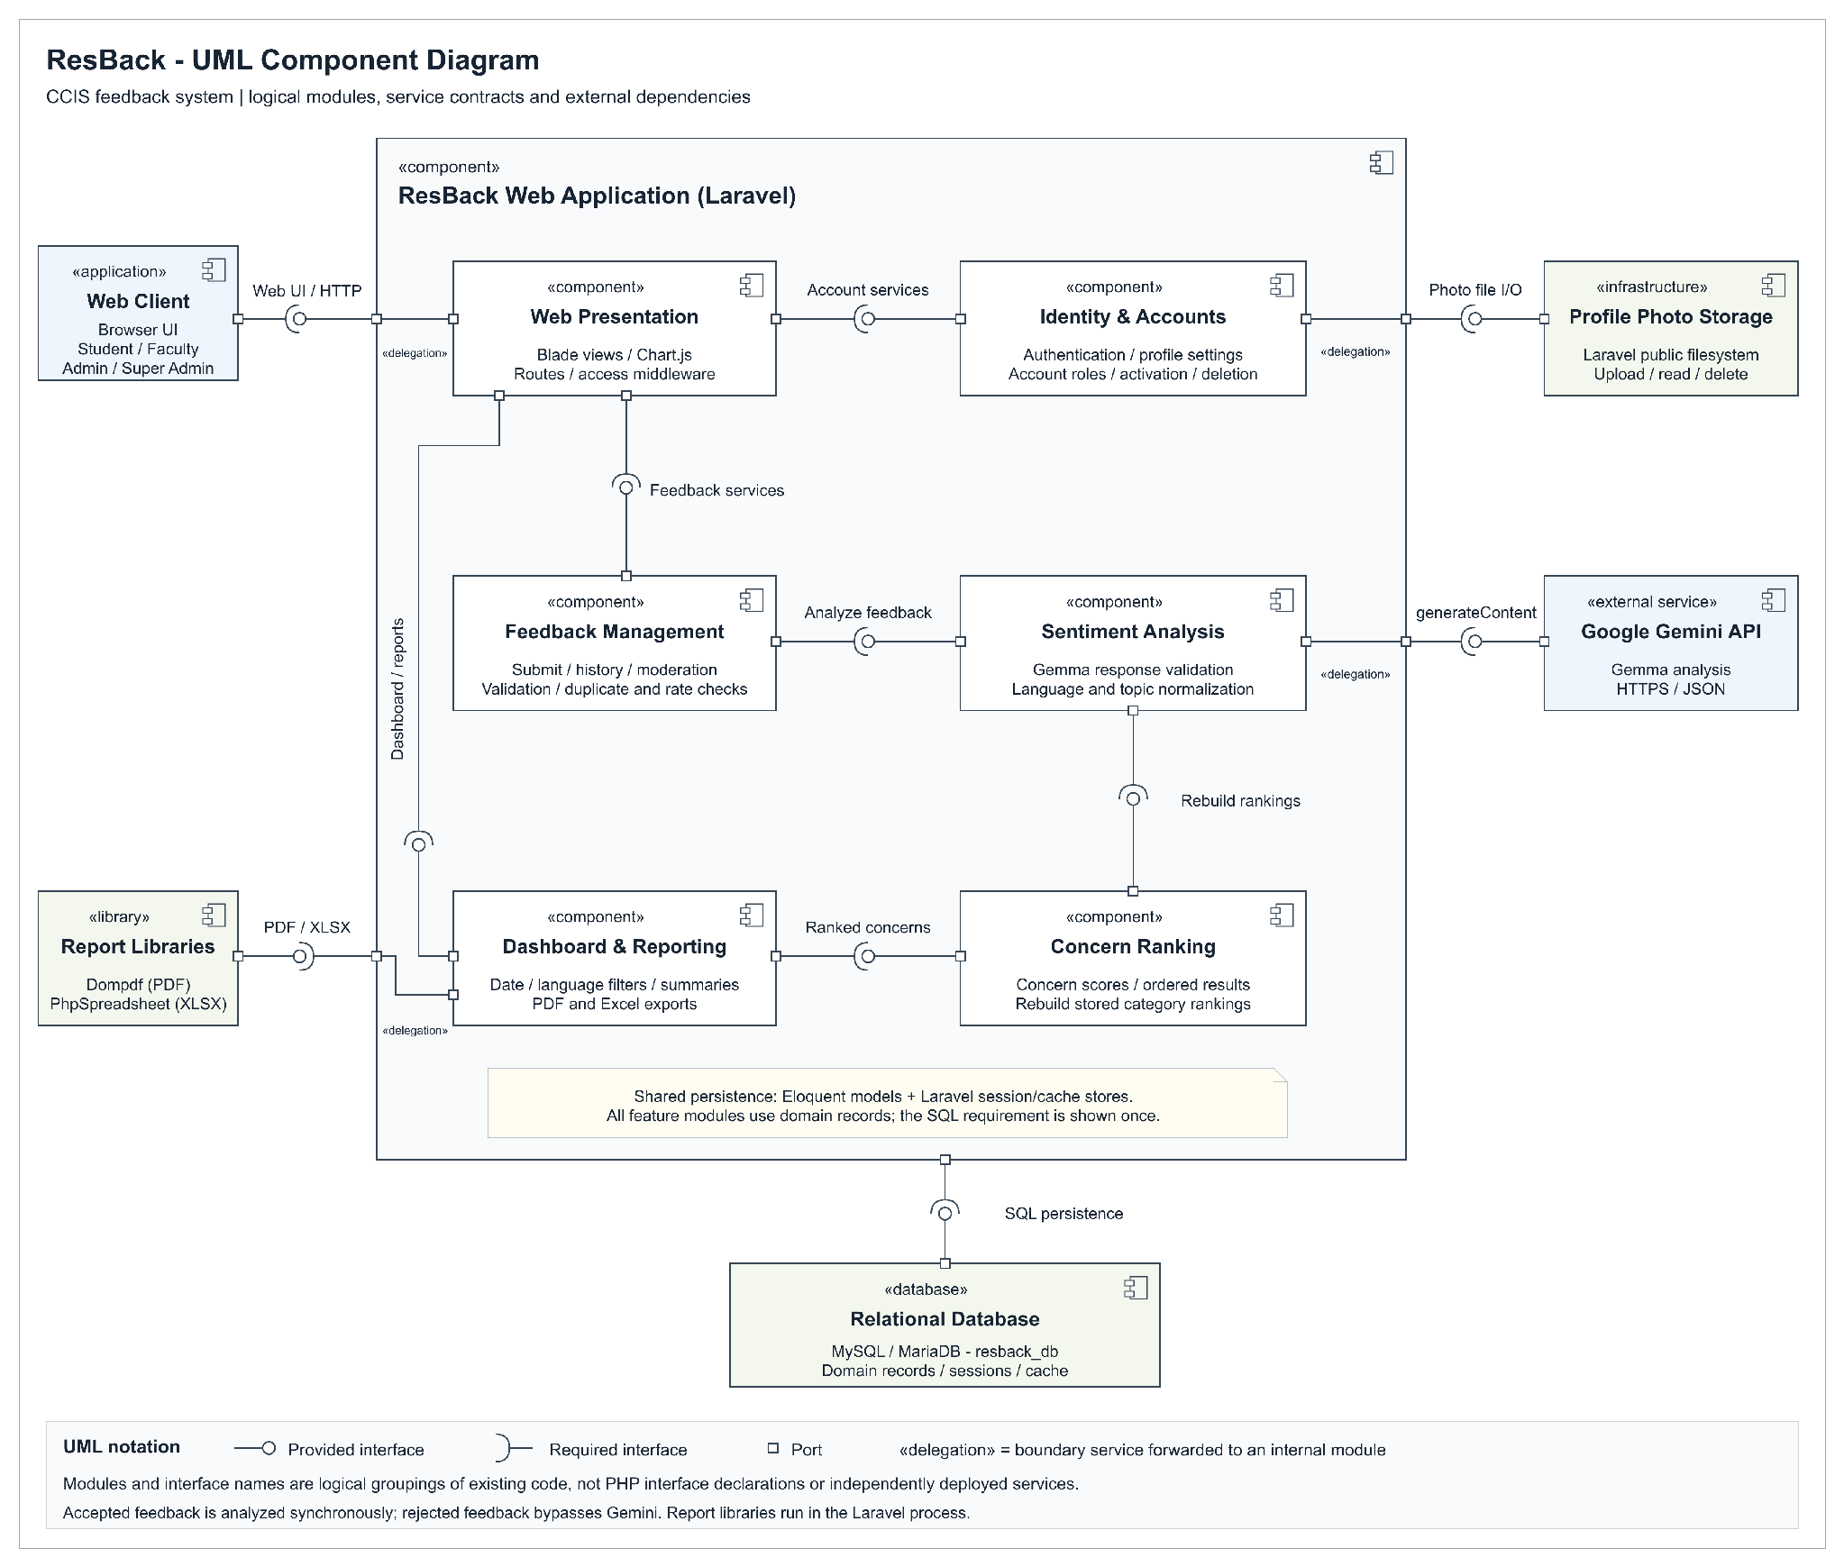
Figure 28 ResBack UML component diagram

APPENDIX H PACKAGE DIAGRAM
Figure 29 groups the application into packages for presentation, account access, feedback handling, analysis, reporting, and persistence. Dashed dependency arrows point toward the package being used. The Google API remains an external dependency.
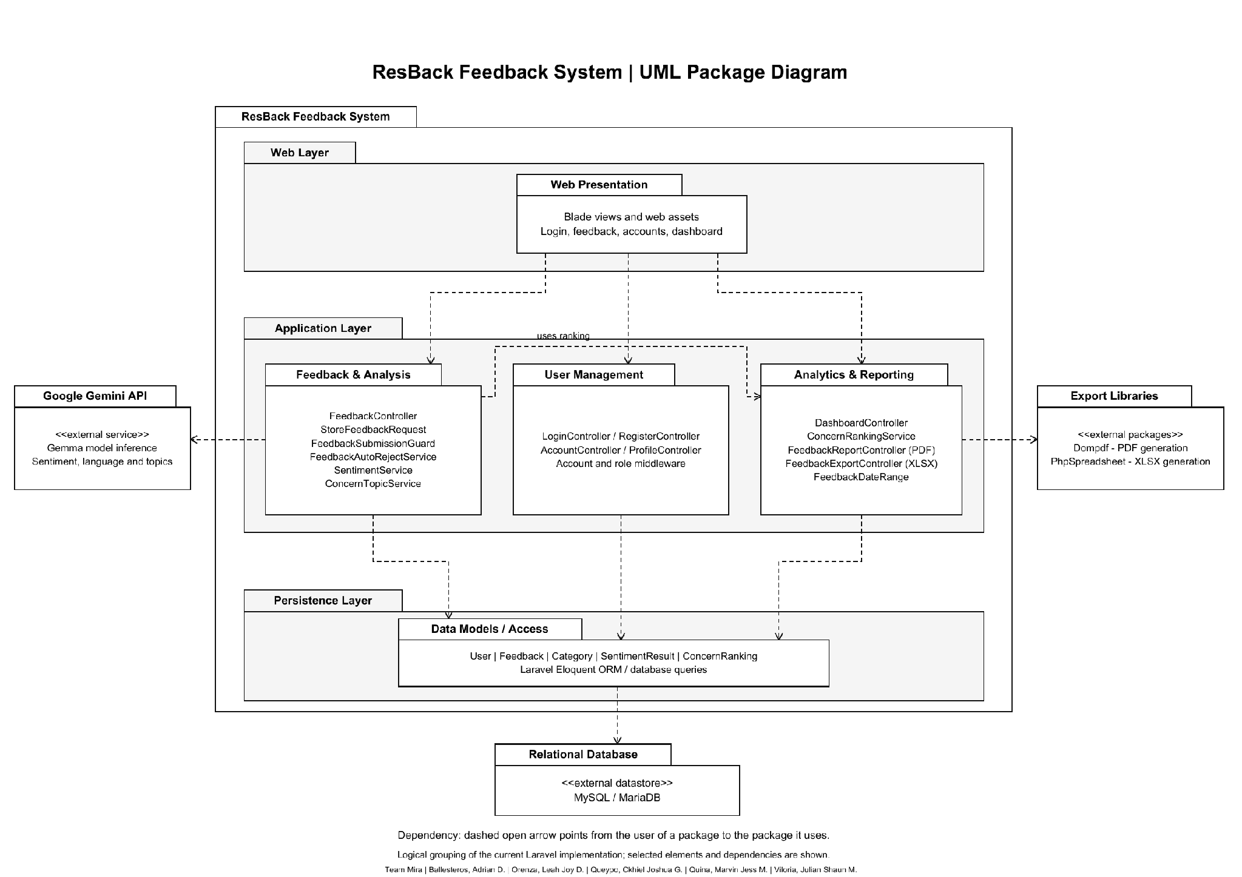
Figure 29 ResBack UML package diagram

APPENDIX I DEPLOYMENT DIAGRAMS LOCAL AND ONLINE
Figure 30 shows the local development deployment: the web browser, PHP development server, XAMPP MySQL or MariaDB, application files, and external Google Gemini API. Web and database services run locally, while Gemma inference requires internet access.
Figure 31 shows the proposed online deployment on Render with Supabase PostgreSQL and profile-photo storage. This remains a target architecture and requires database compatibility, persistent-storage integration, deployment configuration, and operational verification.
The local and online diagrams are separate views. Solid communication paths identify the protocols between execution environments and services.
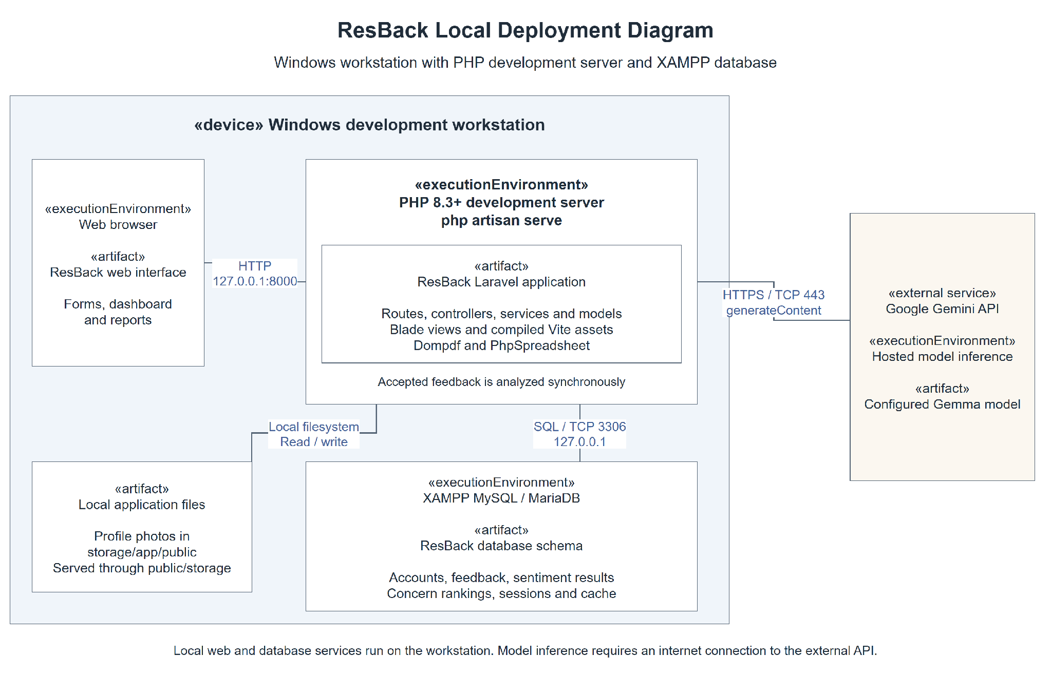
Figure 30 ResBack UML local deployment diagram
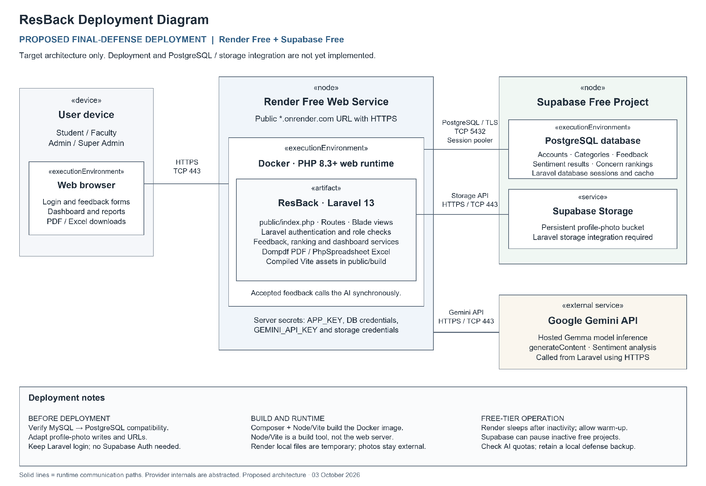
Figure 31 Proposed online deployment diagram

